K8s setup in GCP

1.select k8s engine

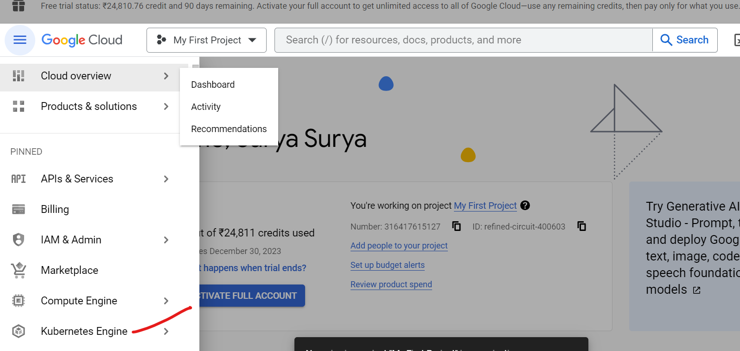

Enable k8s ensgine ensble

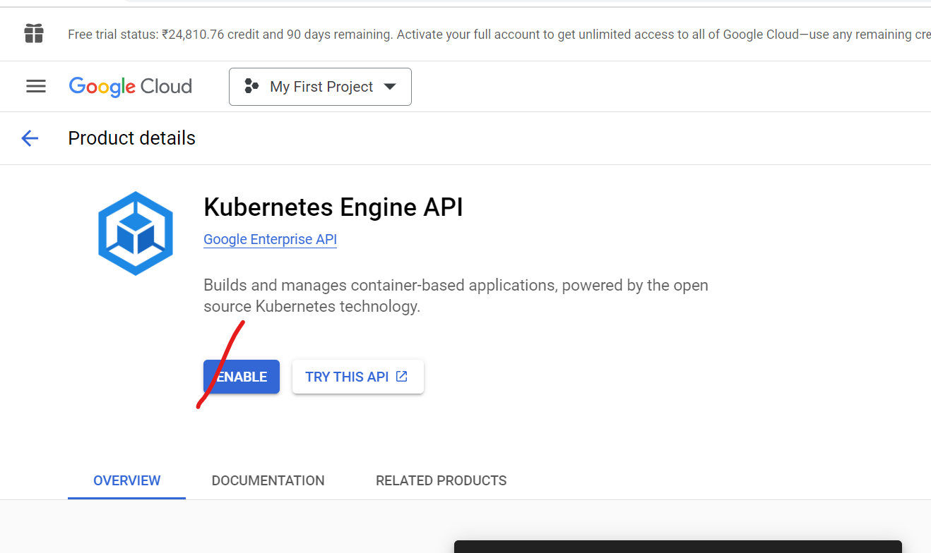

After enable Now create cluster

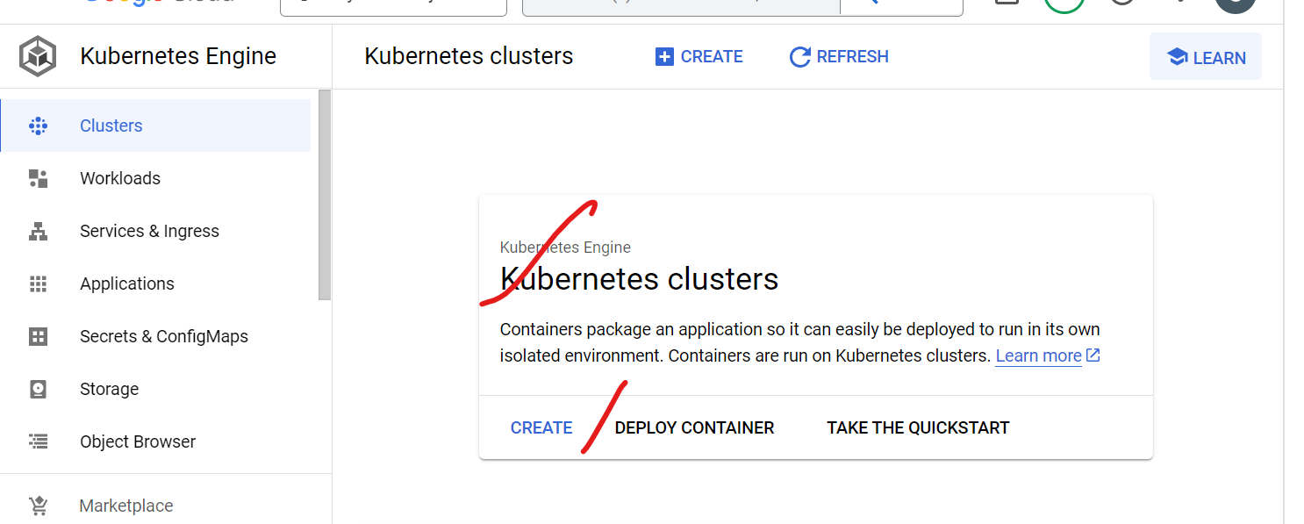

And then select create

Select standard cluster

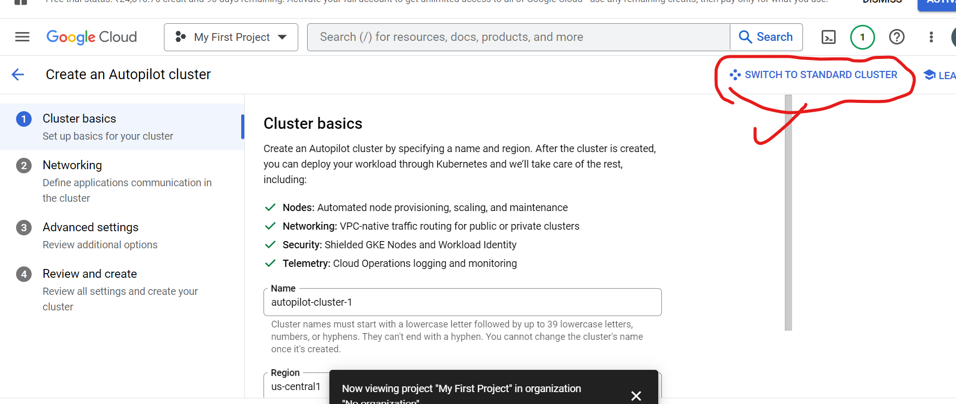

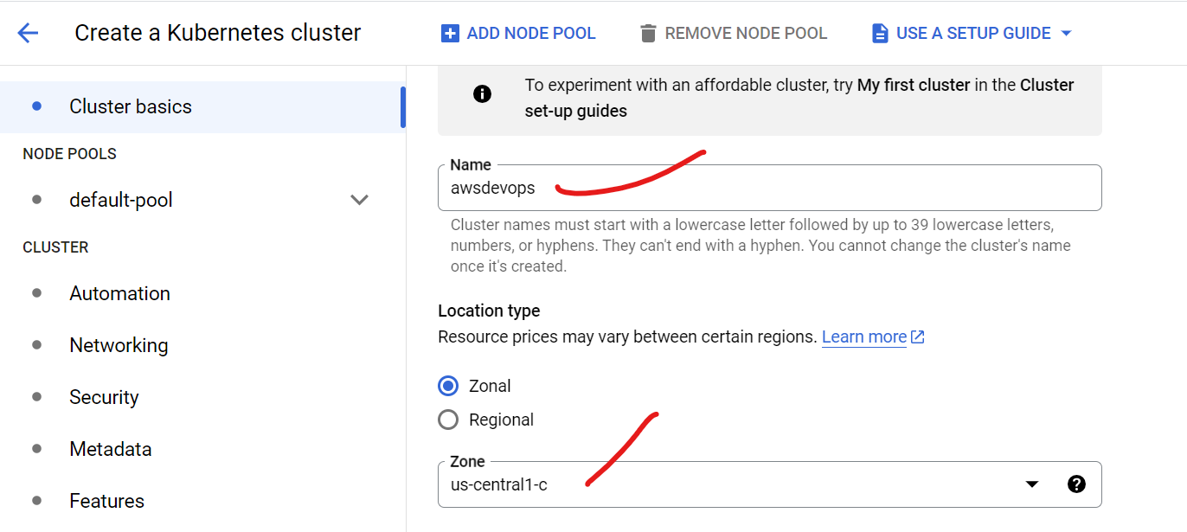

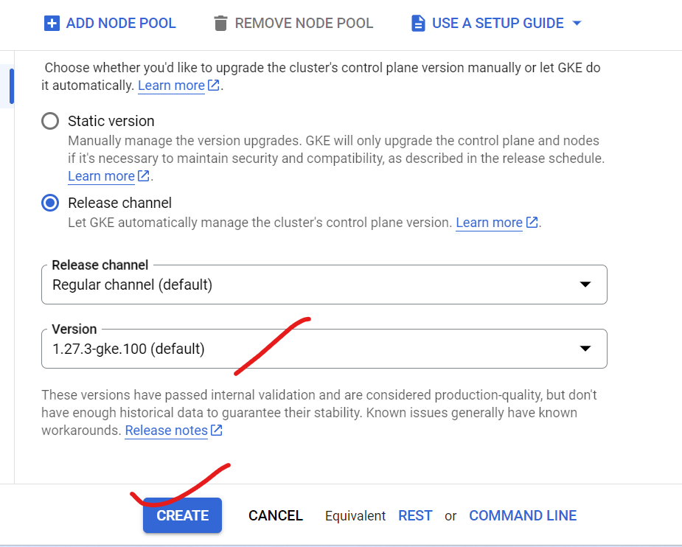

Select add pool

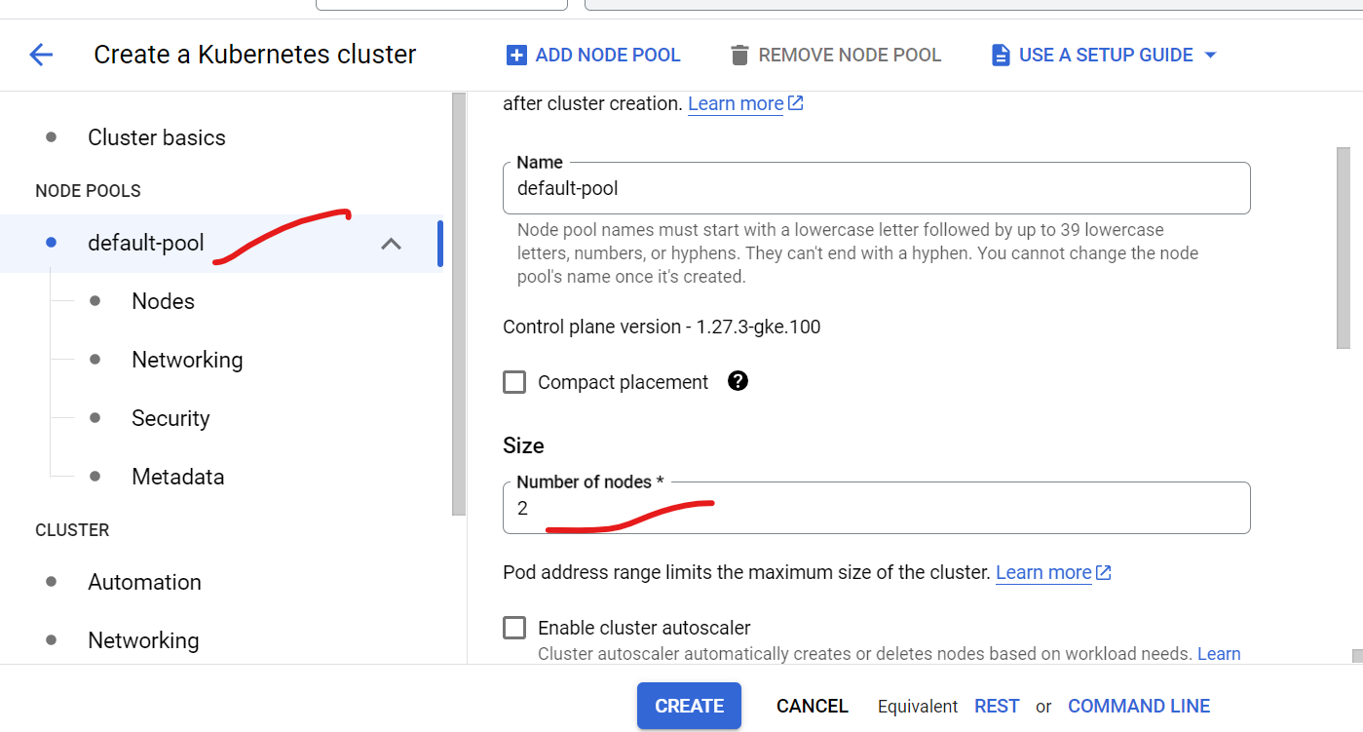

Then go to nodes

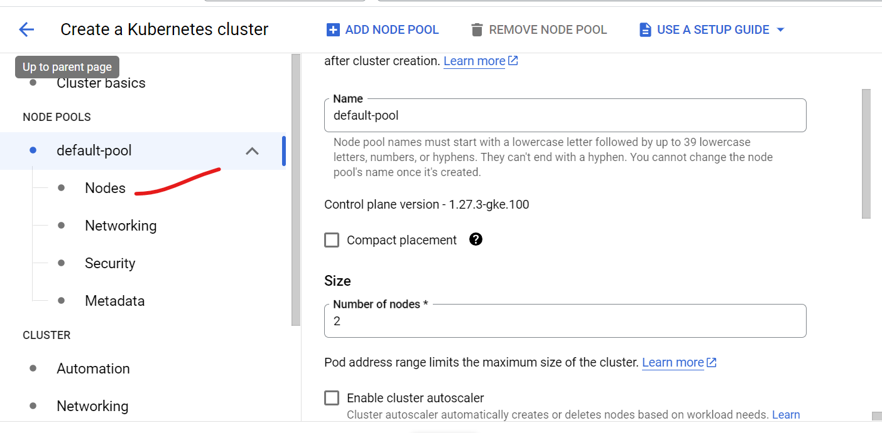

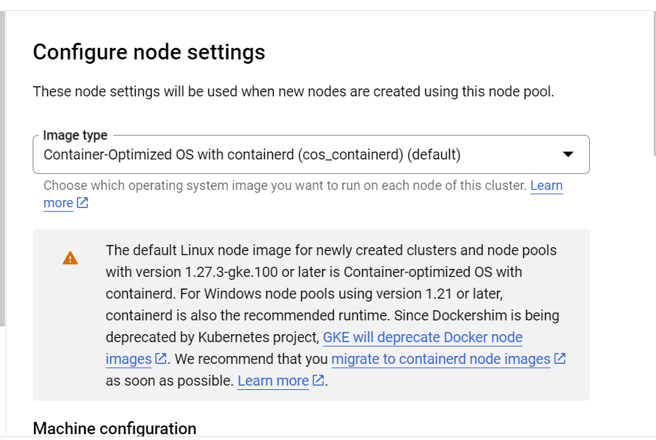

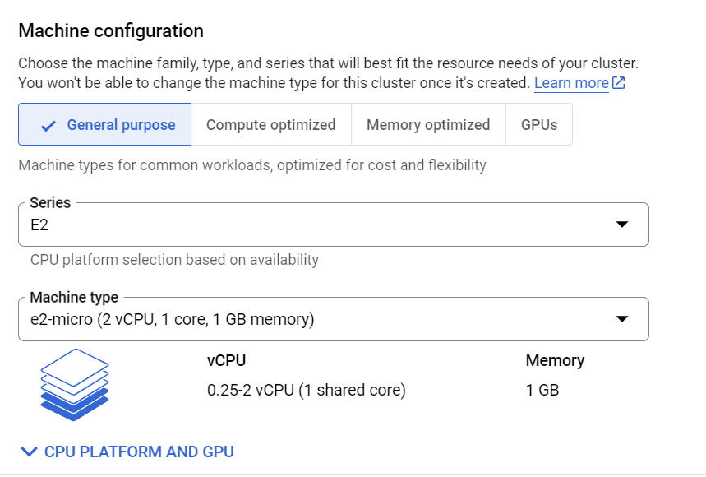

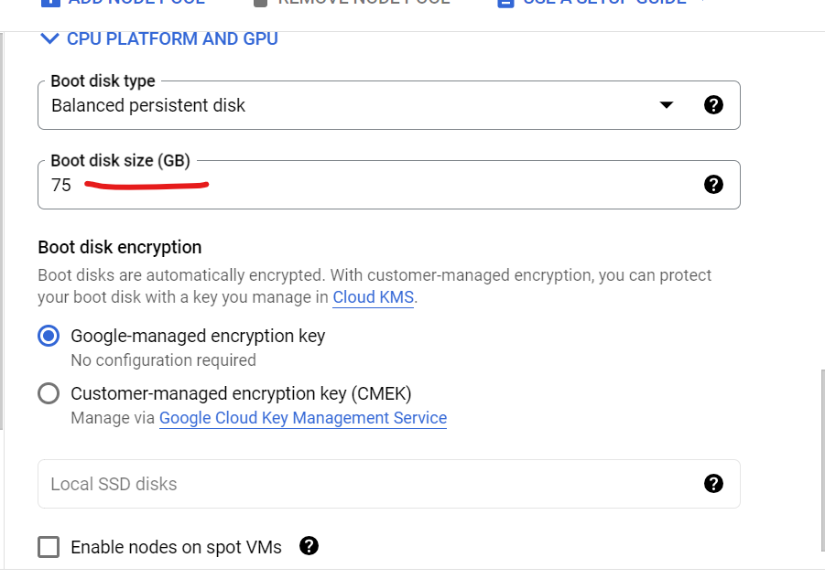

All other default and create cluster

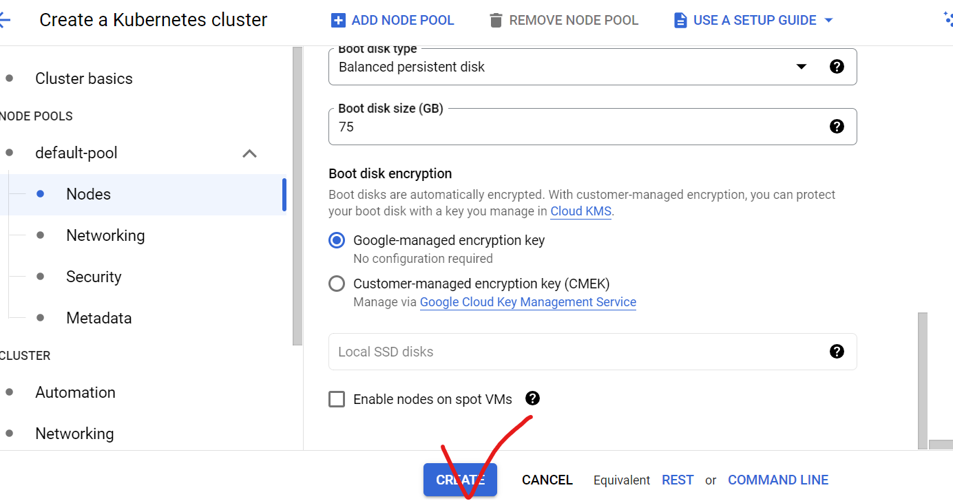

Select cluster

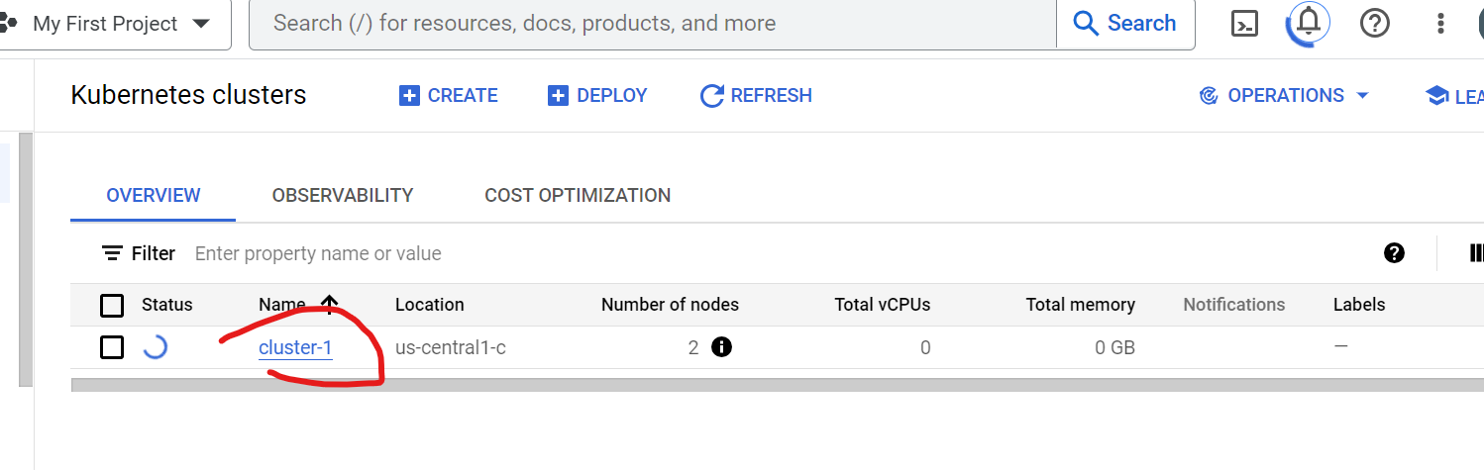

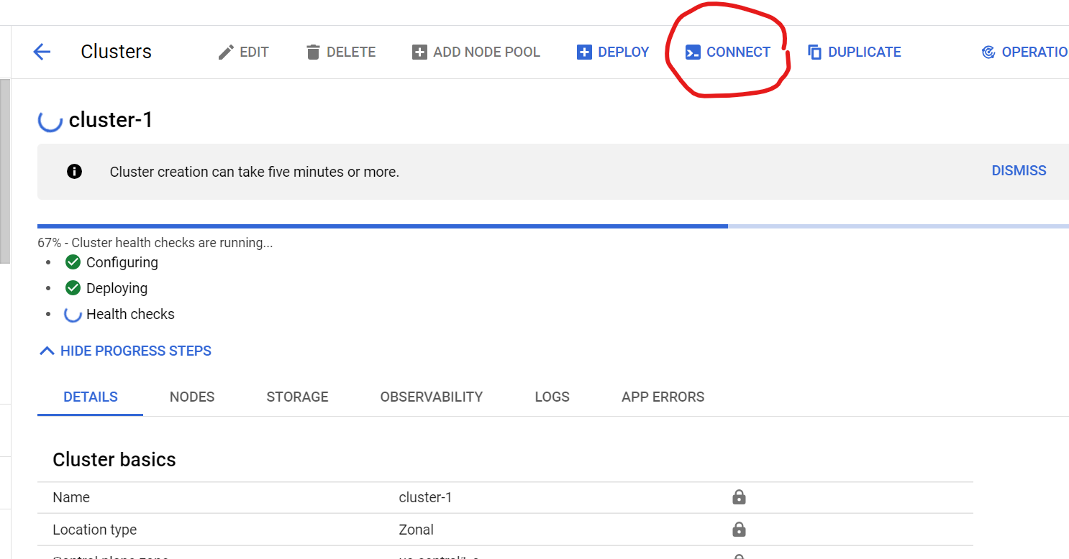

Select cloud shell

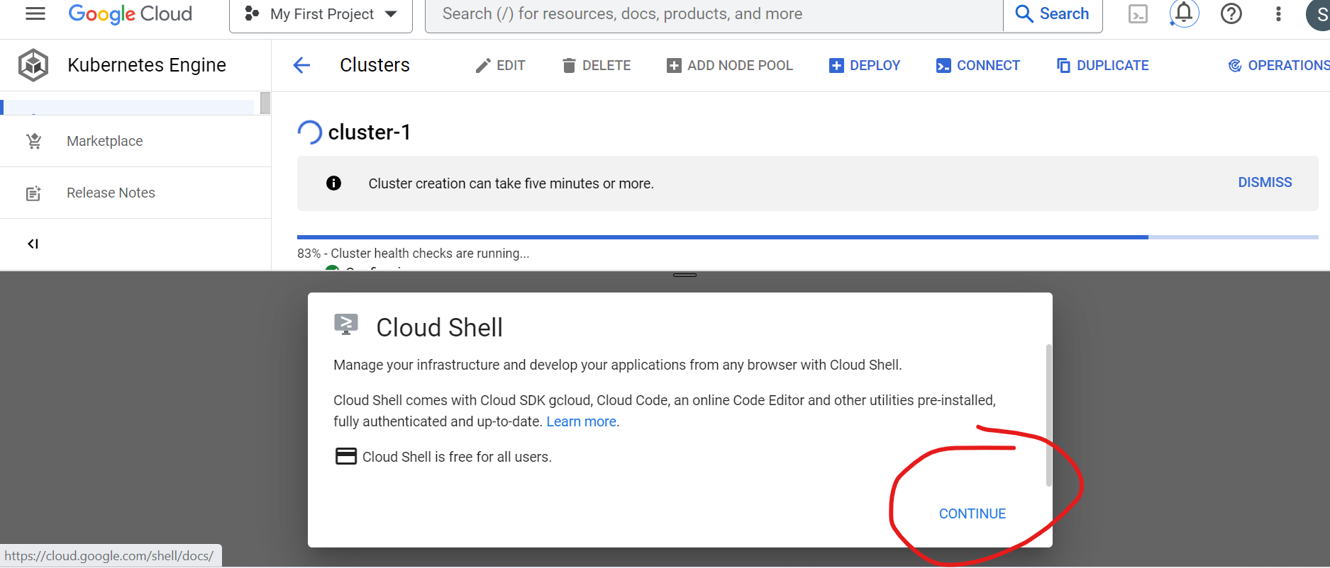

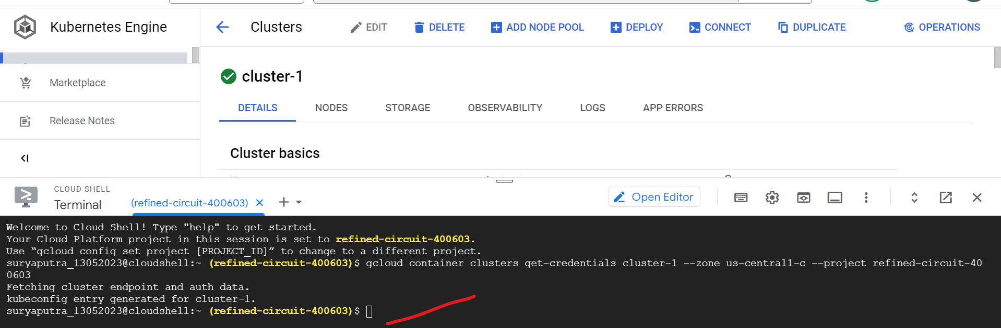

Cluster running

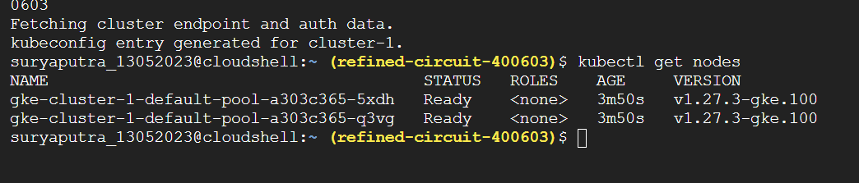

Ley it windowshell



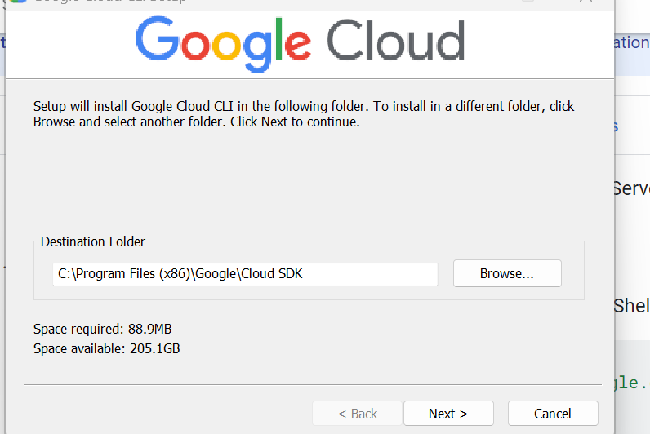

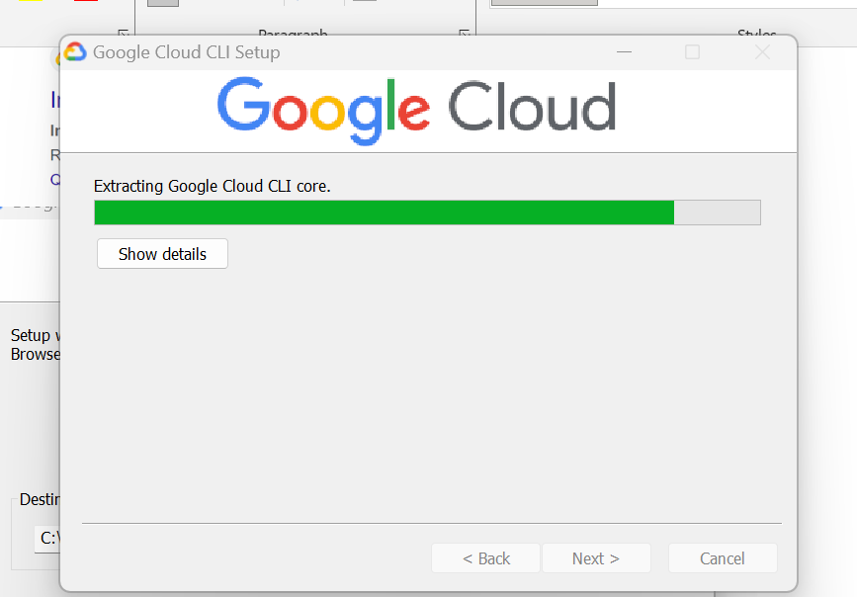

Pod creation

<https://github.com/nextopsvideos/kubernetesyt/blob/main/04_workload_components/sample_deploy.yml>

kubeconfig entry generated for cluster-1.

suryaputra_13052023@cloudshell:~ (refined-circuit-400603)$ kubectl get nodes

NAME STATUS ROLES AGE VERSION

gke-cluster-1-default-pool-a303c365-5xdh Ready <none> 3m50s v1.27.3-gke.100

gke-cluster-1-default-pool-a303c365-q3vg Ready <none> 3m50s v1.27.3-gke.100

suryaputra_13052023@cloudshell:~ (refined-circuit-400603)$ nano deploy

suryaputra_13052023@cloudshell:~ (refined-circuit-400603)$ kubectl apply -f deploy

pod/my-pod created

suryaputra_13052023@cloudshell:~ (refined-circuit-400603)$ kubectl get pods

NAME READY STATUS RESTARTS AGE

my-pod 1/1 Running 0 63s

suryaputra_13052023@cloudshell:~ (refined-circuit-400603)$ nano pod1

suryaputra_13052023@cloudshell:~ (refined-circuit-400603)$ kubectl apply -f pod1

deployment.apps/my-deployment created

suryaputra_13052023@cloudshell:~ (refined-circuit-400603)$ kubectl get pods

NAME READY STATUS RESTARTS AGE

my-deployment-c84f48dd5-8qtwq 1/1 Running 0 5s

my-deployment-c84f48dd5-b7269 0/1 ContainerCreating 0 5s

my-deployment-c84f48dd5-bdb6z 0/1 ContainerCreating 0 5s

my-deployment-c84f48dd5-hcnzs 1/1 Running 0 5s

my-pod 1/1 Running 0 105s

suryaputra_13052023@cloudshell:~ (refined-circuit-400603)$ kubectl get pods

NAME READY STATUS RESTARTS AGE

my-deployment-c84f48dd5-8qtwq 1/1 Running 0 45s

my-deployment-c84f48dd5-b7269 1/1 Running 0 45s

my-deployment-c84f48dd5-bdb6z 1/1 Running 0 45s

my-deployment-c84f48dd5-hcnzs 1/1 Running 0 45s

my-pod 1/1 Running 0 2m25s

suryaputra_13052023@cloudshell:~ (refined-circuit-400603)$ kubectl describe pod my-deployment

Name: my-deployment-c84f48dd5-8qtwq

Namespace: default

Priority: 0

Service Account: default

Node: gke-cluster-1-default-pool-a303c365-q3vg/10.128.0.3

Start Time: Sun, 01 Oct 2023 00:41:44 +0000

Labels: app=my-app

pod-template-hash=c84f48dd5

Annotations: <none>

Status: Running

IP: 10.4.0.11

IPs:

IP: 10.4.0.11

Controlled By: ReplicaSet/my-deployment-c84f48dd5

Containers:

my-container:

Container ID: containerd://ba4296b48ef82e37383ccff37c402b330f7821be49cf2b5e11f927286dcc252e

Image: nginx:latest

Image ID: docker.io/library/nginx@sha256:32da30332506740a2f7c34d5dc70467b7f14ec67d912703568daff790ab3f755

Port: 8080/TCP

Host Port: 0/TCP

State: Running

Started: Sun, 01 Oct 2023 00:41:46 +0000

Ready: True

Restart Count: 0

Environment: <none>

Mounts:

/var/run/secrets/kubernetes.io/serviceaccount from kube-api-access-h6hj7 (ro)

Conditions:

Type Status

Initialized True

Ready True

ContainersReady True

PodScheduled True

Volumes:

kube-api-access-h6hj7:

Type: Projected (a volume that contains injected data from multiple sources)

TokenExpirationSeconds: 3607

ConfigMapName: kube-root-ca.crt

ConfigMapOptional: <nil>

DownwardAPI: true

QoS Class: BestEffort

Node-Selectors: <none>

Tolerations: node.kubernetes.io/not-ready:NoExecute op=Exists for 300s

node.kubernetes.io/unreachable:NoExecute op=Exists for 300s

Events:

Type Reason Age From Message

---- ------ ---- ---- -------

Normal Scheduled 108s default-scheduler Successfully assigned default/my-deployment-c84f48dd5-8qtwq to gke-cluster-1-default-pool-a303c365-q3vg

Normal Pulling 107s kubelet Pulling image "nginx:latest"

Normal Pulled 107s kubelet Successfully pulled image "nginx:latest" in 291.41099ms (292.39105ms including waiting)

Normal Created 107s kubelet Created container my-container

Normal Started 106s kubelet Started container my-container

Name: my-deployment-c84f48dd5-b7269

Namespace: default

Priority: 0

Service Account: default

Node: gke-cluster-1-default-pool-a303c365-5xdh/10.128.0.4

Start Time: Sun, 01 Oct 2023 00:41:44 +0000

Labels: app=my-app

pod-template-hash=c84f48dd5

Annotations: <none>

Status: Running

IP: 10.4.1.8

IPs:

IP: 10.4.1.8

Controlled By: ReplicaSet/my-deployment-c84f48dd5

Containers:

my-container:

Container ID: containerd://b5b1f89208ed7c02eaac055bee501b61f4295b9f02ee0bff5f0011e0ca6b2821

Image: nginx:latest

Image ID: docker.io/library/nginx@sha256:32da30332506740a2f7c34d5dc70467b7f14ec67d912703568daff790ab3f755

Port: 8080/TCP

Host Port: 0/TCP

State: Running

Started: Sun, 01 Oct 2023 00:41:54 +0000

Ready: True

Restart Count: 0

Environment: <none>

Mounts:

/var/run/secrets/kubernetes.io/serviceaccount from kube-api-access-pwqbs (ro)

Conditions:

Type Status

Initialized True

Ready True

ContainersReady True

PodScheduled True

Volumes:

kube-api-access-pwqbs:

Type: Projected (a volume that contains injected data from multiple sources)

TokenExpirationSeconds: 3607

ConfigMapName: kube-root-ca.crt

ConfigMapOptional: <nil>

DownwardAPI: true

QoS Class: BestEffort

Node-Selectors: <none>

Tolerations: node.kubernetes.io/not-ready:NoExecute op=Exists for 300s

node.kubernetes.io/unreachable:NoExecute op=Exists for 300s

Events:

Type Reason Age From Message

---- ------ ---- ---- -------

Normal Scheduled 108s default-scheduler Successfully assigned default/my-deployment-c84f48dd5-b7269 to gke-cluster-1-default-pool-a303c365-5xdh

Normal Pulling 106s kubelet Pulling image "nginx:latest"

Normal Pulled 99s kubelet Successfully pulled image "nginx:latest" in 7.053117102s (7.054770698s including waiting)

Normal Created 99s kubelet Created container my-container

Normal Started 98s kubelet Started container my-container

Name: my-deployment-c84f48dd5-bdb6z

Namespace: default

Priority: 0

Service Account: default

Node: gke-cluster-1-default-pool-a303c365-5xdh/10.128.0.4

Start Time: Sun, 01 Oct 2023 00:41:44 +0000

Labels: app=my-app

pod-template-hash=c84f48dd5

Annotations: <none>

Status: Running

IP: 10.4.1.7

IPs:

IP: 10.4.1.7

Controlled By: ReplicaSet/my-deployment-c84f48dd5

Containers:

my-container:

Container ID: containerd://823dd940af0b21617e62a487b7d8e3c3bea920e61877b4b380324d1a99e49bf0

Image: nginx:latest

Image ID: docker.io/library/nginx@sha256:32da30332506740a2f7c34d5dc70467b7f14ec67d912703568daff790ab3f755

Port: 8080/TCP

Host Port: 0/TCP

State: Running

Started: Sun, 01 Oct 2023 00:41:54 +0000

Ready: True

Restart Count: 0

Environment: <none>

Mounts:

/var/run/secrets/kubernetes.io/serviceaccount from kube-api-access-54mmf (ro)

Conditions:

Type Status

Initialized True

Ready True

ContainersReady True

PodScheduled True

Volumes:

kube-api-access-54mmf:

Type: Projected (a volume that contains injected data from multiple sources)

TokenExpirationSeconds: 3607

ConfigMapName: kube-root-ca.crt

ConfigMapOptional: <nil>

DownwardAPI: true

QoS Class: BestEffort

Node-Selectors: <none>

Tolerations: node.kubernetes.io/not-ready:NoExecute op=Exists for 300s

node.kubernetes.io/unreachable:NoExecute op=Exists for 300s

Events:

Type Reason Age From Message

---- ------ ---- ---- -------

Normal Scheduled 109s default-scheduler Successfully assigned default/my-deployment-c84f48dd5-bdb6z to gke-cluster-1-default-pool-a303c365-5xdh

Normal Pulling 107s kubelet Pulling image "nginx:latest"

Normal Pulled 100s kubelet Successfully pulled image "nginx:latest" in 7.052986734s (7.054635832s including waiting)

Normal Created 100s kubelet Created container my-container

Normal Started 99s kubelet Started container my-container

Name: my-deployment-c84f48dd5-hcnzs

Namespace: default

Priority: 0

Service Account: default

Node: gke-cluster-1-default-pool-a303c365-q3vg/10.128.0.3

Start Time: Sun, 01 Oct 2023 00:41:44 +0000

Labels: app=my-app

pod-template-hash=c84f48dd5

Annotations: <none>

Status: Running

IP: 10.4.0.12

IPs:

IP: 10.4.0.12

Controlled By: ReplicaSet/my-deployment-c84f48dd5

Containers:

my-container:

Container ID: containerd://dae197a1579171e28cb133073ea753d734e6bba85521ffafab68695d0e464700

Image: nginx:latest

Image ID: docker.io/library/nginx@sha256:32da30332506740a2f7c34d5dc70467b7f14ec67d912703568daff790ab3f755

Port: 8080/TCP

Host Port: 0/TCP

State: Running

Started: Sun, 01 Oct 2023 00:41:46 +0000

Ready: True

Restart Count: 0

Environment: <none>

Mounts:

/var/run/secrets/kubernetes.io/serviceaccount from kube-api-access-mvrn2 (ro)

Conditions:

Type Status

Initialized True

Ready True

ContainersReady True

PodScheduled True

Volumes:

kube-api-access-mvrn2:

Type: Projected (a volume that contains injected data from multiple sources)

TokenExpirationSeconds: 3607

ConfigMapName: kube-root-ca.crt

ConfigMapOptional: <nil>

DownwardAPI: true

QoS Class: BestEffort

Node-Selectors: <none>

Tolerations: node.kubernetes.io/not-ready:NoExecute op=Exists for 300s

node.kubernetes.io/unreachable:NoExecute op=Exists for 300s

Events:

Type Reason Age From Message

---- ------ ---- ---- -------

Normal Scheduled 109s default-scheduler Successfully assigned default/my-deployment-c84f48dd5-hcnzs to gke-cluster-1-default-pool-a303c365-q3vg

Normal Pulling 108s kubelet Pulling image "nginx:latest"

Normal Pulled 108s kubelet Successfully pulled image "nginx:latest" in 219.433163ms (219.447613ms including waiting)

Normal Created 108s kubelet Created container my-container

Normal Started 107s kubelet Started container my-container

Edit deployment



Act as vi mode open the file

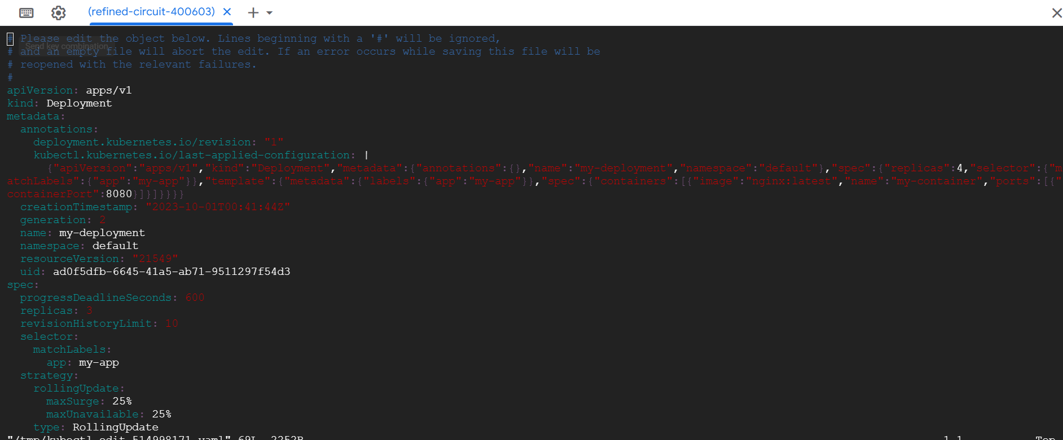

Wt is self healing in pod

Qu:if u delete pod wt happen

It is self healing process and if u deleted pod automacally create new pod maintain the replicaset as per u give main fest file

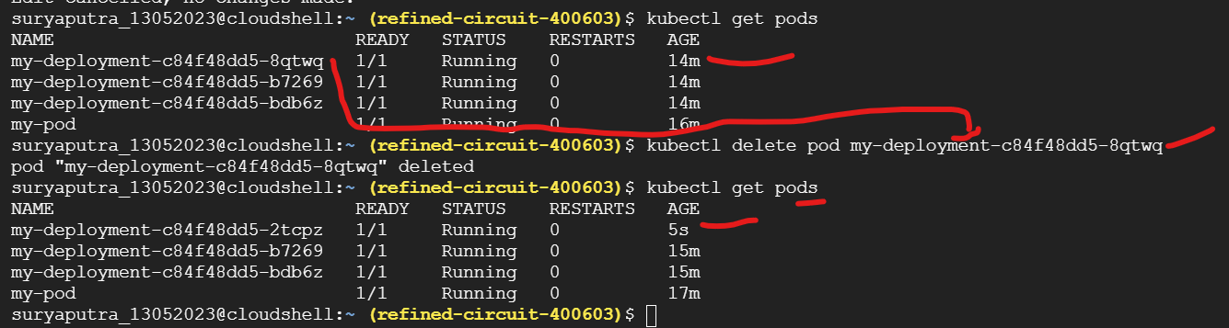

Workloadcluster

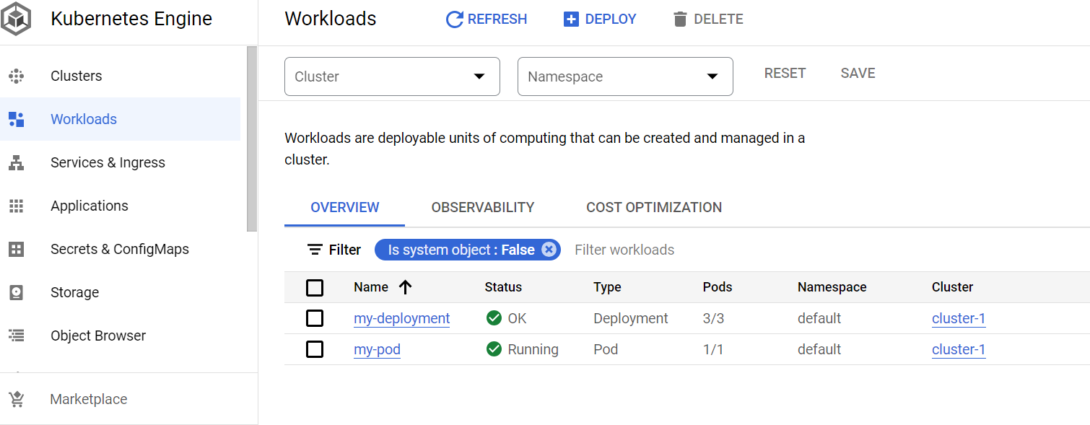

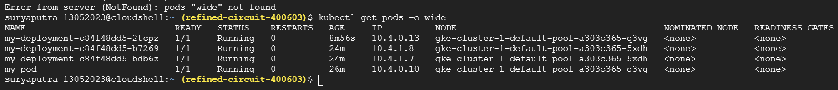

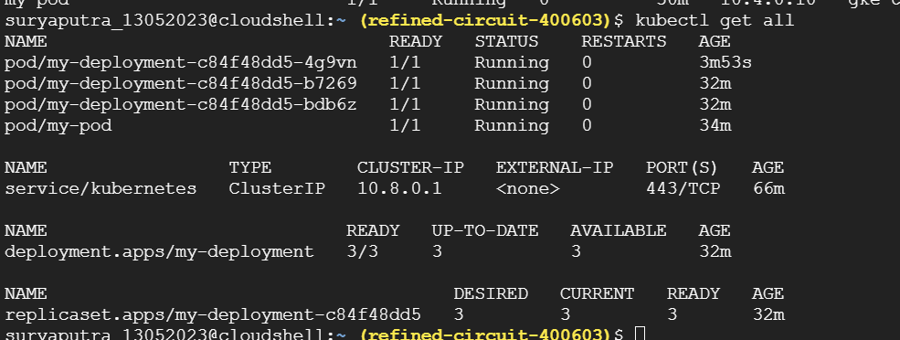

Services:

if u delete pod wt happen

It is self healing process and if u deleted pod automacally create new pod maintain the replicaset as per u give main fest file

Old io pod 10.4.0.13

New pod ip 10.4.0.14 check below screenshot

But communication issue haapend new ip created new pod that is sinario we are using the service

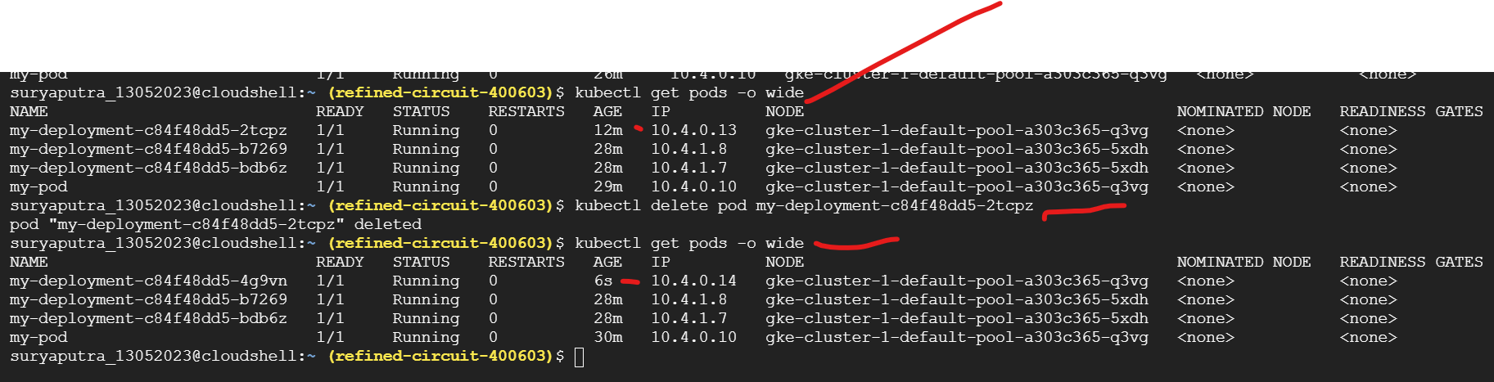

Cluster ip service creation:

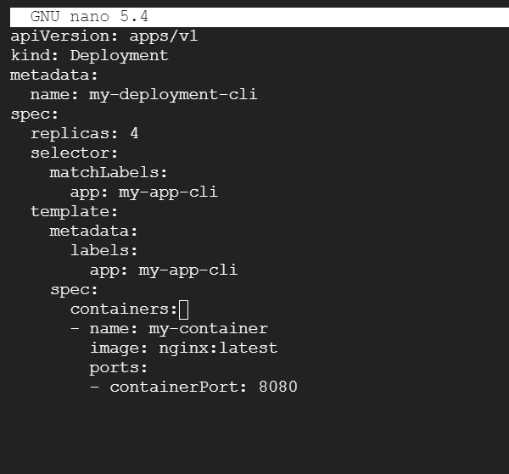

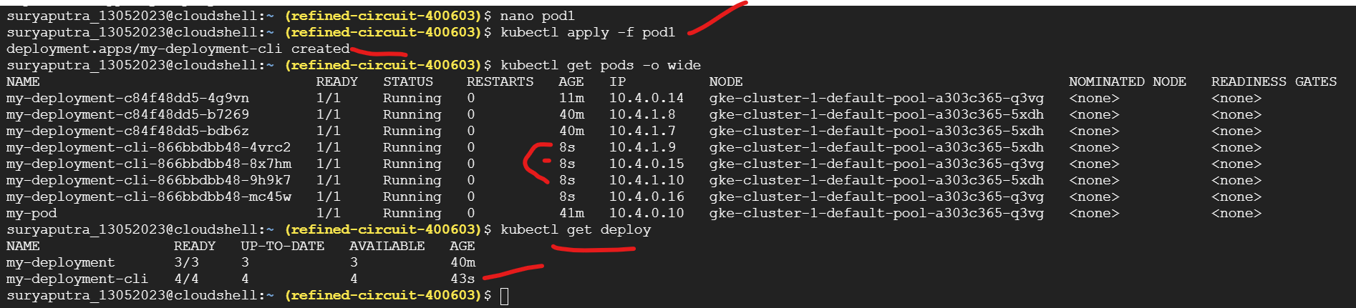

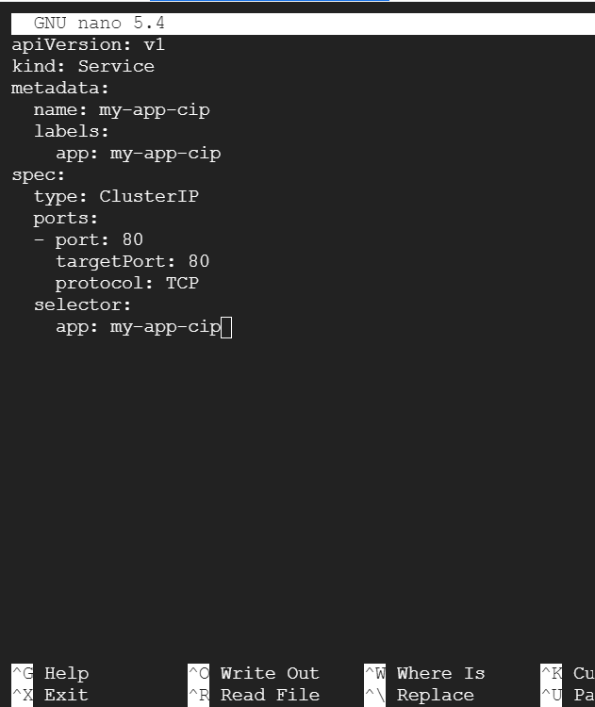

<https://github.com/nextopsvideos/kubernetesyt/blob/main/05_Services/dep_cip.yml>

copy paste above link service

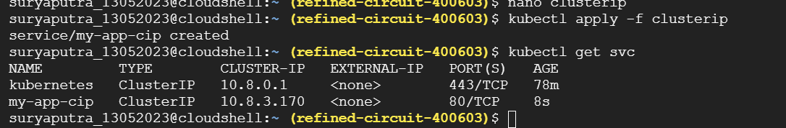

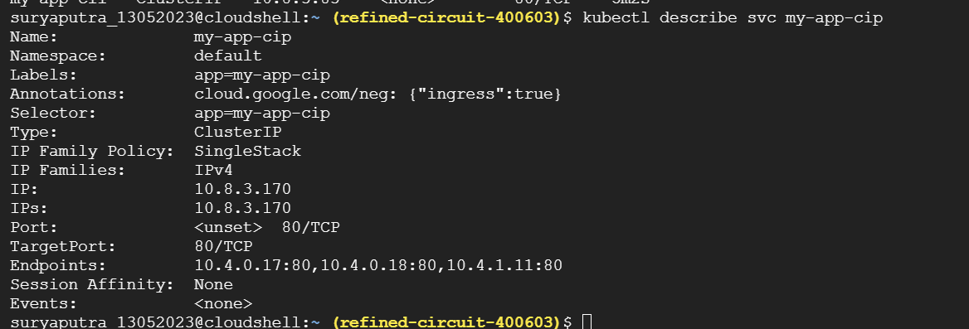

kubectl describe svc my-app-cip



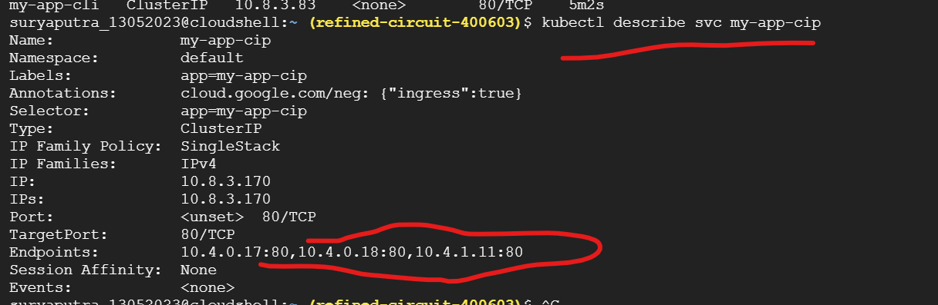

Kubectl get nodes -o wide

Get internal & externs lip of nodes

Node port service creation:

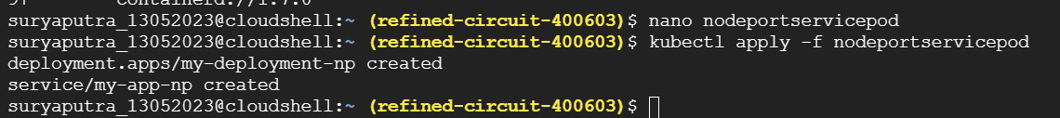

Cp & paste in git hub

<https://github.com/nextopsvideos/kubernetesyt/blob/main/05_Services/dep_np.yml>

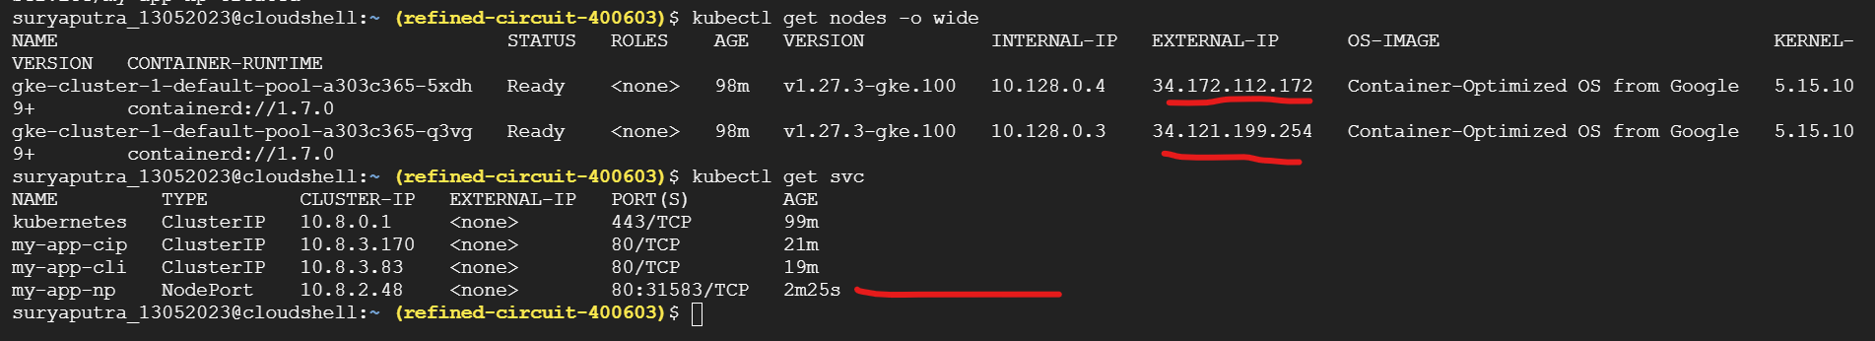

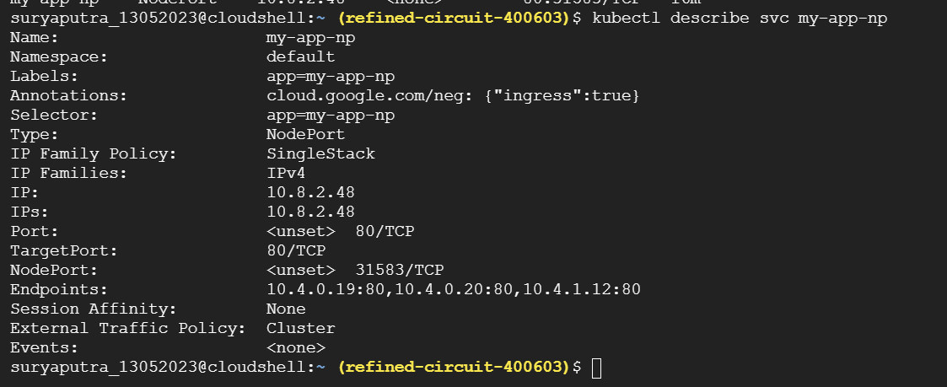

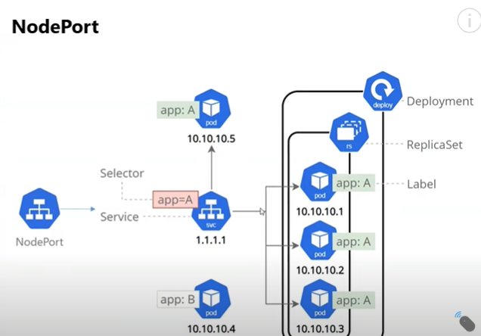

<https://github.com/nextopsvideos/kubernetesyt/blob/main/05_Services/dep_lb.yml>

copy and paste in nano



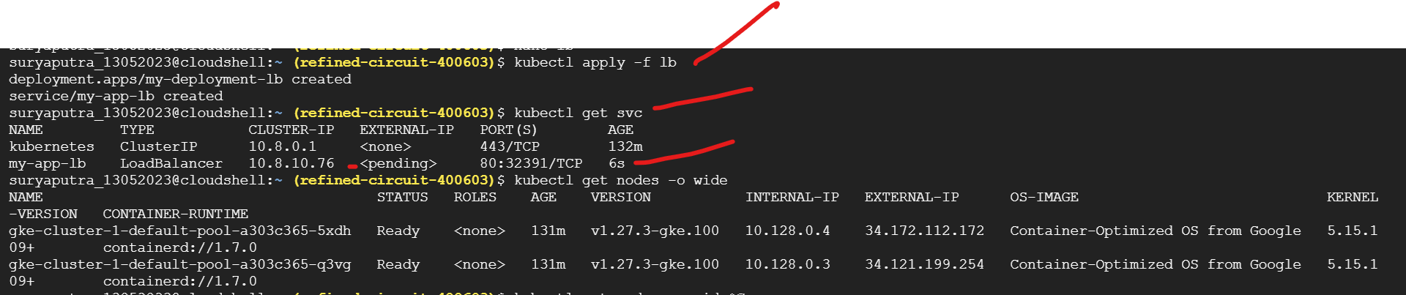

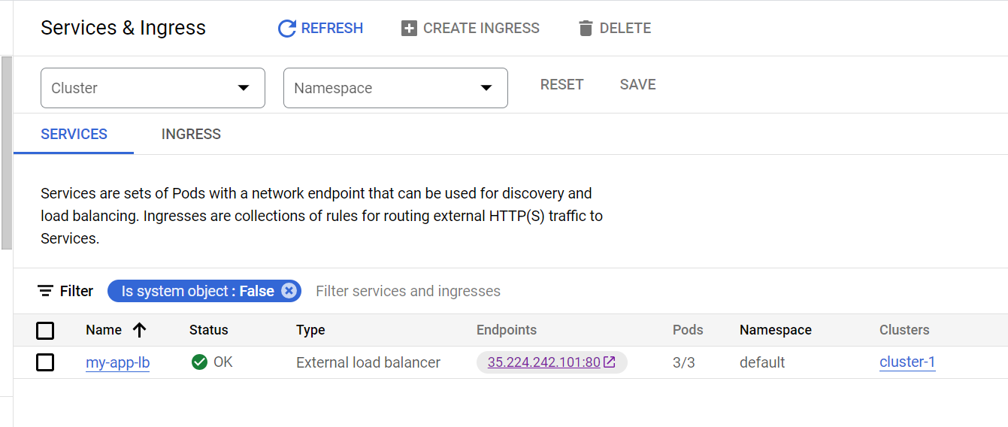

Automacticaly created with help of cloud controller manger

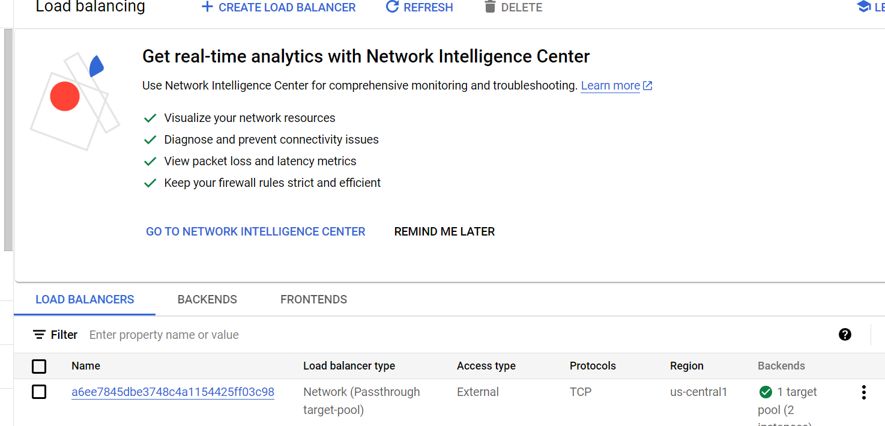

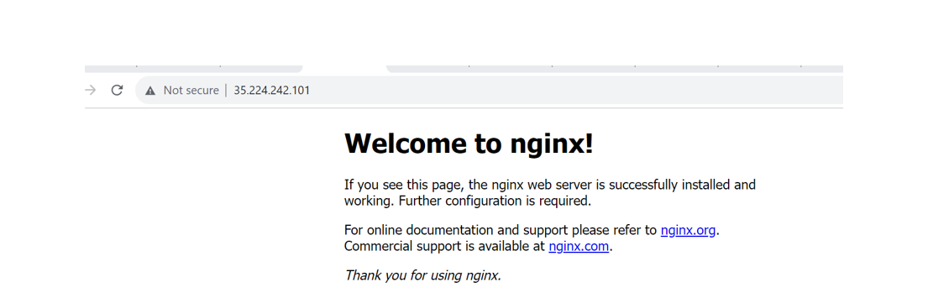

Ingress load balancer crestion:

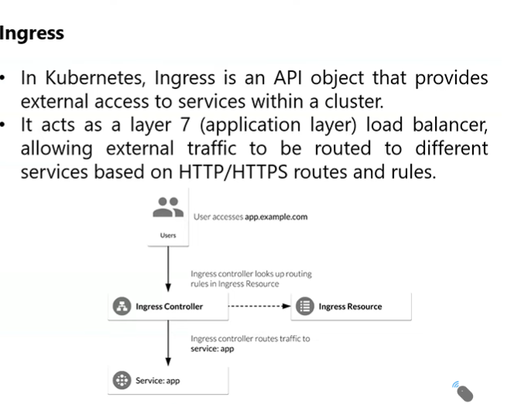

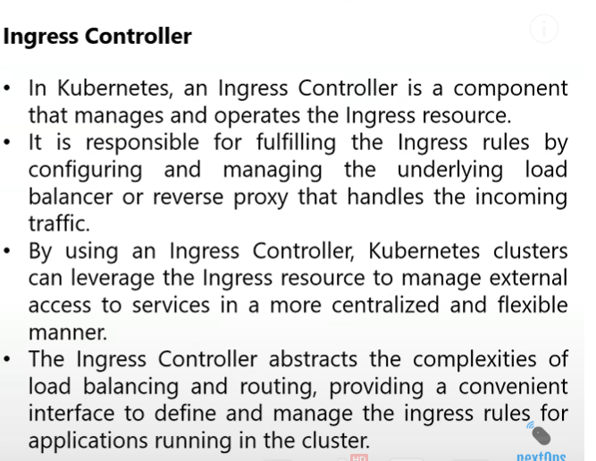

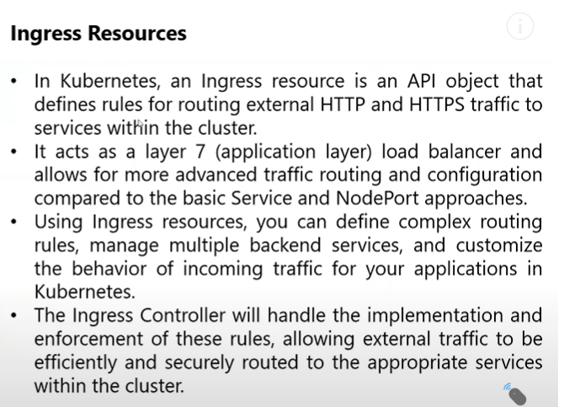s

1.step create name space



suryaputra_13052023@cloudshell:~ (refined-circuit-400603)$ kubectl create namespace ingress-nginx

<https://raw.githubusercontent.com/kubernetes/ingress-nginx/controller-v1.2.1/deploy/static/provider/cloud/deploy.yaml>

step 2

suryaputra_13052023@cloudshell:~ (refined-circuit-400603)$ kubectl apply -f https://raw.githubusercontent.com/kubernetes/ingress-nginx/controller-v1.2.1/deploy/static/provider/cloud/deploy.yaml

u

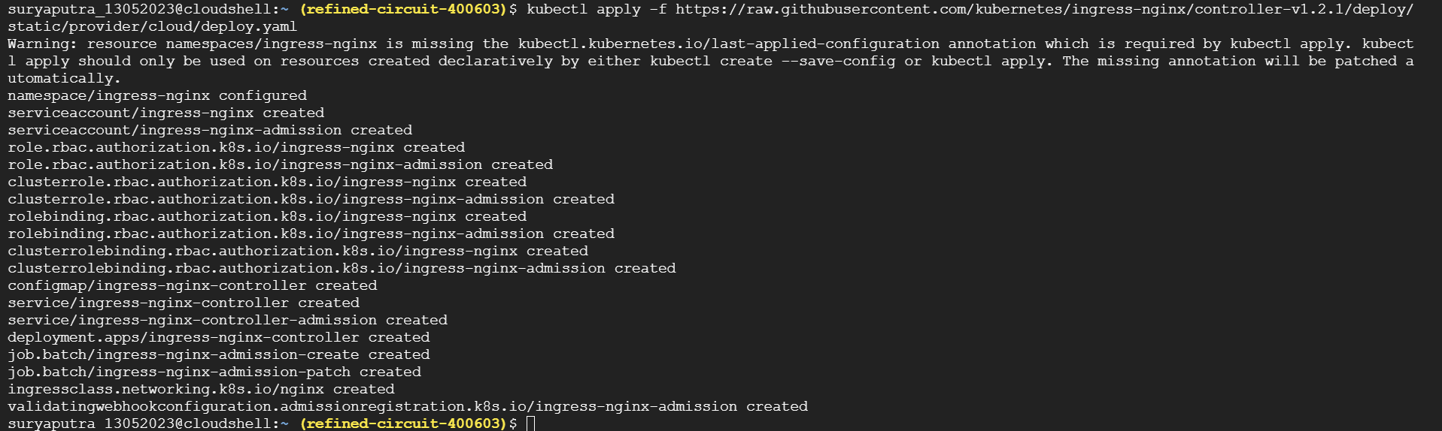

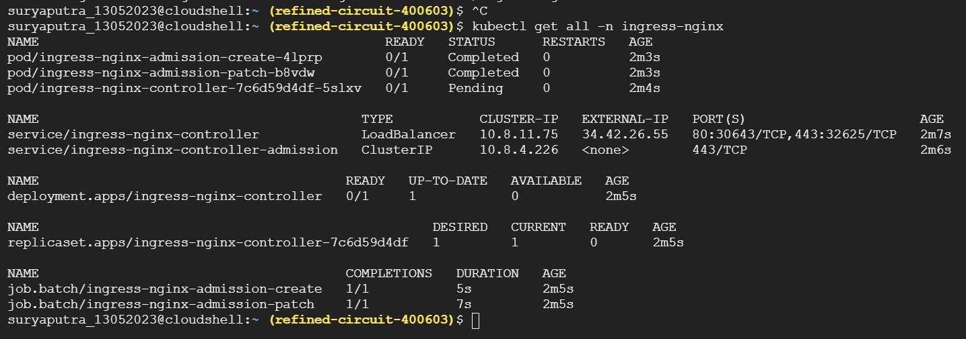

3rd step

<https://github.com/nextopsvideos/kubernetesyt/blob/main/06_Ingress/dep_one.yml>

copy and paste in nano

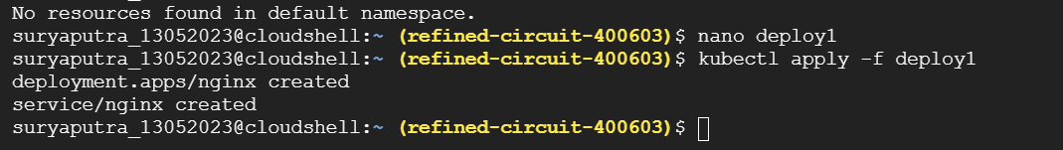

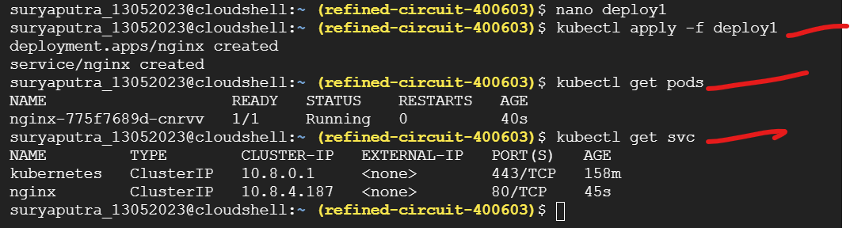

4th step

<https://github.com/nextopsvideos/kubernetesyt/blob/main/06_Ingress/dep_two.yml>

copy and paste in nano

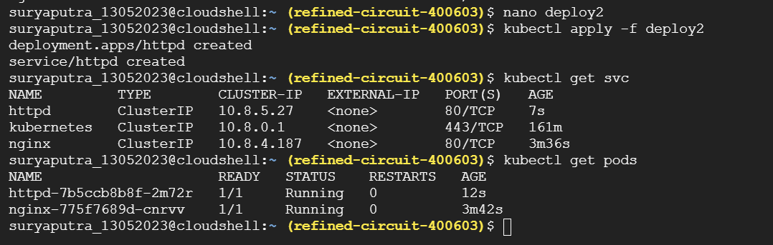

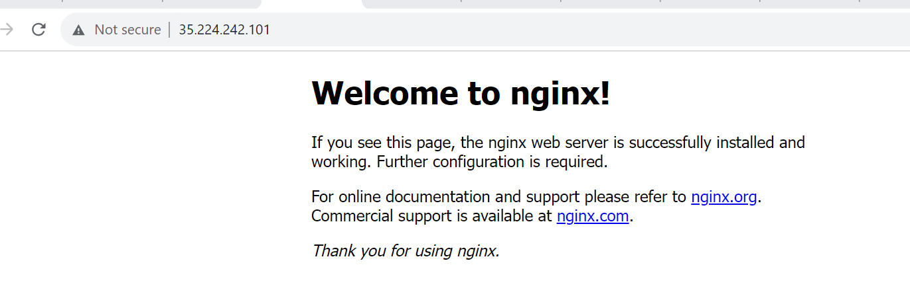

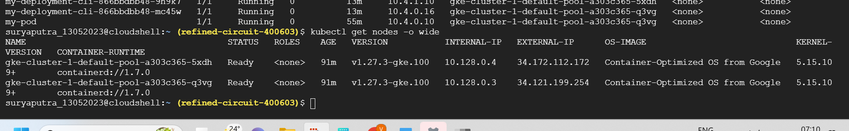

Statefullset:

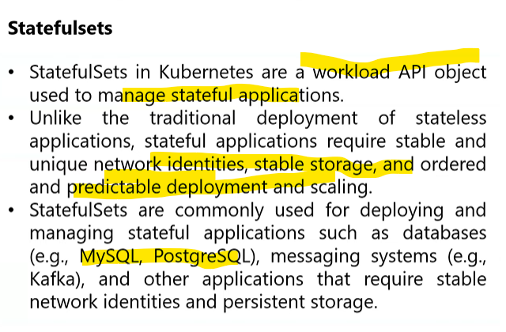

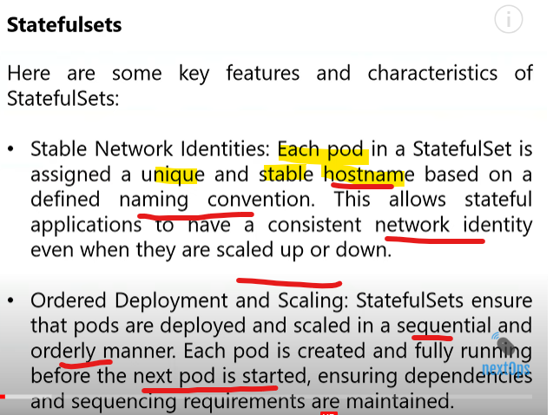

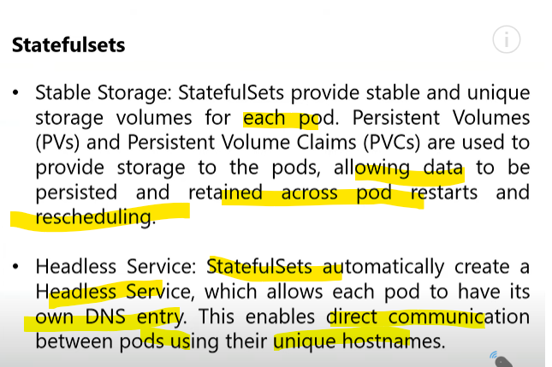

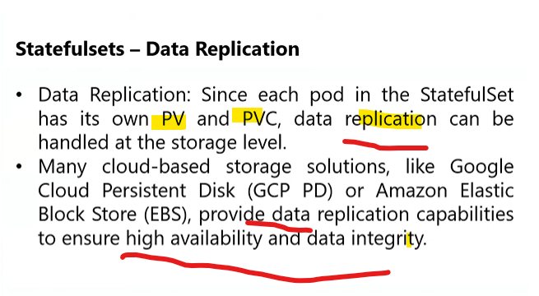

<https://github.com/nextopsvideos/kubernetesyt/blob/main/09_Statefulsets/mysql-cm.yml>

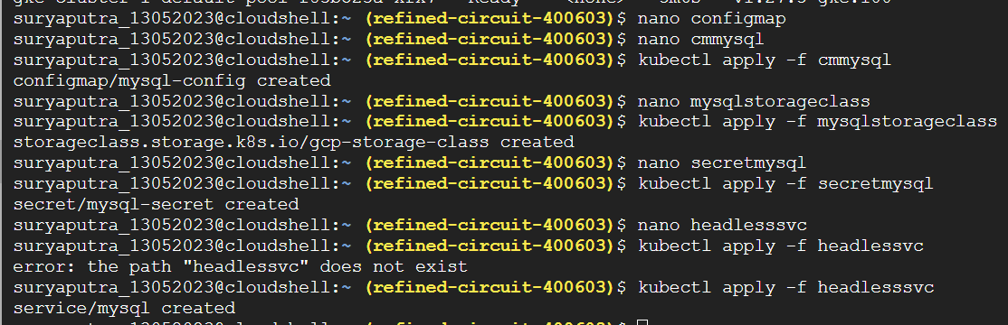

Create file one by one

Output;

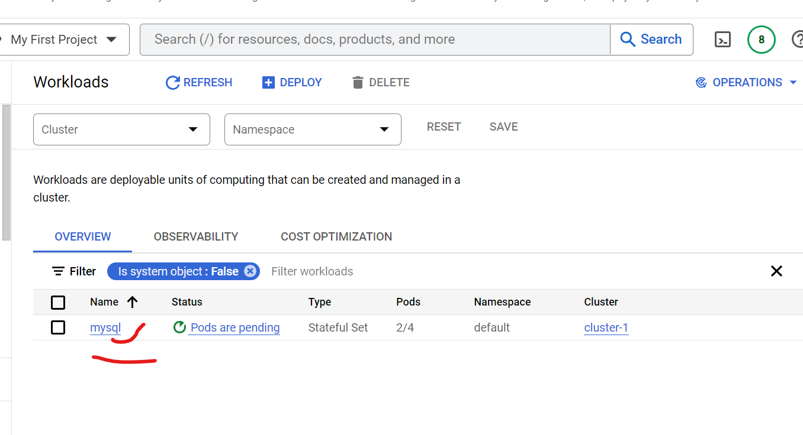

Created order means one by one

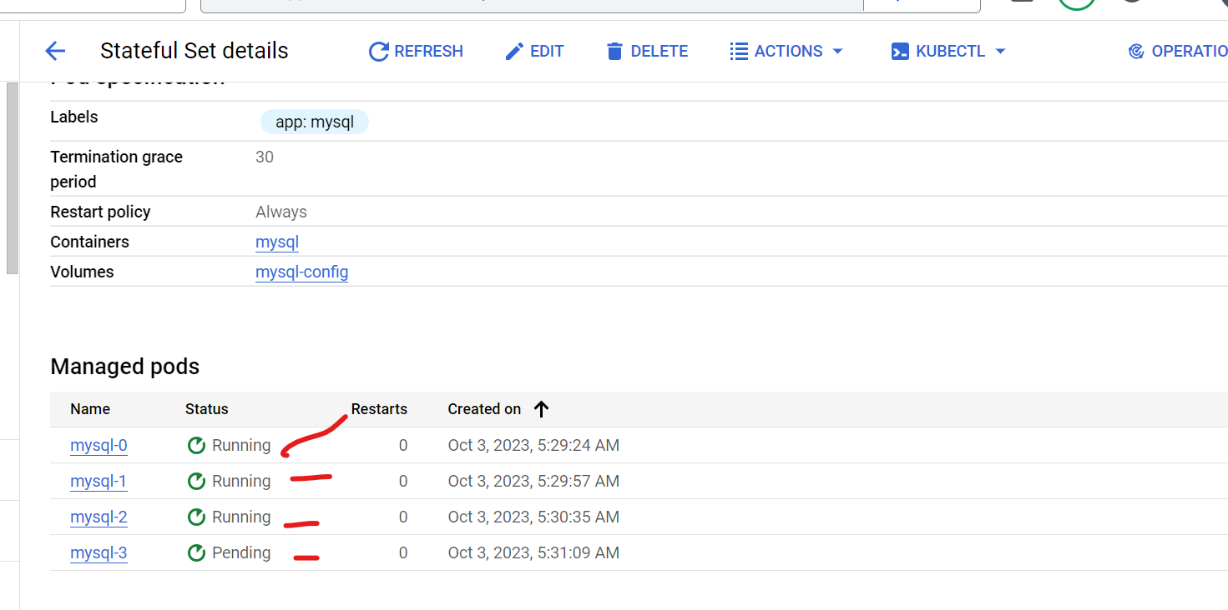

Each pod attached to disk

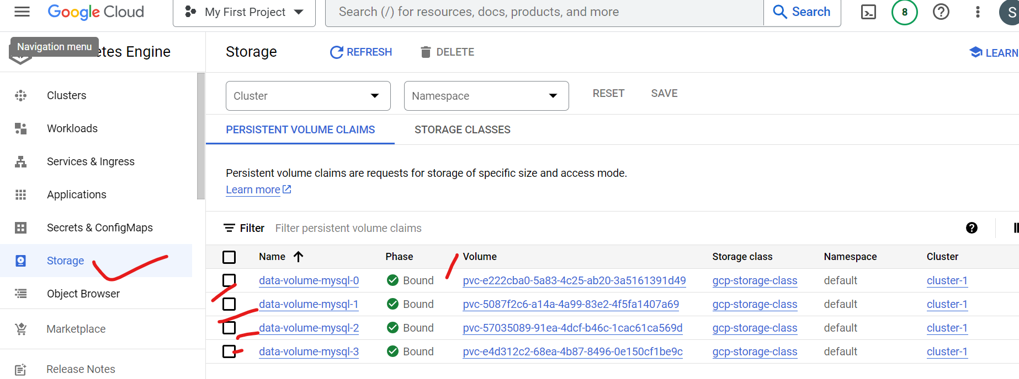

Edit 3 replicas let see out pods and pvc

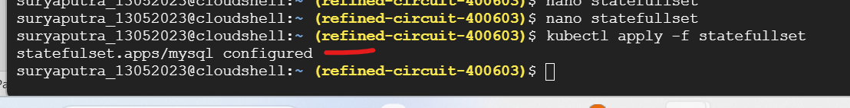

It will termintated last one

Sequestional delete the pod latest one in statefull set,in deployment set delete not maintain the order

Before delete pod

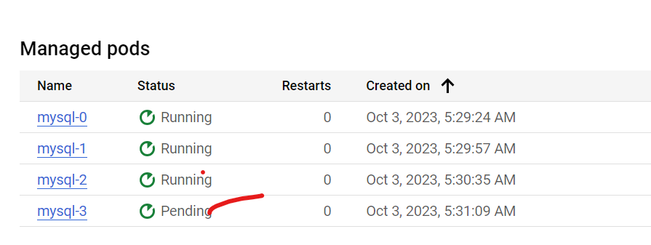

After delete pod

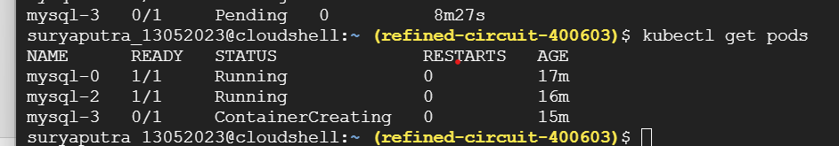

INIT container:

What is an init container?

Init containers are just like regular containers, but they run to completion and run before the main container starts. There are various use cases for init containers, such as init containers can contain certain utilities or custom code for the setup that is not present for the app container.

Sidecar container:

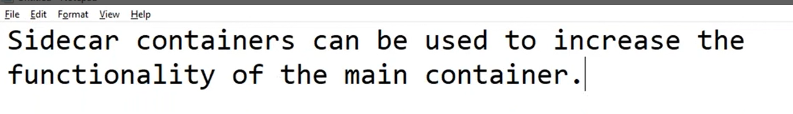

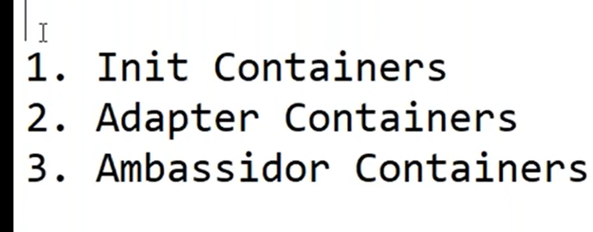

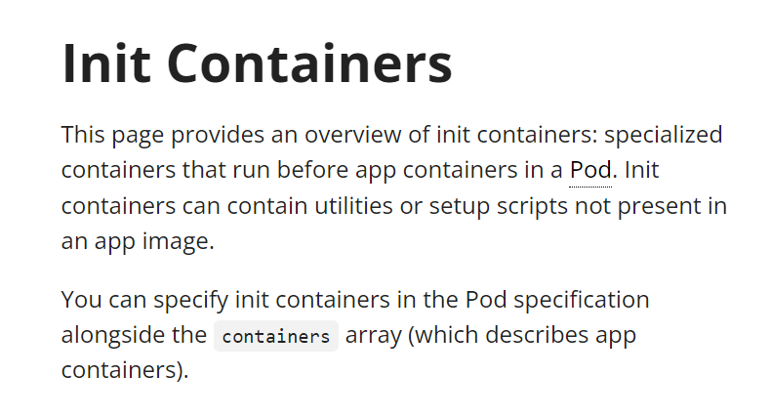

<https://kubernetes.io/docs/concepts/workloads/pods/init-containers/>

## Understanding init containers

A [Pod](https://kubernetes.io/docs/concepts/workloads/pods/) can have multiple containers running apps within it, but it can also have one or more init containers, which are run before the app containers are started.

Init containers are exactly like regular containers, except:

* Init containers always run to completion.
* Each init container must complete successfully before the next one starts.

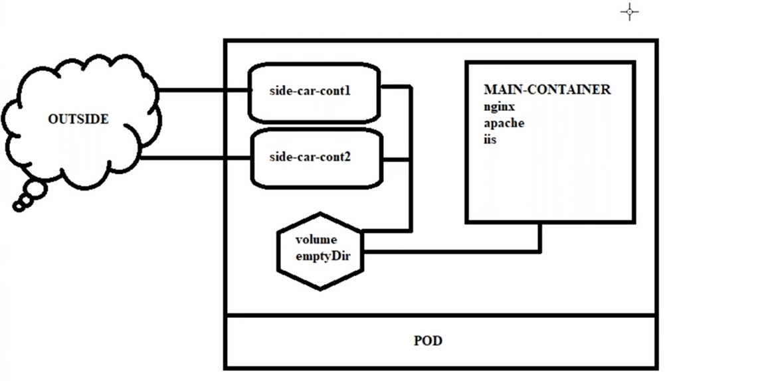

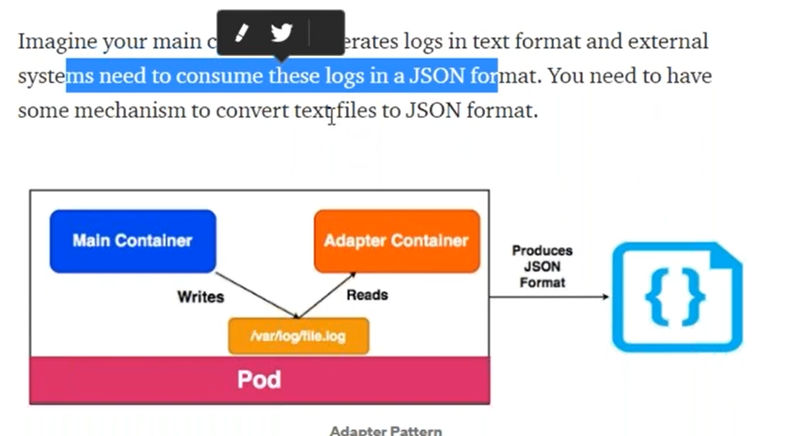

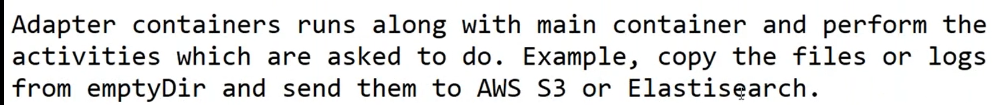

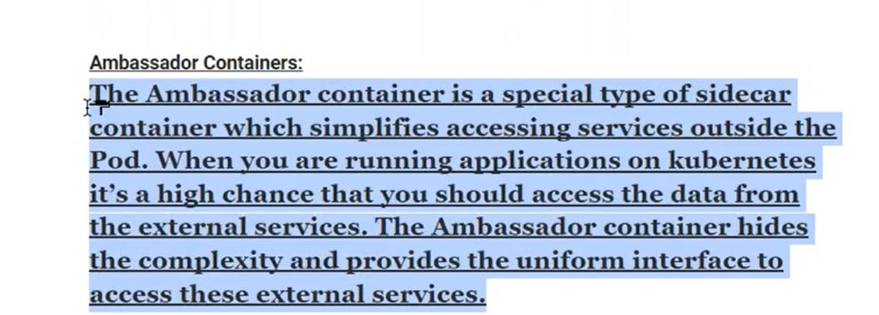

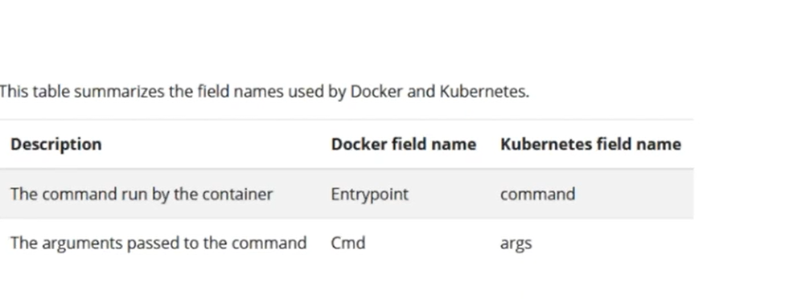

What is the difference between Readwrite once and ReadWriteMany?

Access mode  
  
ReadWriteOnce : Volume allows read/write by only one node at the same time. ReadOnlyMany : Volume allows read-only mode by many nodes at the same time. ReadWriteMany : Volume allows read/write by multiple nodes at the same time

Namespace:

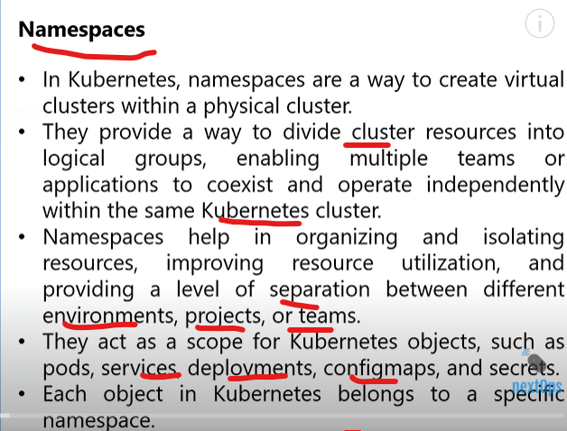

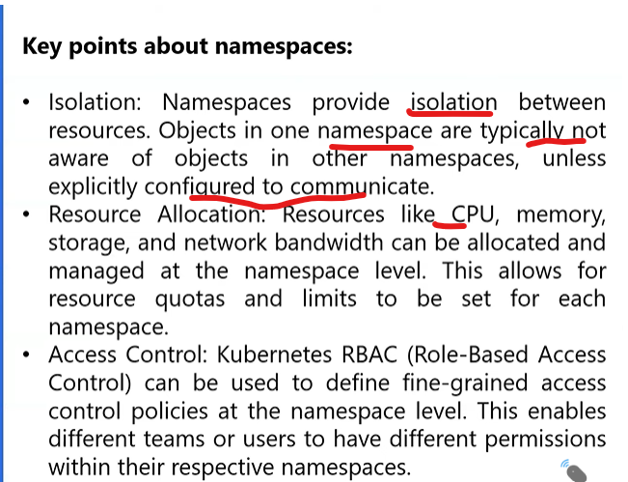

What is kube-system used for?

kube-system—a default space for Kubernetes system objects, such as kube-dns and kube-proxy, and add-ons providing cluster-level features, such as web UI dashboards, ingresses, and cluster-level logging. kube-public—a default space for resources available to all users without authentication.

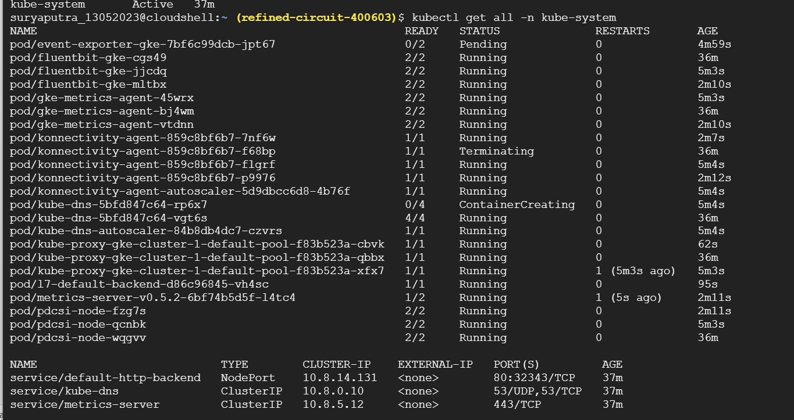

Kube-pubcli:public readable clister wide resources



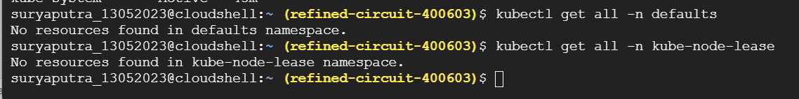

default : This is the default namespace for objects with no other namespace. kube-system : This namespace is for objects created by the Kubernetes system. kube-public : This namespace is automatically created and readable by all user

kube-node-lease. This namespace holds Lease objects associated with each node. Node leases allow the kubelet to send heartbeats so that the control plane can detect node failure

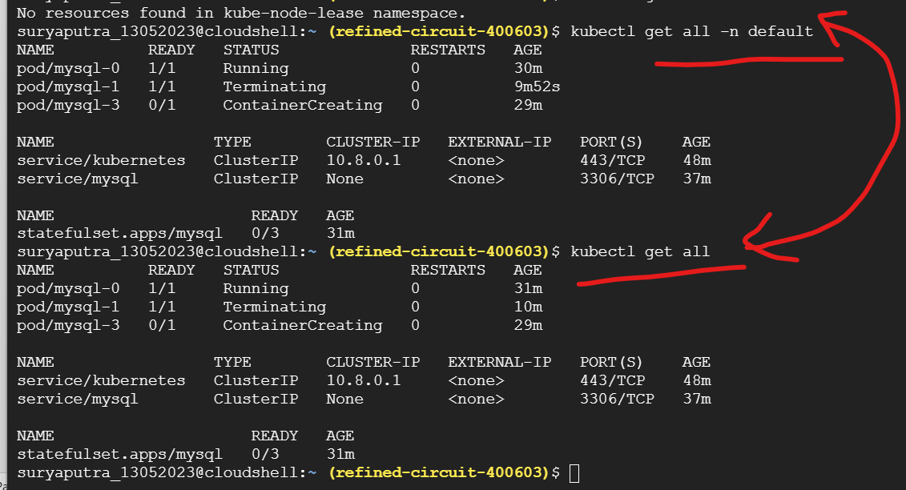

Create namespace & create pods under namespace

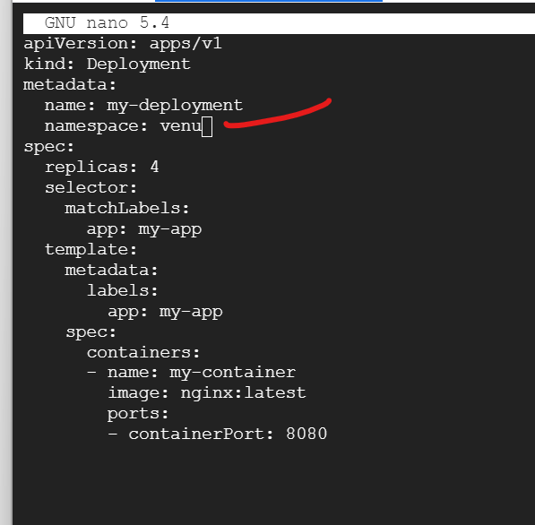

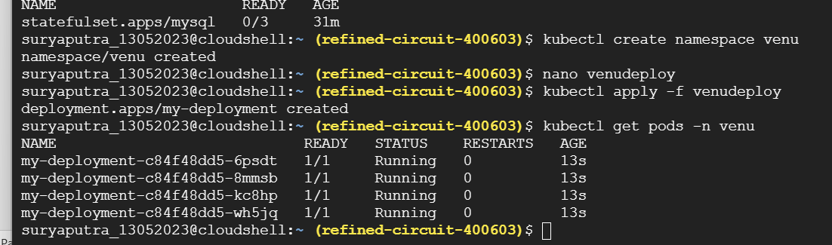

Remove name space

Then create it

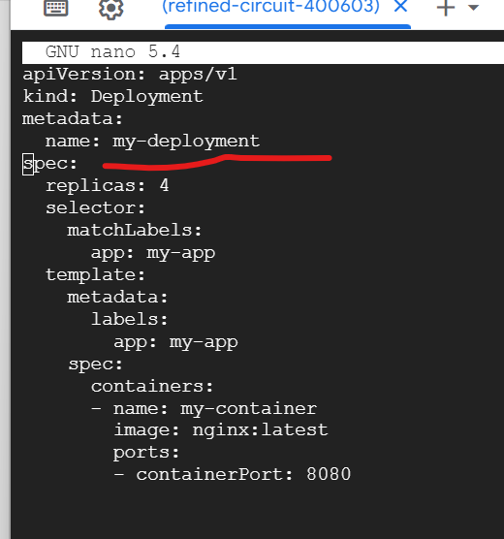

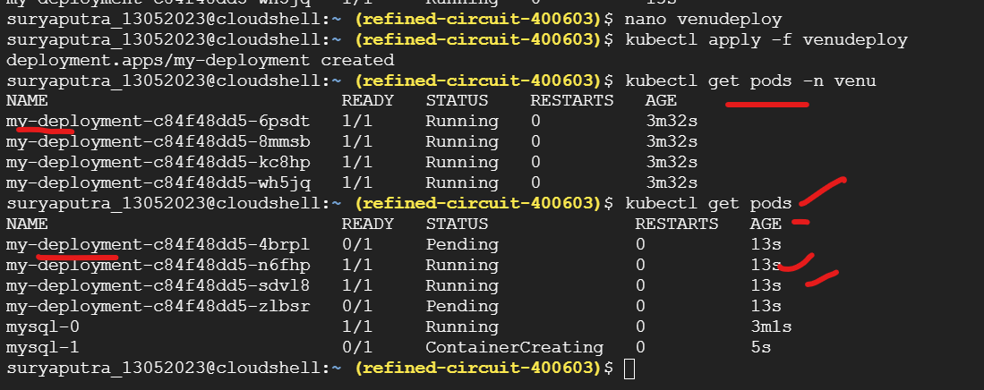

Created pods default name with name it is isolated process,

If create same pod name with same name ,it will delete old one & create new one ,but now create same pod with diff name space it is isolated process

Kube-sytem namespace using cluster running related resources

Config map:

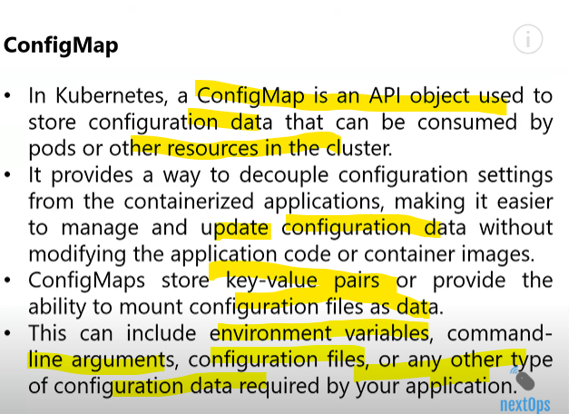

This is non namespace

Secret

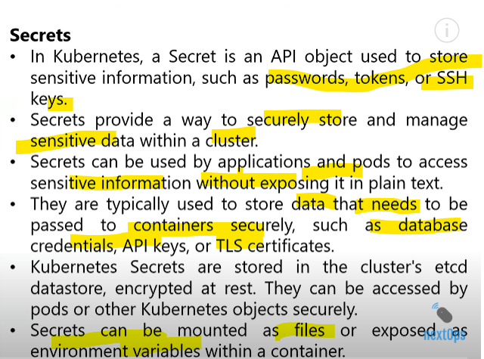

Secrets run only in the memory of the Nodes where the PODs are running. They are not saved in any folder or disk storage and get wiped out when the secret is created.

echo -n AABBCCCDDDSECRETKEY | base64

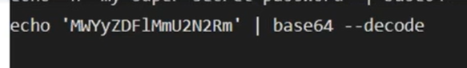

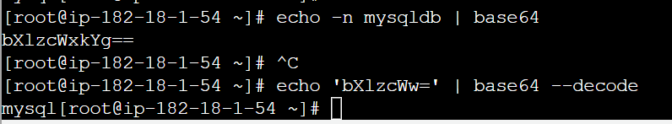

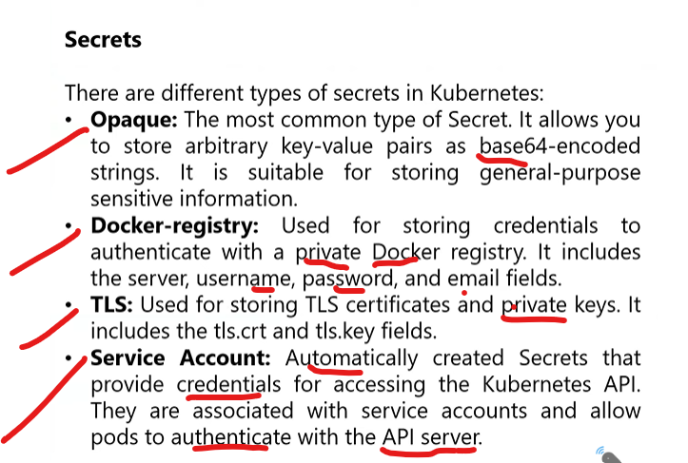

PS C:\Users\Hi> cd env:

PS Env:\> ls

Name Value

---- -----

ALLUSERSPROFILE C:\ProgramData

APPDATA C:\Users\Hi\AppData\Roaming

CommonProgramFiles C:\Program Files\Common Files

CommonProgramFiles(x86) C:\Program Files (x86)\Common Files

CommonProgramW6432 C:\Program Files\Common Files

COMPUTERNAME DESKTOP-8MI04H2

ComSpec C:\WINDOWS\system32\cmd.exe

DriverData C:\Windows\System32\Drivers\DriverData

EFC_9220 1

HOMEDRIVE C:

HOMEPATH \Users\Hi

LOCALAPPDATA C:\Users\Hi\AppData\Local

LOGONSERVER \\DESKTOP-8MI04H2

NUMBER_OF_PROCESSORS 8

OneDrive D:\C\Desktop\New folder\OneDrive

OneDriveConsumer D:\C\Desktop\New folder\OneDrive

OS Windows_NT

Path C:\WINDOWS\system32;C:\WINDOWS;C:\WINDOWS\System32\Wbem;C:\WINDOWS\System32\WindowsPo...

PATHEXT .COM;.EXE;.BAT;.CMD;.VBS;.VBE;.JS;.JSE;.WSF;.WSH;.MSC;.CPL

PROCESSOR_ARCHITECTURE AMD64

PROCESSOR_IDENTIFIER Intel64 Family 6 Model 142 Stepping 12, GenuineIntel

PROCESSOR_LEVEL 6

PROCESSOR_REVISION 8e0c

ProgramData C:\ProgramData

ProgramFiles C:\Program Files

ProgramFiles(x86) C:\Program Files (x86)

ProgramW6432 C:\Program Files

PSModulePath C:\Users\Hi\Documents\WindowsPowerShell\Modules;C:\Program Files\WindowsPowerShell\Mo...

PUBLIC C:\Users\Public

SESSIONNAME Console

SystemDrive C:

SystemRoot C:\WINDOWS

TEMP C:\Users\Hi\AppData\Local\Temp

TMP C:\Users\Hi\AppData\Local\Temp

USERDOMAIN DESKTOP-8MI04H2

USERDOMAIN_ROAMINGPROFILE DESKTOP-8MI04H2

USERNAME Hi

USERPROFILE C:\Users\Hi

windir C:\WINDOWS

ZES_ENABLE_SYSMAN 1

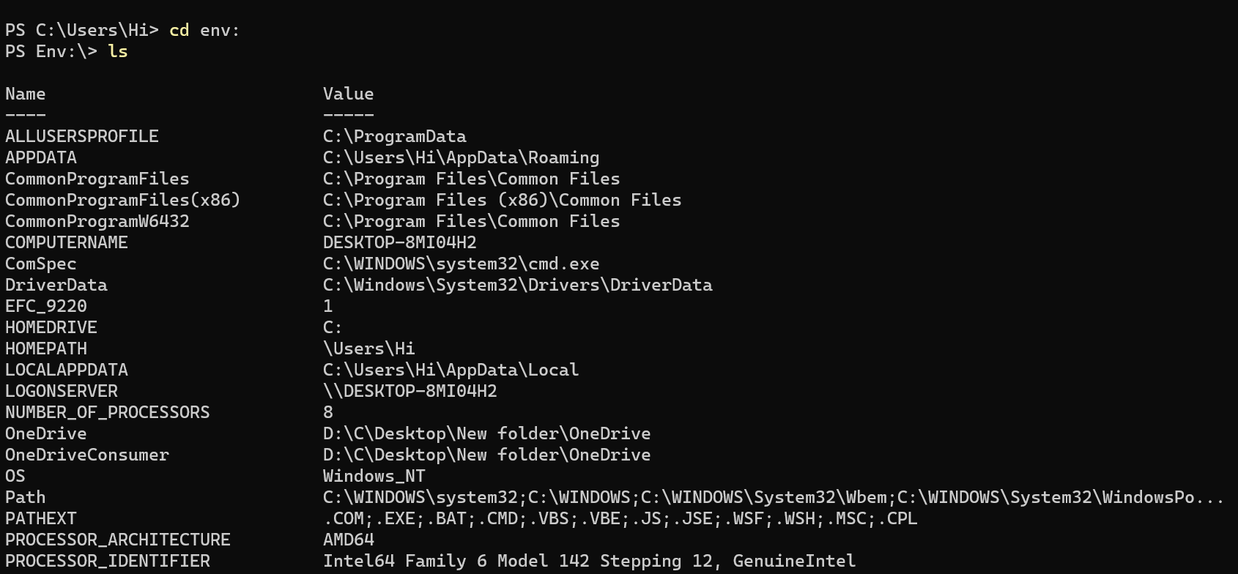

07_Configmap_Secrets

<https://github.com/nextopsvideos/kubernetesyt/tree/main/07_Configmap_Secrets>

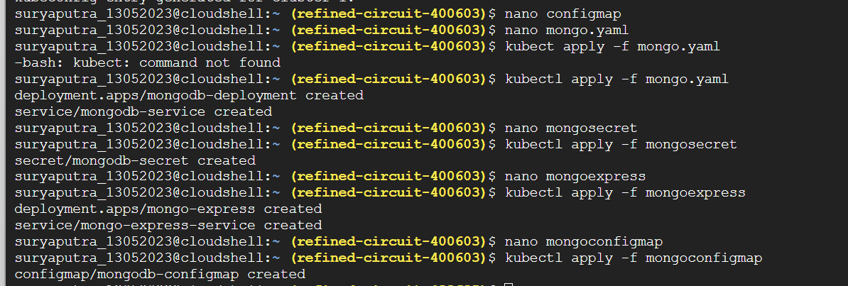

Kubectl get pods

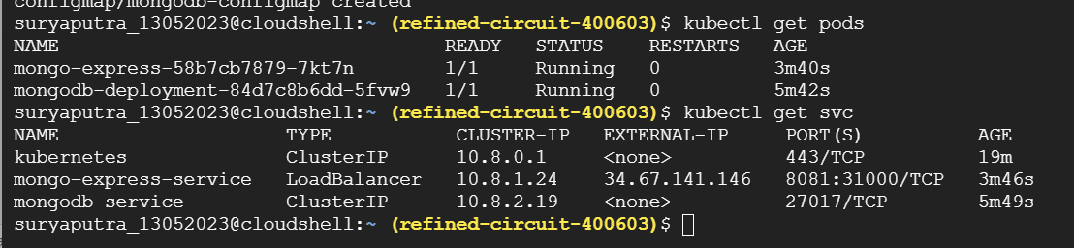

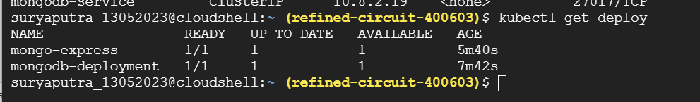

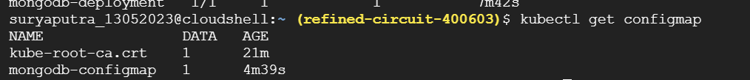

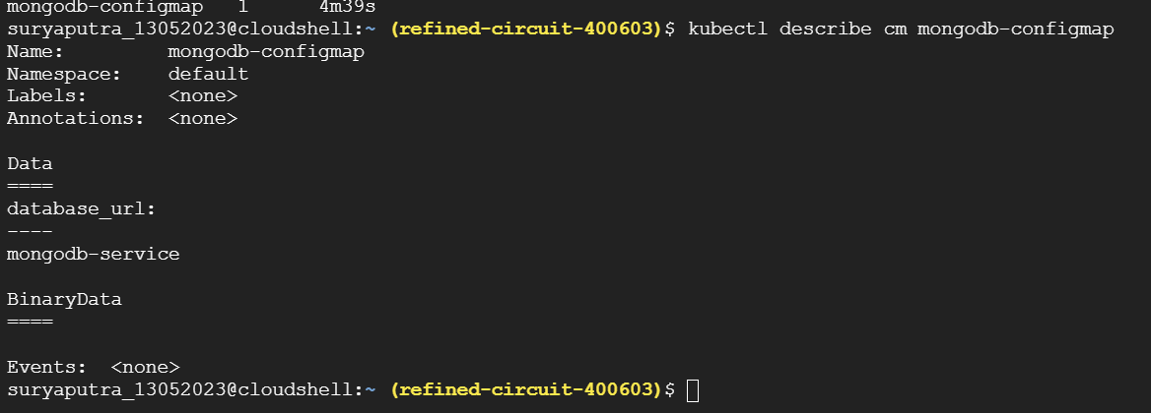

uryaputra_13052023@cloudshell:~ (refined-circuit-400603)$ kubectl get secret

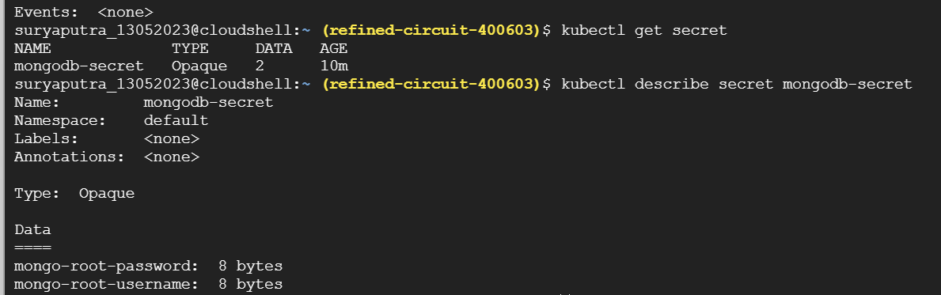

kubectl describe secret mongodb-secret

suryaputra_13052023@cloudshell:~ (refined-circuit-400603)$ kubectl exec -it mongo-express-58b7cb7879-7kt7n env

kubectl exec [POD] [COMMAND] is DEPRECATED and will be removed in a future version. Use kubectl exec [POD] -- [COMMAND] instead.

PATH=/usr/local/sbin:/usr/local/bin:/usr/sbin:/usr/bin:/sbin:/bin

HOSTNAME=mongo-express-58b7cb7879-7kt7n

NODE_VERSION=12.22.7

YARN_VERSION=1.22.15

ME_CONFIG_EDITORTHEME=default

ME_CONFIG_MONGODB_URL=mongodb://mongo:27017

ME_CONFIG_MONGODB_ENABLE_ADMIN=true

ME_CONFIG_BASICAUTH_USERNAME=

ME_CONFIG_BASICAUTH_PASSWORD=

VCAP_APP_HOST=0.0.0.0

MONGO_EXPRESS=1.0.0-alpha.4

ME_CONFIG_MONGODB_ADMINUSERNAME=username

ME_CONFIG_MONGODB_ADMINPASSWORD=password

ME_CONFIG_MONGODB_SERVER=mongodb-service

MONGO_EXPRESS_SERVICE_PORT_8081_TCP_ADDR=10.8.1.24

KUBERNETES_SERVICE_PORT=443

KUBERNETES_PORT=tcp://10.8.0.1:443

KUBERNETES_PORT_443_TCP_ADDR=10.8.0.1

MONGODB_SERVICE_SERVICE_PORT=27017

MONGO_EXPRESS_SERVICE_SERVICE_PORT=8081

MONGO_EXPRESS_SERVICE_SERVICE_HOST=10.8.1.24

MONGO_EXPRESS_SERVICE_PORT_8081_TCP=tcp://10.8.1.24:8081

MONGODB_SERVICE_PORT_27017_TCP=tcp://10.8.2.19:27017

MONGODB_SERVICE_PORT_27017_TCP_PROTO=tcp

MONGODB_SERVICE_PORT_27017_TCP_ADDR=10.8.2.19

MONGO_EXPRESS_SERVICE_PORT=tcp://10.8.1.24:8081

MONGO_EXPRESS_SERVICE_PORT_8081_TCP_PROTO=tcp

MONGO_EXPRESS_SERVICE_PORT_8081_TCP_PORT=8081

KUBERNETES_SERVICE_PORT_HTTPS=443

MONGODB_SERVICE_SERVICE_HOST=10.8.2.19

MONGODB_SERVICE_PORT_27017_TCP_PORT=27017

KUBERNETES_PORT_443_TCP=tcp://10.8.0.1:443

KUBERNETES_PORT_443_TCP_PROTO=tcp

KUBERNETES_PORT_443_TCP_PORT=443

MONGODB_SERVICE_PORT=tcp://10.8.2.19:27017

KUBERNETES_SERVICE_HOST=10.8.0.1

TERM=xterm

HOME=/root

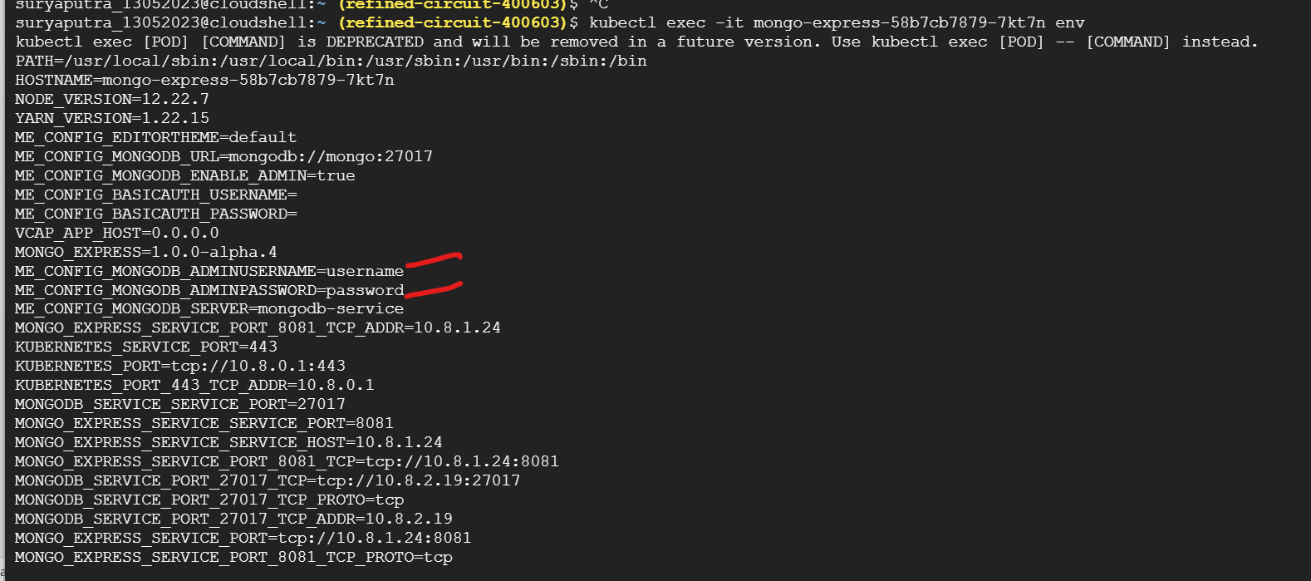

Env passed in container

Let me check mongodb service

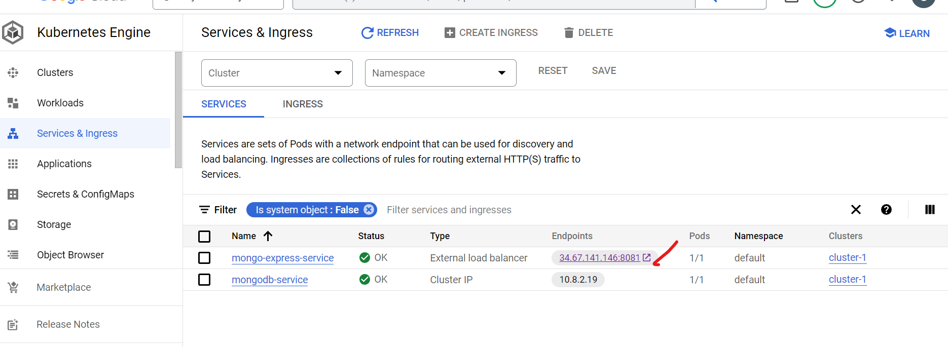

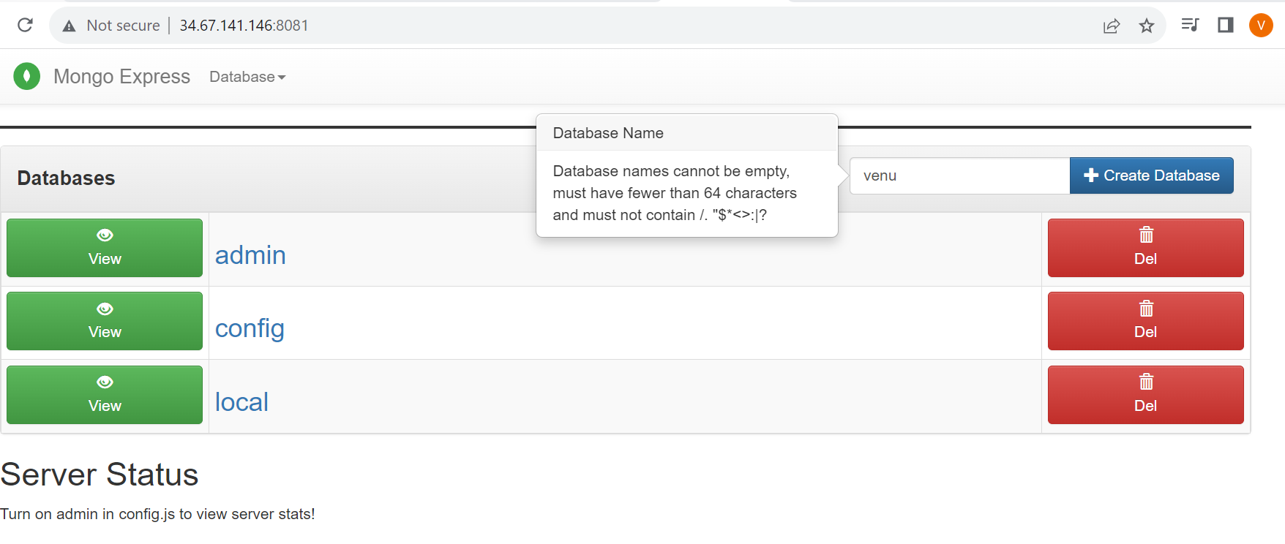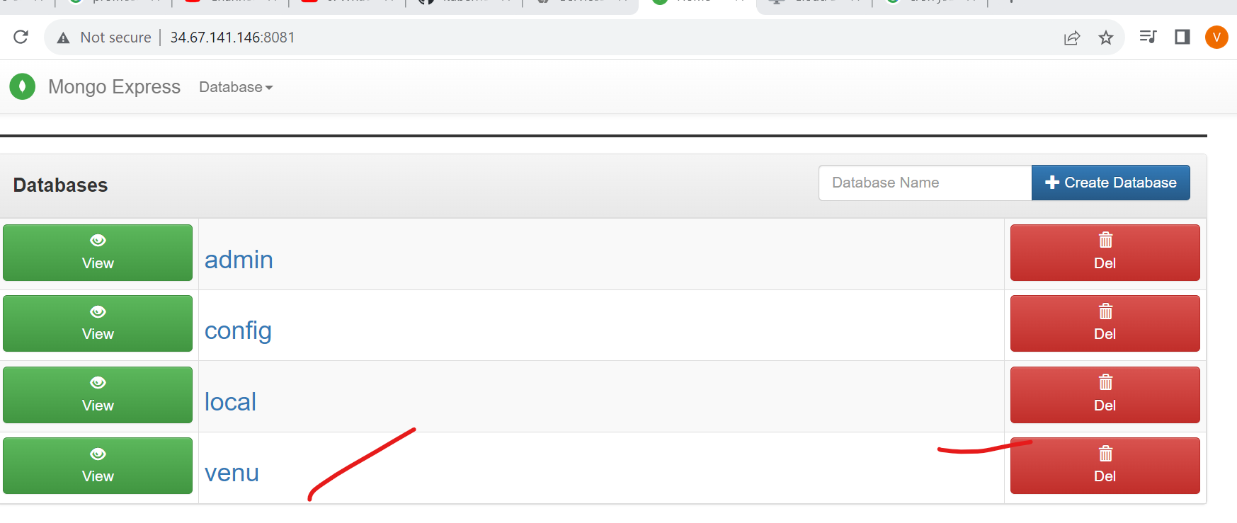

This is frond user interface authenticate access mongodb by sing of service

How to delete pod

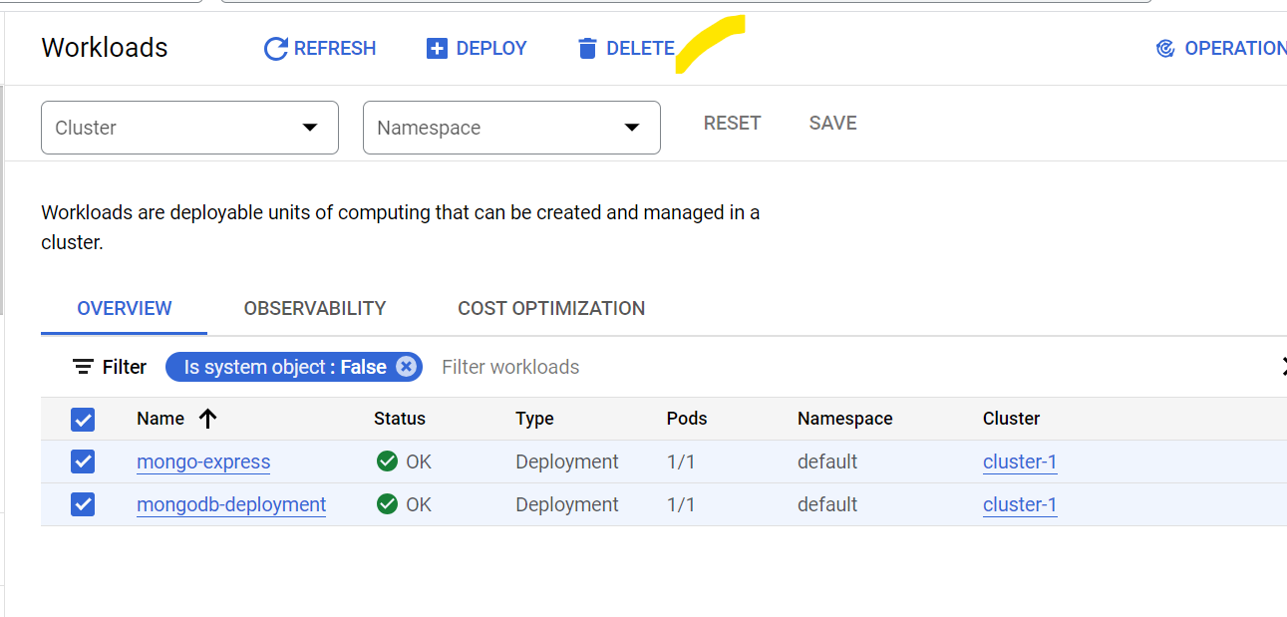

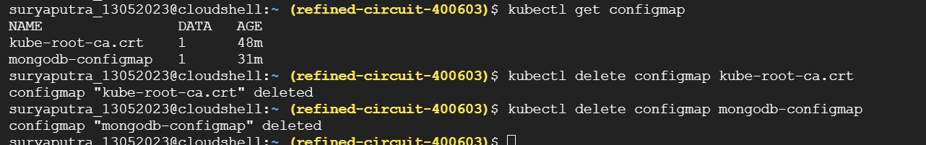

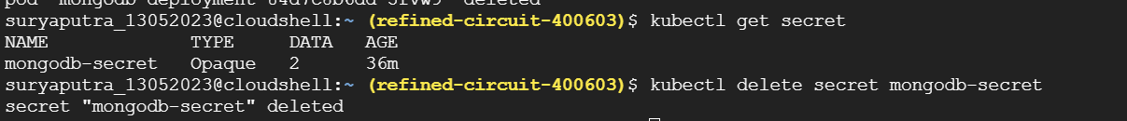

PV :]

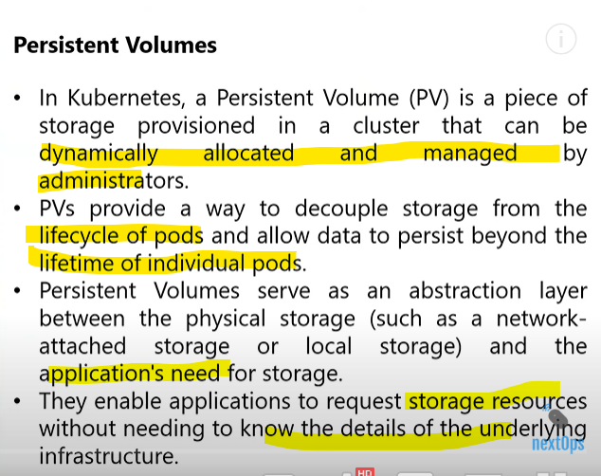

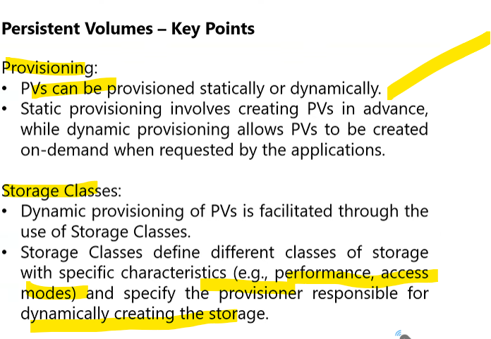

Automatic created storage pv in cluster by storage class

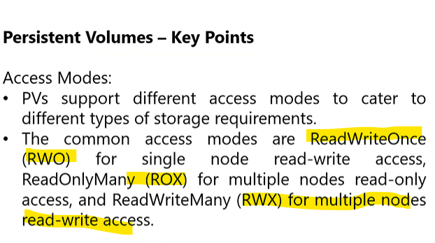

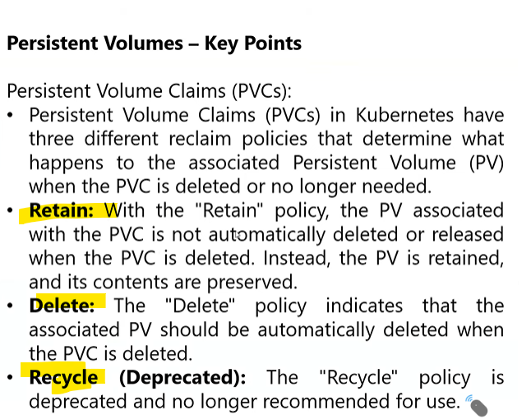

<https://github.com/nextopsvideos/kubernetesyt/tree/main/08_PersistentVolumes>

copy and pastre create all yaml file in cluster

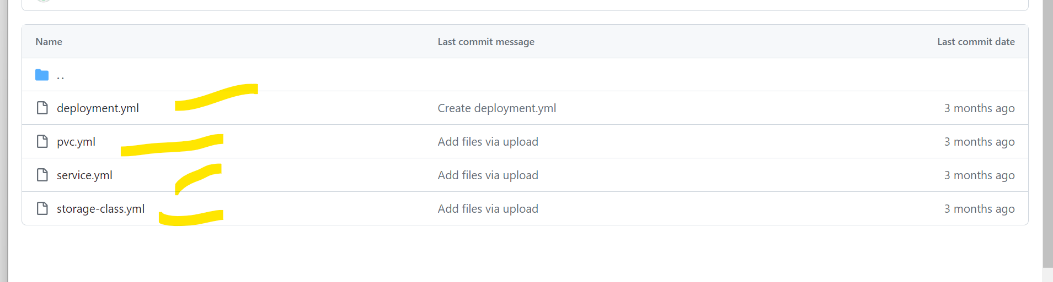

4 yaml file create it

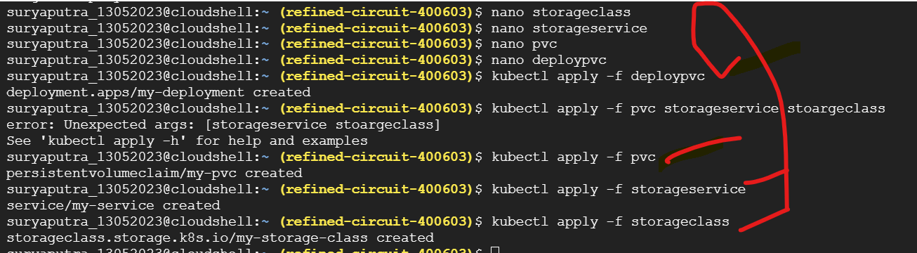

Check disk in server level node

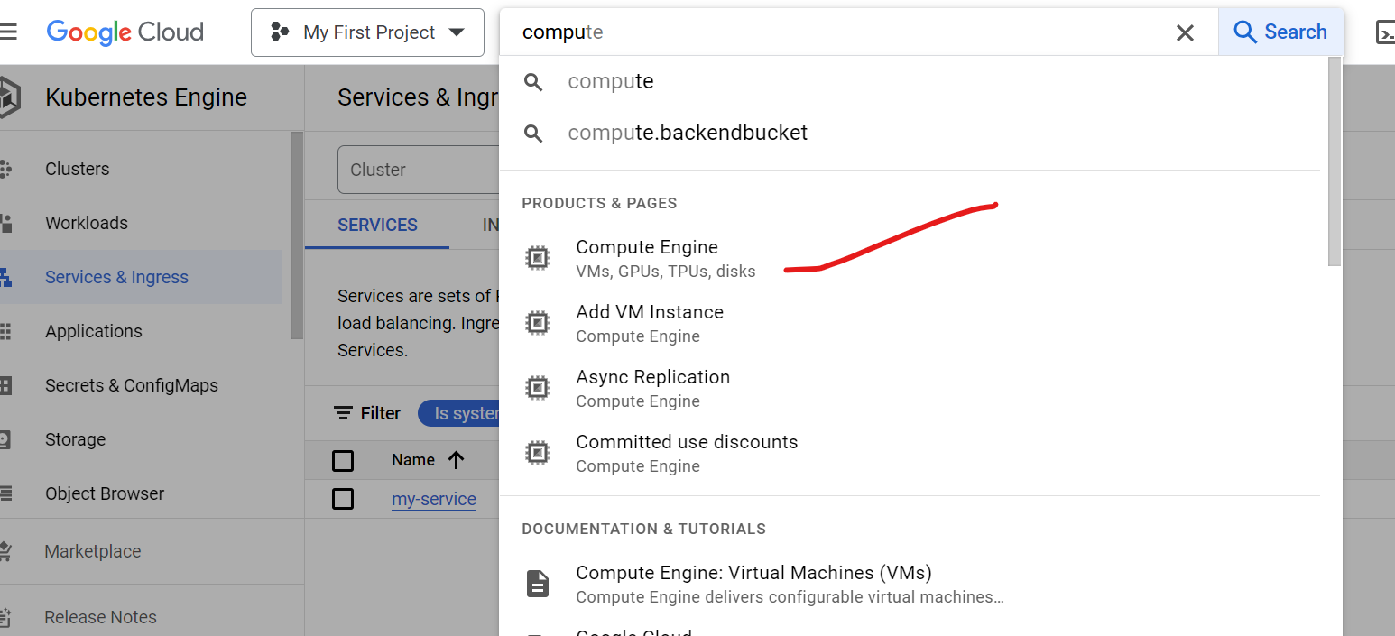

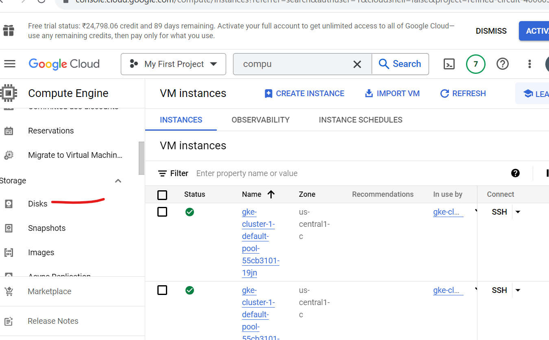

Select disk

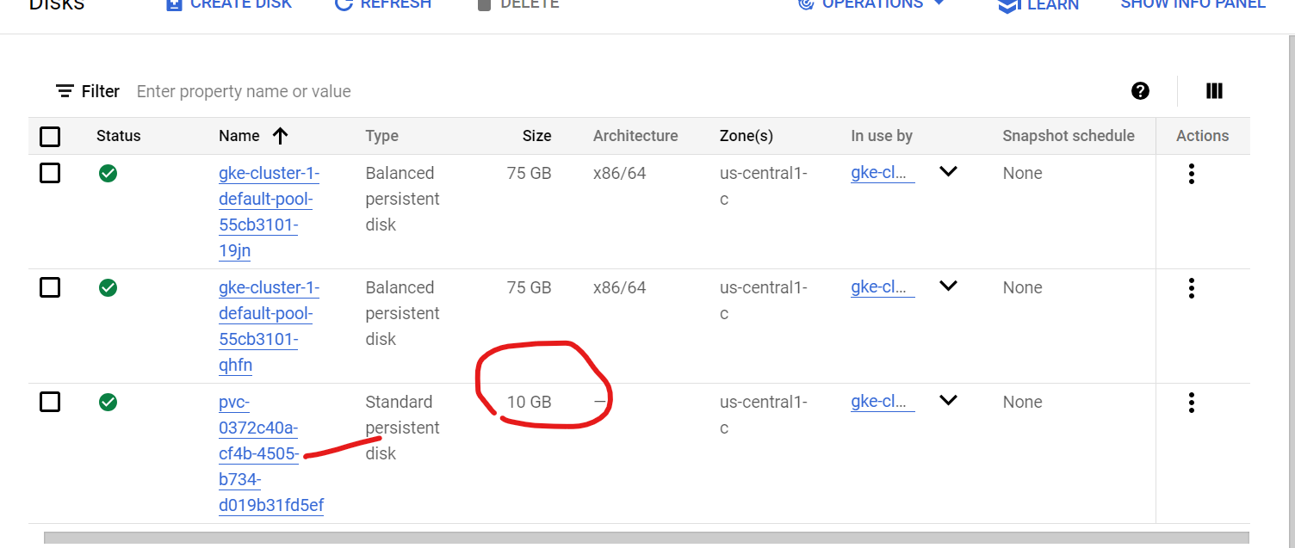

10 gb created pvc

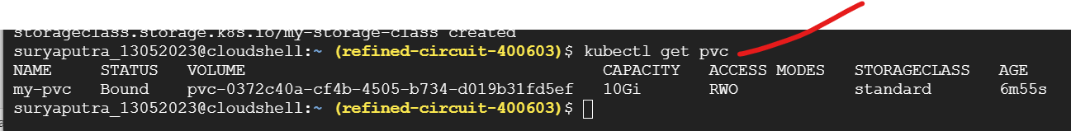

Status bond

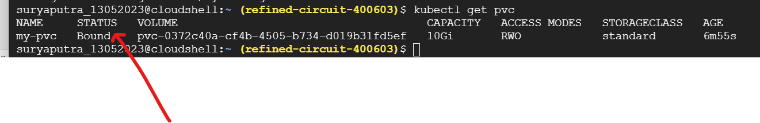

Pvc attached to pod

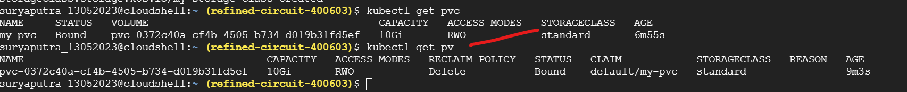

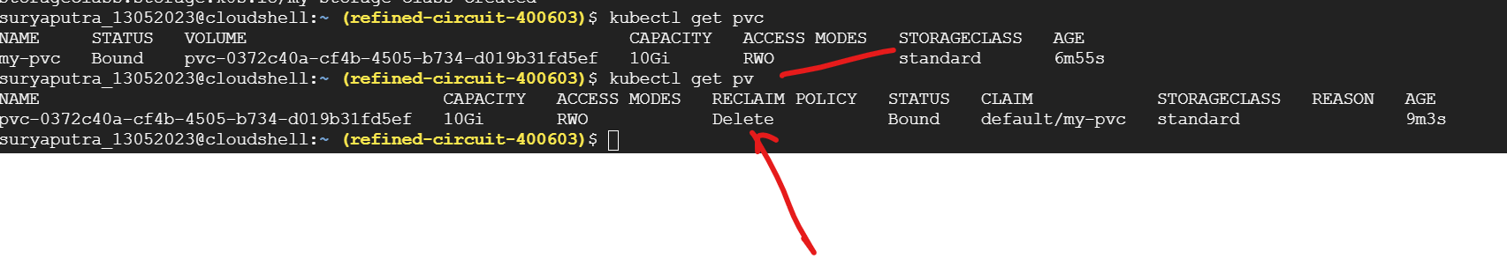

We can reclaim policy now delete by using edit we can change to retain

Changed retain

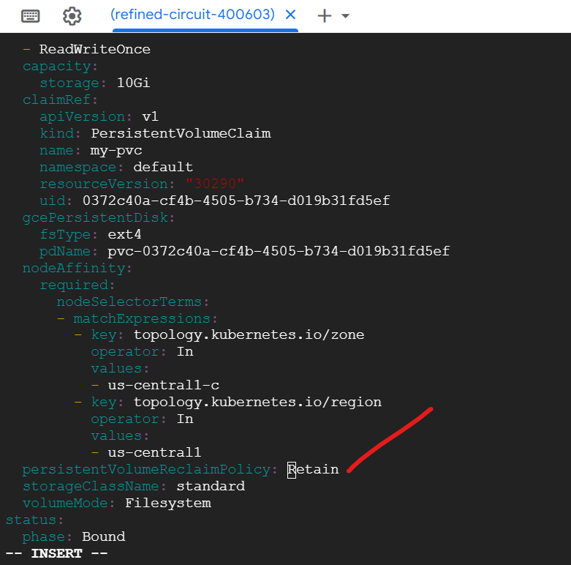

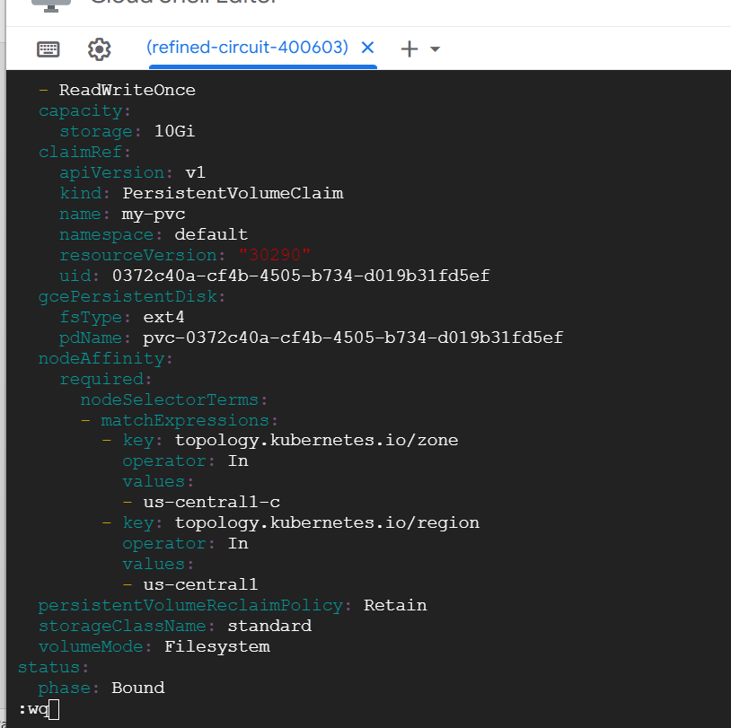



Delete :When pod deleted pv also delted in cluster

Retain : when pod deleted but pv is available



Now retain : reclaim policy

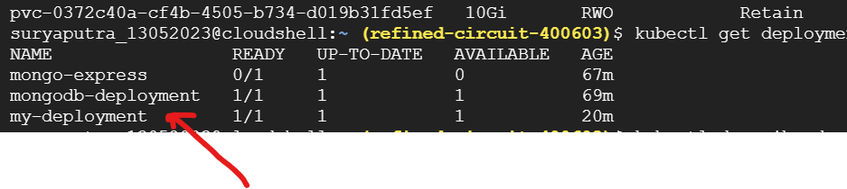

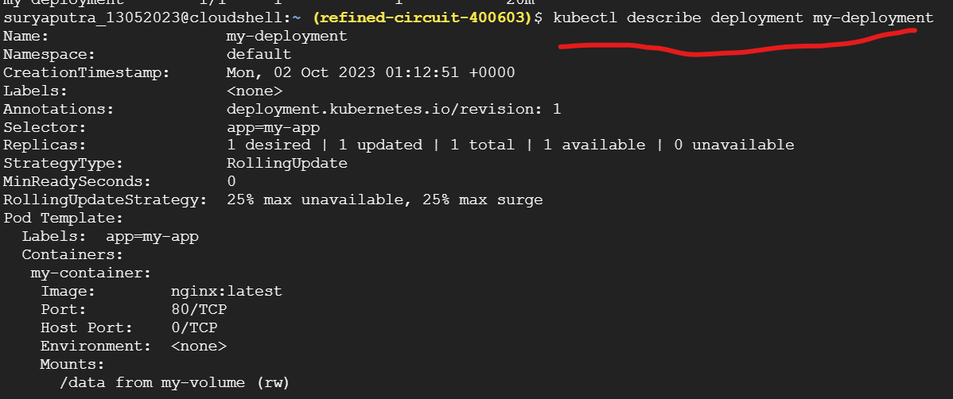

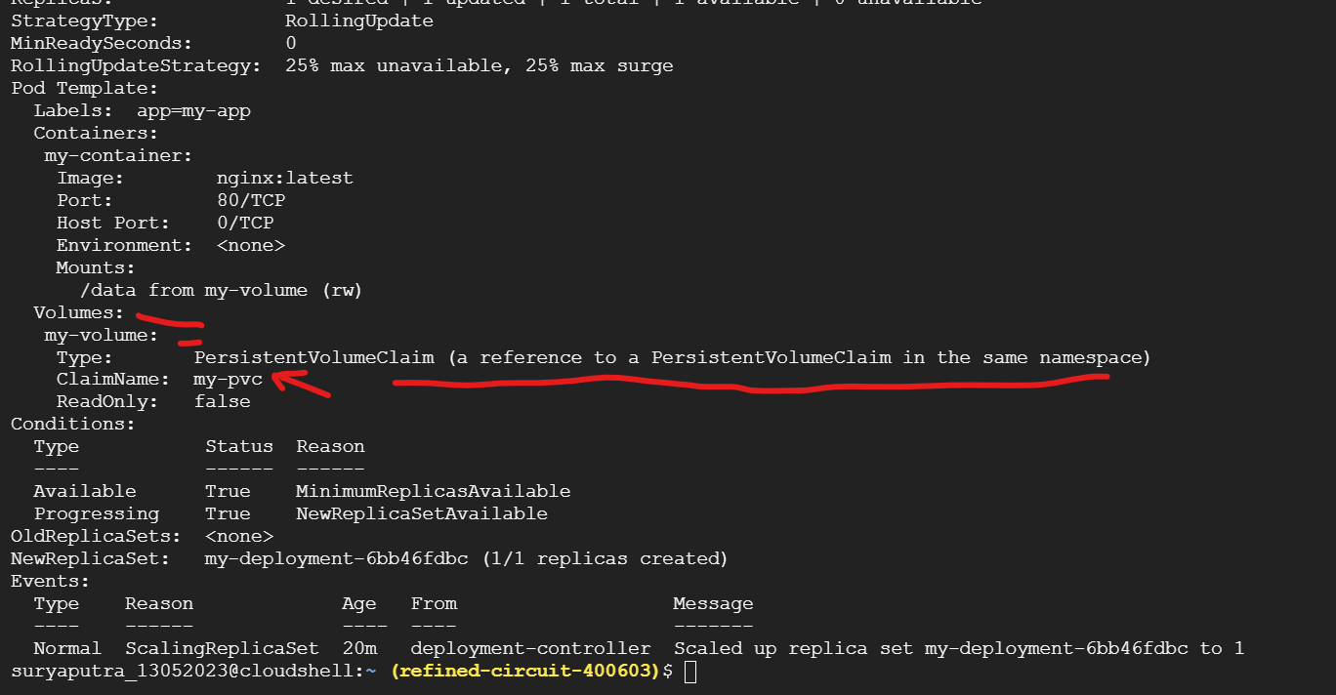

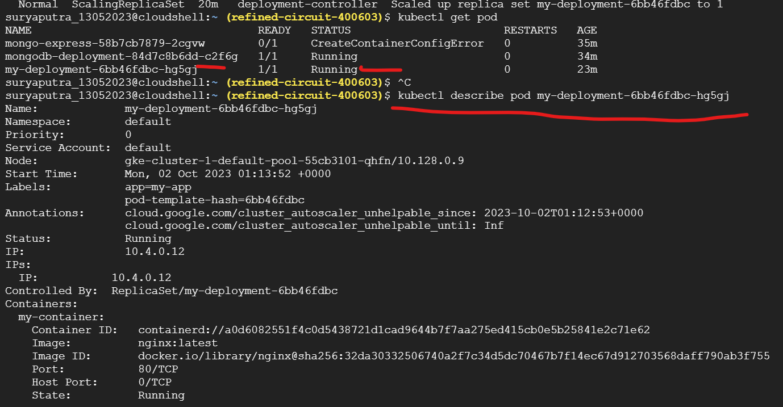

kubectl describe pod my-deployment-6bb46fdbc-hg5gj

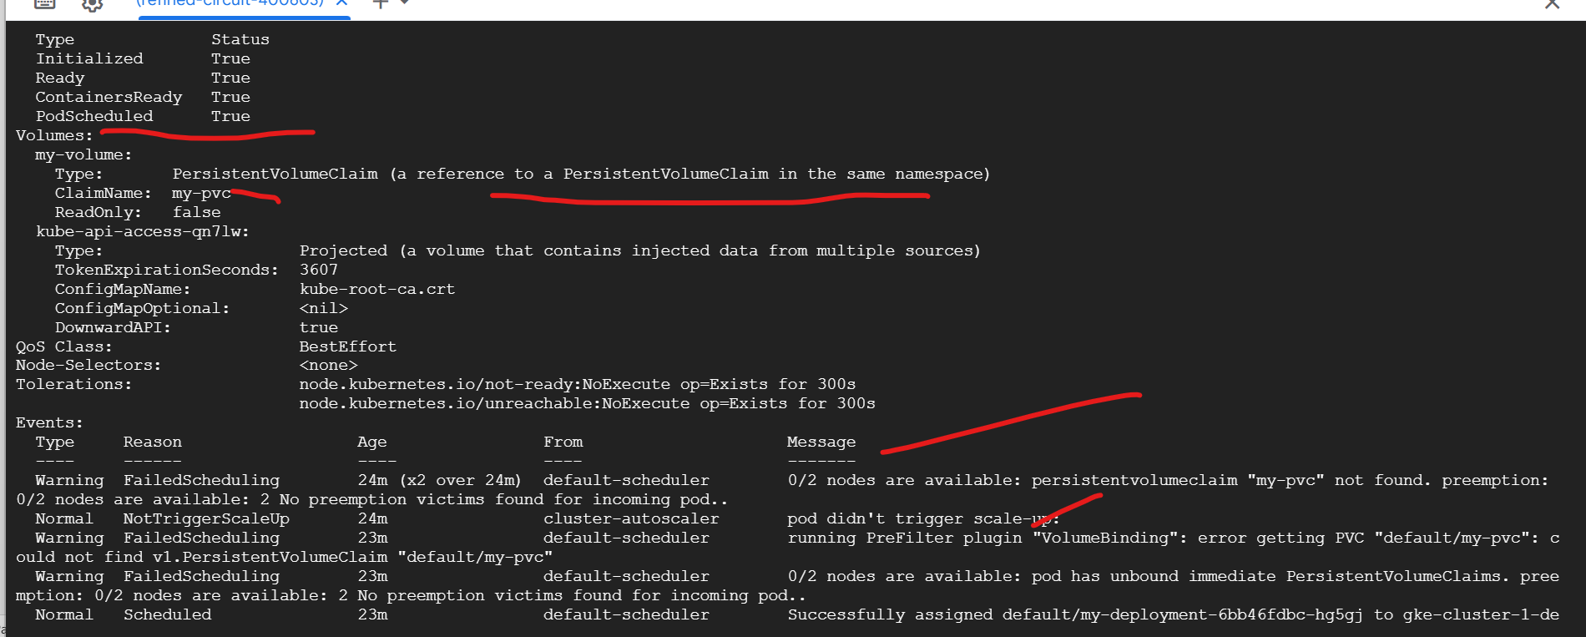

This retain policy:

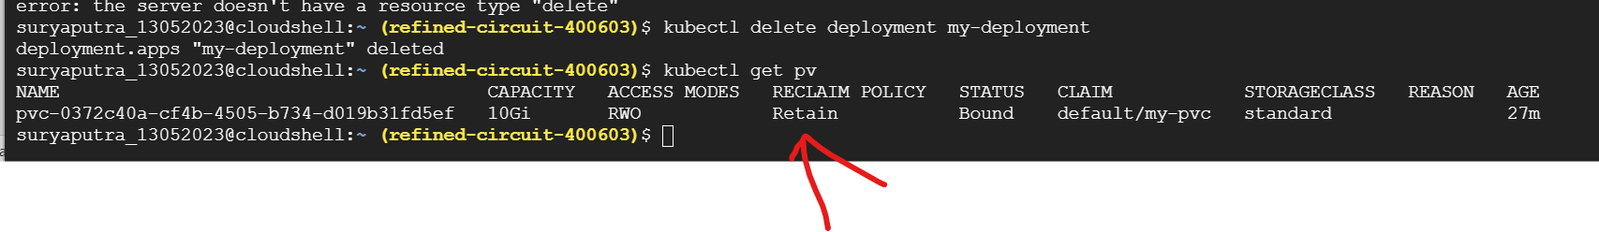

If pvc is deleted but pv still available bcz it retain policy

If pvc is deleted and pv deleted bcz in delete policy

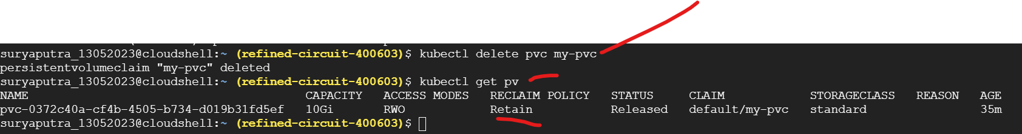

Above screen shot Retain policy

Let me create deletion policy

Create new pvc

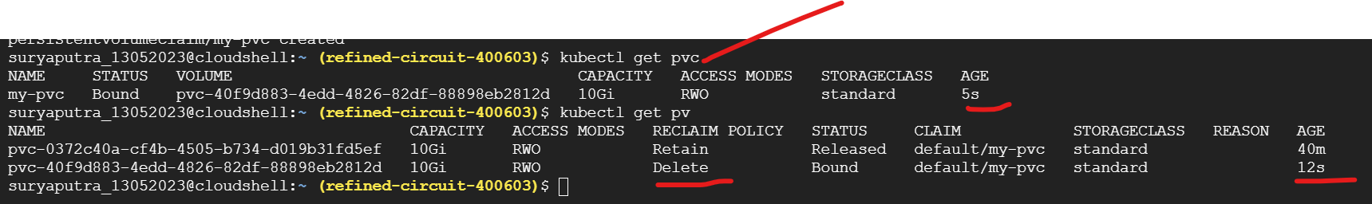

After delet pvc



Pv alsl deleted

Deamoonset:

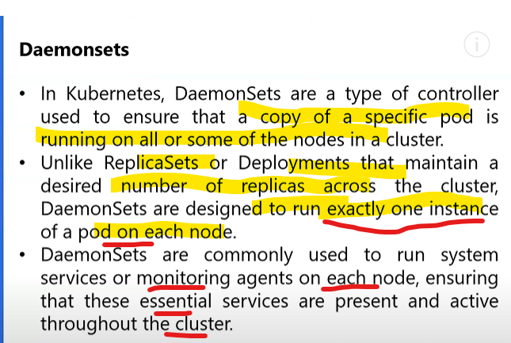

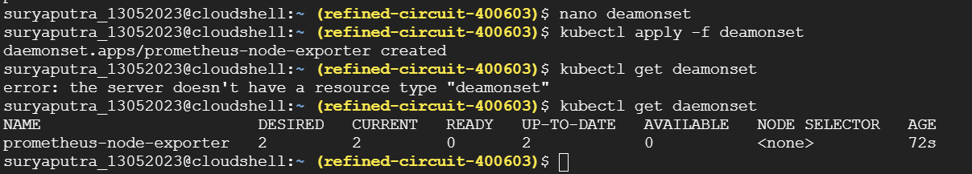

<https://github.com/nextopsvideos/kubernetesyt/blob/main/10_Misc/daemonset.yml>

cp and paste create yaml

wt is job

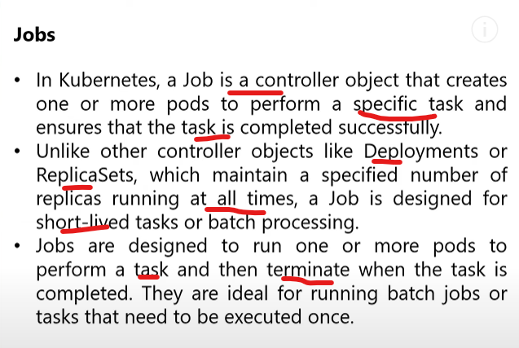

<https://github.com/nextopsvideos/kubernetesyt/blob/main/10_Misc/job.yml>

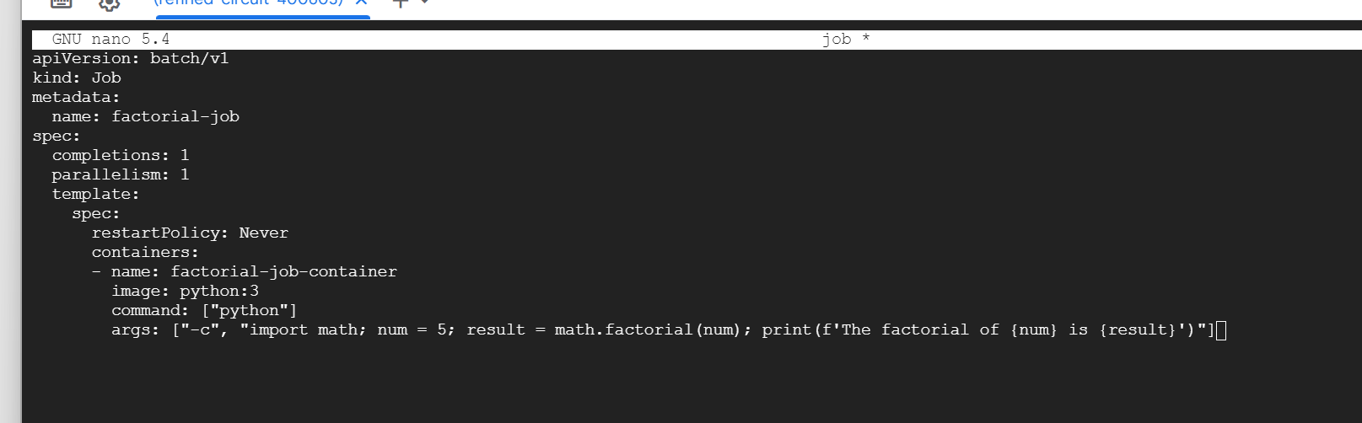

Job Task completed then pod is terminated automatically

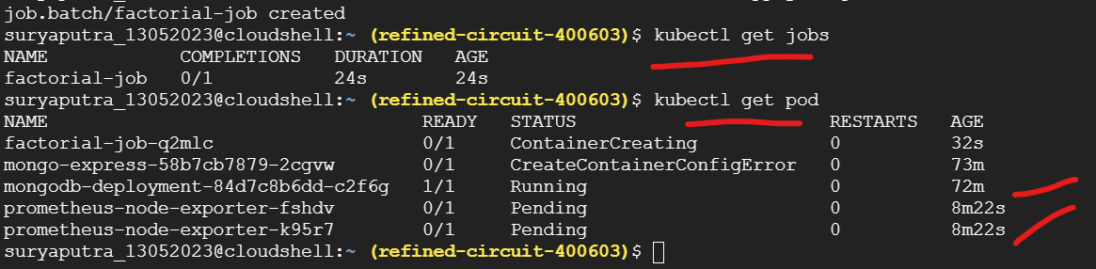

Wt is cluster autoscaler:

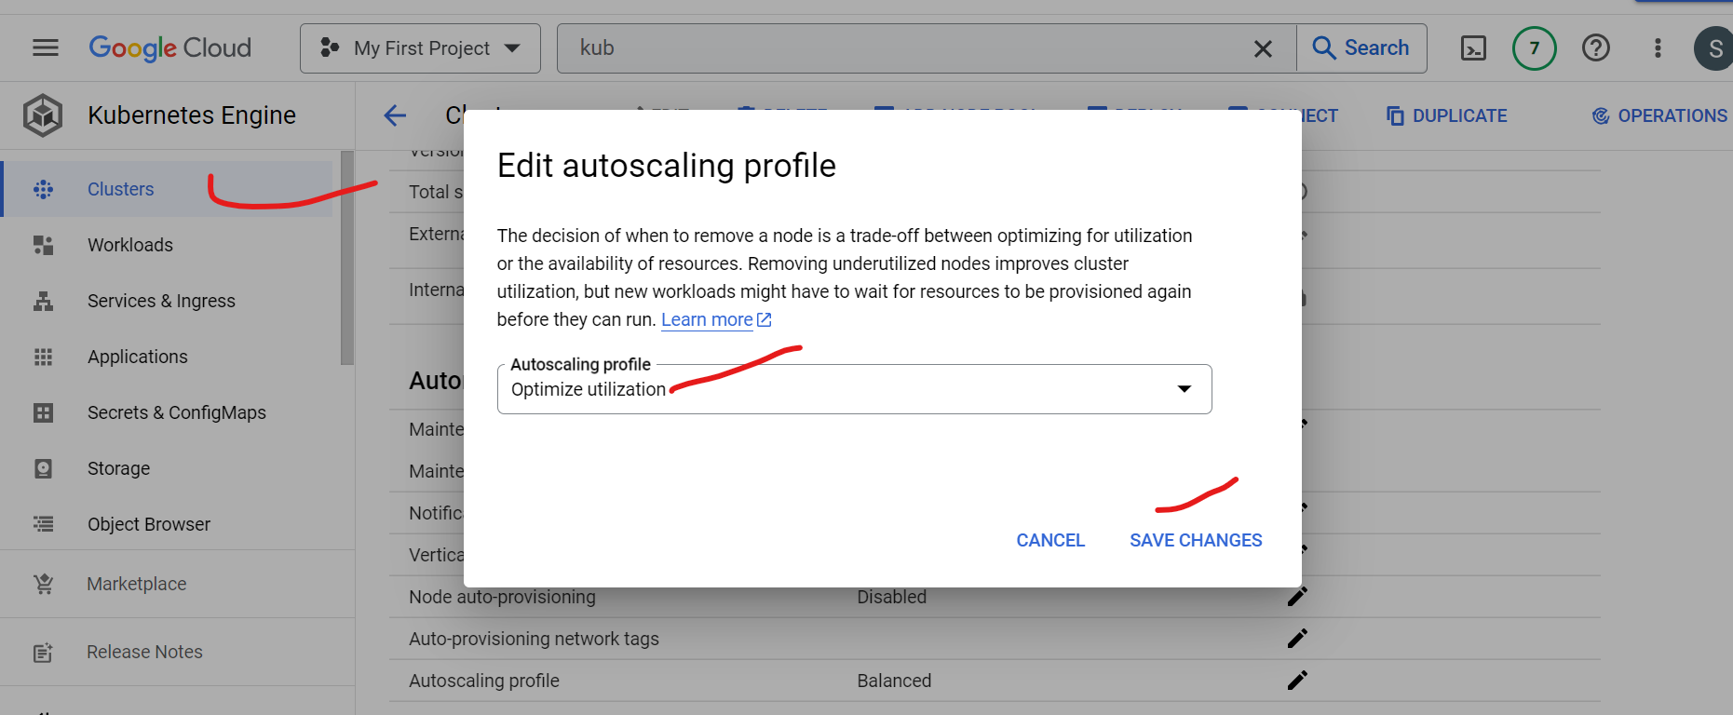

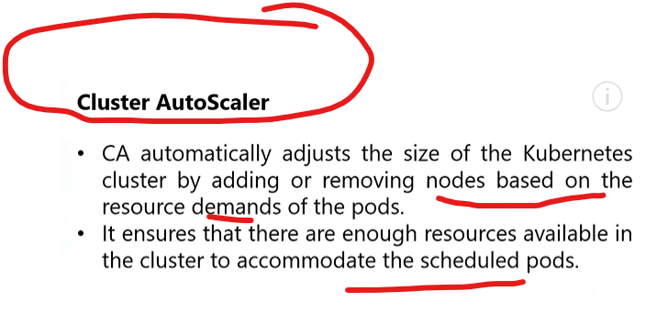

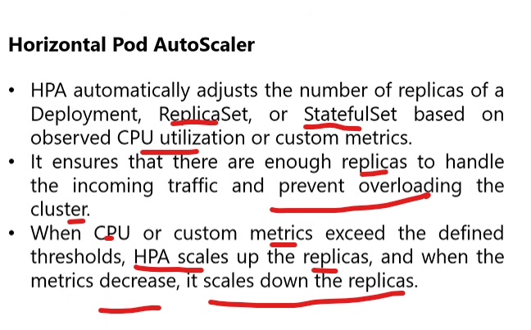

Find metric server in kubesystem namespace:

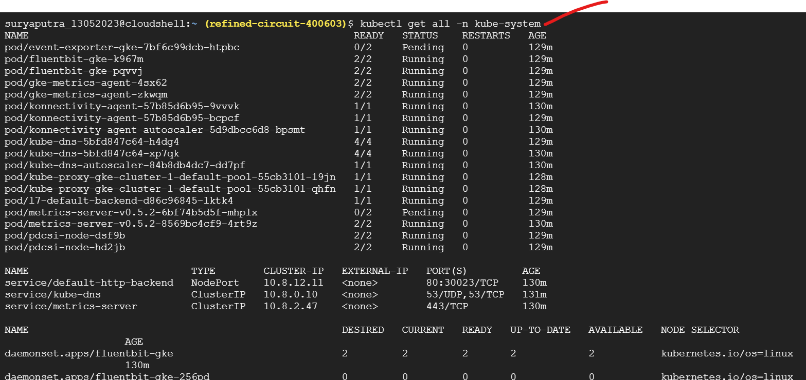

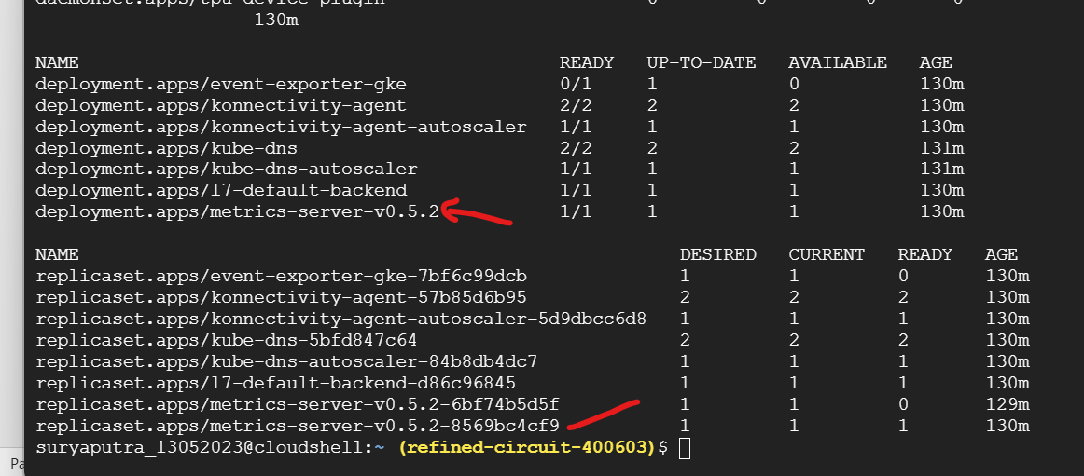

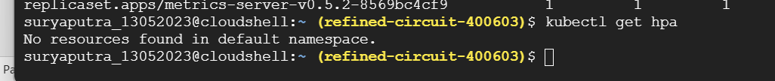

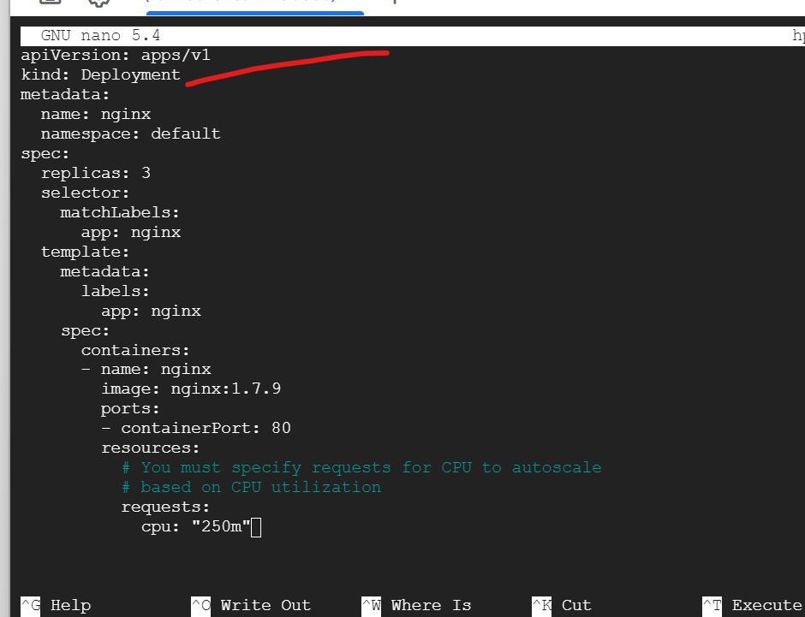

<https://github.com/nextopsvideos/kubernetesyt/blob/main/10_Misc/deployment.yml>

copy and paste in nano file

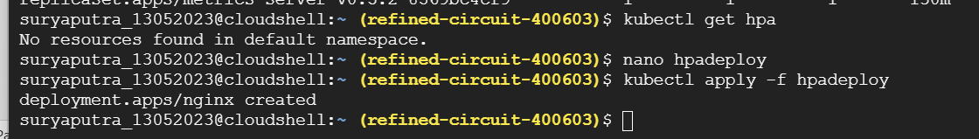

Create it

2 step hpa creation

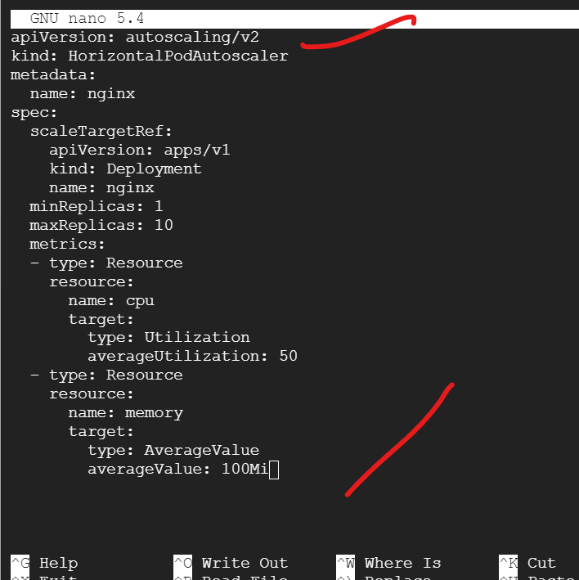

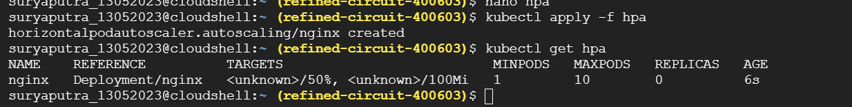

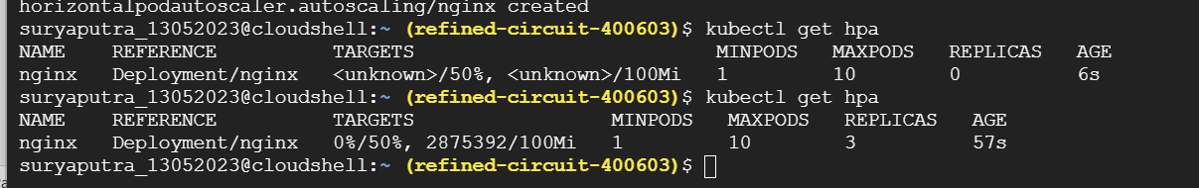

3 concept

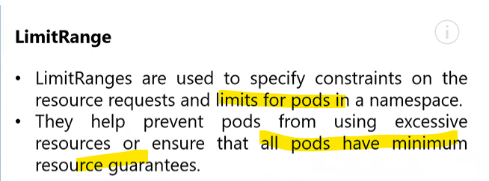

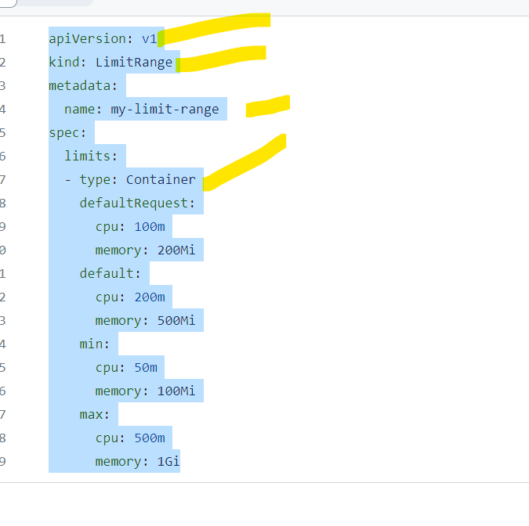

Resource limit range restrict purpose using limit in name space

<https://github.com/nextopsvideos/kubernetesyt/blob/main/10_Misc/limitrange.yml>

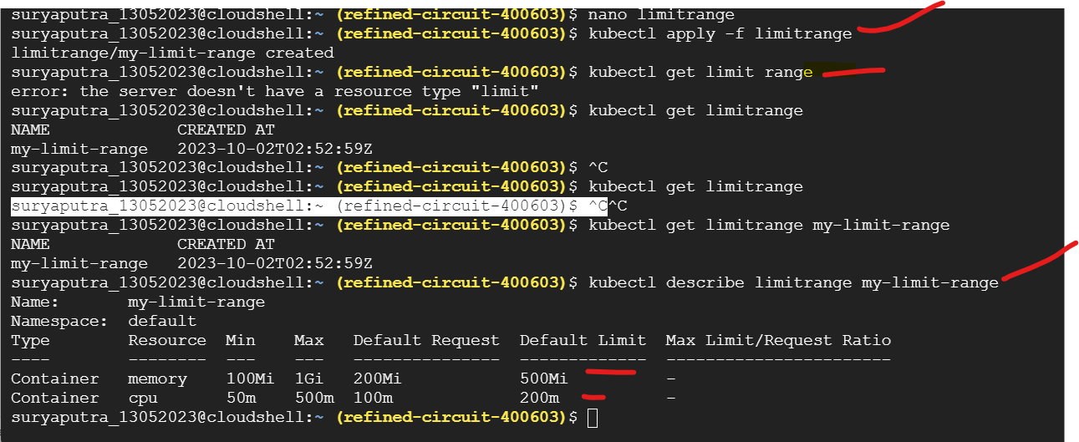

Wt is resource quota:

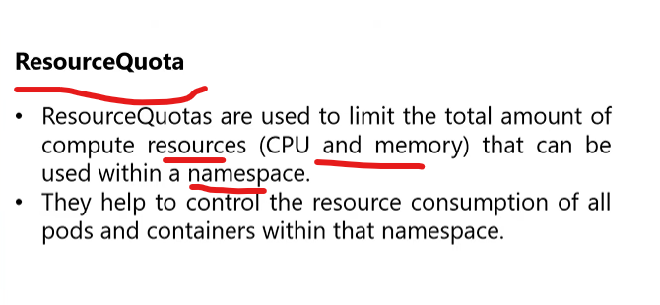

<https://github.com/nextopsvideos/kubernetesyt/blob/main/10_Misc/resourcequota.yml>

1.create ns

2.create resourse range in ns

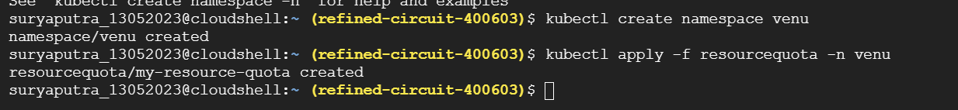



Trableshoot

suryaputra_13052023@cloudshell:~ (refined-circuit-400603)$ kubectl logs mongodb-deployment-84d7c8b6dd-c2f6g

about to fork child process, waiting until server is ready for connections.

forked process: 28

{"t":{"$date":"2023-10-02T01:01:54.015+00:00"},"s":"I", "c":"CONTROL", "id":20698, "ctx":"main","msg":"***** SERVER RESTARTED *****"}

{"t":{"$date":"2023-10-02T01:01:54.030+00:00"},"s":"I", "c":"NETWORK", "id":4915701, "ctx":"main","msg":"Initialized wire specification","attr":{"spec":{"incomingExternalClient":{"minWireVersion":0,"maxWireVersion":21},"incomingInternalClient":{"minWireVersion":0,"maxWireVersion":21},"outgoing":{"minWireVersion":6,"maxWireVersion":21},"isInternalClient":true}}}

{"t":{"$date":"2023-10-02T01:01:54.031+00:00"},"s":"I", "c":"CONTROL", "id":23285, "ctx":"main","msg":"Automatically disabling TLS 1.0, to force-enable TLS 1.0 specify --sslDisabledProtocols 'none'"}

{"t":{"$date":"2023-10-02T01:01:54.035+00:00"},"s":"I", "c":"NETWORK", "id":4648601, "ctx":"main","msg":"Implicit TCP FastOpen unavailable. If TCP FastOpen is required, set tcpFastOpenServer, tcpFastOpenClient, and tcpFastOpenQueueSize."}

{"t":{"$date":"2023-10-02T01:01:54.046+00:00"},"s":"I", "c":"REPL", "id":5123008, "ctx":"main","msg":"Successfully registered PrimaryOnlyService","attr":{"service":"TenantMigrationDonorService","namespace":"config.tenantMigrationDonors"}}

{"t":{"$date":"2023-10-02T01:01:54.046+00:00"},"s":"I", "c":"REPL", "id":5123008, "ctx":"main","msg":"Successfully registered PrimaryOnlyService","attr":{"service":"TenantMigrationRecipientService","namespace":"config.tenantMigrationRecipients"}}

{"t":{"$date":"2023-10-02T01:01:54.047+00:00"},"s":"I", "c":"CONTROL", "id":5945603, "ctx":"main","msg":"Multi threading initialized"}

{"t":{"$date":"2023-10-02T01:01:54.048+00:00"},"s":"I", "c":"TENANT_M", "id":7091600, "ctx":"main","msg":"Starting TenantMigrationAccessBlockerRegistry"}

{"t":{"$date":"2023-10-02T01:01:54.048+00:00"},"s":"I", "c":"CONTROL", "id":4615611, "ctx":"initandlisten","msg":"MongoDB starting","attr":{"pid":28,"port":27017,"dbPath":"/data/db","architecture":"64-bit","host":"mongodb-deployment-84d7c8b6dd-c2f6g"}}

{"t":{"$date":"2023-10-02T01:01:54.048+00:00"},"s":"I", "c":"CONTROL", "id":23403, "ctx":"initandlisten","msg":"Build Info","attr":{"buildInfo":{"version":"7.0.1","gitVersion":"425a0454d12f2664f9e31002bbe4a386a25345b5","openSSLVersion":"OpenSSL 3.0.2 15 Mar 2022","modules":[],"allocator":"tcmalloc","environment":{"distmod":"ubuntu2204","distarch":"x86_64","target_arch":"x86_64"}}}}

{"t":{"$date":"2023-10-02T01:01:54.048+00:00"},"s":"I", "c":"CONTROL", "id":51765, "ctx":"initandlisten","msg":"Operating System","attr":{"os":{"name":"Ubuntu","version":"22.04"}}}

{"t":{"$date":"2023-10-02T01:01:54.048+00:00"},"s":"I", "c":"CONTROL", "id":21951, "ctx":"initandlisten","msg":"Options set by command line","attr":{"options":{"net":{"bindIp":"127.0.0.1","port":27017,"tls":{"mode":"disabled"}},"processManagement":{"fork":true,"pidFilePath":"/tmp/docker-entrypoint-temp-mongod.pid"},"systemLog":{"destination":"file","logAppend":true,"path":"/proc/1/fd/1"}}}}

{"t":{"$date":"2023-10-02T01:01:54.051+00:00"},"s":"I", "c":"STORAGE", "id":22297, "ctx":"initandlisten","msg":"Using the XFS filesystem is strongly recommended with the WiredTiger storage engine. See http://dochub.mongodb.org/core/prodnotes-filesystem","tags":["startupWarnings"]}

{"t":{"$date":"2023-10-02T01:01:54.052+00:00"},"s":"I", "c":"STORAGE", "id":22315, "ctx":"initandlisten","msg":"Opening WiredTiger","attr":{"config":"create,cache_size=256M,session_max=33000,eviction=(threads_min=4,threads_max=4),config_base=false,statistics=(fast),log=(enabled=true,remove=true,path=journal,compressor=snappy),builtin_extension_config=(zstd=(compression_level=6)),file_manager=(close_idle_time=600,close_scan_interval=10,close_handle_minimum=2000),statistics_log=(wait=0),json_output=(error,message),verbose=[recovery_progress:1,checkpoint_progress:1,compact_progress:1,backup:0,checkpoint:0,compact:0,evict:0,history_store:0,recovery:0,rts:0,salvage:0,tiered:0,timestamp:0,transaction:0,verify:0,log:0],"}}

{"t":{"$date":"2023-10-02T01:01:54.307+00:00"},"s":"I", "c":"STORAGE", "id":4795906, "ctx":"initandlisten","msg":"WiredTiger opened","attr":{"durationMillis":254}}

{"t":{"$date":"2023-10-02T01:01:54.308+00:00"},"s":"I", "c":"RECOVERY", "id":23987, "ctx":"initandlisten","msg":"WiredTiger recoveryTimestamp","attr":{"recoveryTimestamp":{"$timestamp":{"t":0,"i":0}}}}

{"t":{"$date":"2023-10-02T01:01:54.341+00:00"},"s":"W", "c":"CONTROL", "id":22120, "ctx":"initandlisten","msg":"Access control is not enabled for the database. Read and write access to data and configuration is unrestricted","tags":["startupWarnings"]}

{"t":{"$date":"2023-10-02T01:01:54.341+00:00"},"s":"W", "c":"CONTROL", "id":5123300, "ctx":"initandlisten","msg":"vm.max_map_count is too low","attr":{"currentValue":65530,"recommendedMinimum":1677720,"maxConns":838860},"tags":["startupWarnings"]}

{"t":{"$date":"2023-10-02T01:01:54.342+00:00"},"s":"I", "c":"STORAGE", "id":20320, "ctx":"initandlisten","msg":"createCollection","attr":{"namespace":"admin.system.version","uuidDisposition":"provided","uuid":{"uuid":{"$uuid":"cad90a33-5a8a-418c-bb06-e7d2a740bcf8"}},"options":{"uuid":{"$uuid":"cad90a33-5a8a-418c-bb06-e7d2a740bcf8"}}}}

{"t":{"$date":"2023-10-02T01:01:54.368+00:00"},"s":"I", "c":"INDEX", "id":20345, "ctx":"initandlisten","msg":"Index build: done building","attr":{"buildUUID":null,"collectionUUID":{"uuid":{"$uuid":"cad90a33-5a8a-418c-bb06-e7d2a740bcf8"}},"namespace":"admin.system.version","index":"_id_","ident":"index-1--624298026223847613","collectionIdent":"collection-0--624298026223847613","commitTimestamp":null}}

{"t":{"$date":"2023-10-02T01:01:54.369+00:00"},"s":"I", "c":"REPL", "id":20459, "ctx":"initandlisten","msg":"Setting featureCompatibilityVersion","attr":{"newVersion":"7.0"}}

{"t":{"$date":"2023-10-02T01:01:54.369+00:00"},"s":"I", "c":"REPL", "id":5853300, "ctx":"initandlisten","msg":"current featureCompatibilityVersion value","attr":{"featureCompatibilityVersion":"7.0","context":"setFCV"}}

{"t":{"$date":"2023-10-02T01:01:54.369+00:00"},"s":"I", "c":"NETWORK", "id":4915702, "ctx":"initandlisten","msg":"Updated wire specification","attr":{"oldSpec":{"incomingExternalClient":{"minWireVersion":0,"maxWireVersion":21},"incomingInternalClient":{"minWireVersion":0,"maxWireVersion":21},"outgoing":{"minWireVersion":6,"maxWireVersion":21},"isInternalClient":true},"newSpec":{"incomingExternalClient":{"minWireVersion":0,"maxWireVersion":21},"incomingInternalClient":{"minWireVersion":21,"maxWireVersion":21},"outgoing":{"minWireVersion":21,"maxWireVersion":21},"isInternalClient":true}}}

{"t":{"$date":"2023-10-02T01:01:54.373+00:00"},"s":"I", "c":"NETWORK", "id":4915702, "ctx":"initandlisten","msg":"Updated wire specification","attr":{"oldSpec":{"incomingExternalClient":{"minWireVersion":0,"maxWireVersion":21},"incomingInternalClient":{"minWireVersion":21,"maxWireVersion":21},"outgoing":{"minWireVersion":21,"maxWireVersion":21},"isInternalClient":true},"newSpec":{"incomingExternalClient":{"minWireVersion":0,"maxWireVersion":21},"incomingInternalClient":{"minWireVersion":21,"maxWireVersion":21},"outgoing":{"minWireVersion":21,"maxWireVersion":21},"isInternalClient":true}}}

{"t":{"$date":"2023-10-02T01:01:54.373+00:00"},"s":"I", "c":"REPL", "id":5853300, "ctx":"initandlisten","msg":"current featureCompatibilityVersion value","attr":{"featureCompatibilityVersion":"7.0","context":"startup"}}

{"t":{"$date":"2023-10-02T01:01:54.374+00:00"},"s":"I", "c":"STORAGE", "id":5071100, "ctx":"initandlisten","msg":"Clearing temp directory"}

{"t":{"$date":"2023-10-02T01:01:54.376+00:00"},"s":"I", "c":"CONTROL", "id":6608200, "ctx":"initandlisten","msg":"Initializing cluster server parameters from disk"}

{"t":{"$date":"2023-10-02T01:01:54.376+00:00"},"s":"I", "c":"CONTROL", "id":20536, "ctx":"initandlisten","msg":"Flow Control is enabled on this deployment"}

{"t":{"$date":"2023-10-02T01:01:54.377+00:00"},"s":"I", "c":"FTDC", "id":20625, "ctx":"initandlisten","msg":"Initializing full-time diagnostic data capture","attr":{"dataDirectory":"/data/db/diagnostic.data"}}

{"t":{"$date":"2023-10-02T01:01:54.395+00:00"},"s":"I", "c":"STORAGE", "id":20320, "ctx":"initandlisten","msg":"createCollection","attr":{"namespace":"local.startup_log","uuidDisposition":"generated","uuid":{"uuid":{"$uuid":"5037bde1-0e5e-4bd8-b2b0-16dda3d6ae96"}},"options":{"capped":true,"size":10485760}}}

{"t":{"$date":"2023-10-02T01:01:54.412+00:00"},"s":"I", "c":"INDEX", "id":20345, "ctx":"initandlisten","msg":"Index build: done building","attr":{"buildUUID":null,"collectionUUID":{"uuid":{"$uuid":"5037bde1-0e5e-4bd8-b2b0-16dda3d6ae96"}},"namespace":"local.startup_log","index":"_id_","ident":"index-3--624298026223847613","collectionIdent":"collection-2--624298026223847613","commitTimestamp":null}}

{"t":{"$date":"2023-10-02T01:01:54.412+00:00"},"s":"I", "c":"REPL", "id":6015317, "ctx":"initandlisten","msg":"Setting new configuration state","attr":{"newState":"ConfigReplicationDisabled","oldState":"ConfigPreStart"}}

{"t":{"$date":"2023-10-02T01:01:54.413+00:00"},"s":"I", "c":"STORAGE", "id":22262, "ctx":"initandlisten","msg":"Timestamp monitor starting"}

{"t":{"$date":"2023-10-02T01:01:54.414+00:00"},"s":"I", "c":"NETWORK", "id":23015, "ctx":"listener","msg":"Listening on","attr":{"address":"/tmp/mongodb-27017.sock"}}

{"t":{"$date":"2023-10-02T01:01:54.414+00:00"},"s":"I", "c":"NETWORK", "id":23015, "ctx":"listener","msg":"Listening on","attr":{"address":"127.0.0.1"}}

{"t":{"$date":"2023-10-02T01:01:54.414+00:00"},"s":"I", "c":"NETWORK", "id":23016, "ctx":"listener","msg":"Waiting for connections","attr":{"port":27017,"ssl":"off"}}

child process started successfully, parent exiting

{"t":{"$date":"2023-10-02T01:01:54.476+00:00"},"s":"I", "c":"STORAGE", "id":20320, "ctx":"LogicalSessionCacheRefresh","msg":"createCollection","attr":{"namespace":"config.system.sessions","uuidDisposition":"generated","uuid":{"uuid":{"$uuid":"0aecbbda-2c32-4eaf-9724-945ddf8e1a1c"}},"options":{}}}

{"t":{"$date":"2023-10-02T01:01:54.485+00:00"},"s":"I", "c":"CONTROL", "id":20712, "ctx":"LogicalSessionCacheReap","msg":"Sessions collection is not set up; waiting until next sessions reap interval","attr":{"error":"NamespaceNotFound: config.system.sessions does not exist"}}

{"t":{"$date":"2023-10-02T01:01:54.578+00:00"},"s":"I", "c":"REPL", "id":7360102, "ctx":"LogicalSessionCacheRefresh","msg":"Added oplog entry for create to transaction","attr":{"namespace":"config.$cmd","uuid":{"uuid":{"$uuid":"0aecbbda-2c32-4eaf-9724-945ddf8e1a1c"}},"object":{"create":"system.sessions","idIndex":{"v":2,"key":{"_id":1},"name":"_id_"}}}}

{"t":{"$date":"2023-10-02T01:01:54.578+00:00"},"s":"I", "c":"REPL", "id":7360100, "ctx":"LogicalSessionCacheRefresh","msg":"Added oplog entry for createIndexes to transaction","attr":{"namespace":"config.$cmd","uuid":{"uuid":{"$uuid":"0aecbbda-2c32-4eaf-9724-945ddf8e1a1c"}},"object":{"createIndexes":"system.sessions","v":2,"key":{"lastUse":1},"name":"lsidTTLIndex","expireAfterSeconds":1800}}}

{"t":{"$date":"2023-10-02T01:01:54.589+00:00"},"s":"I", "c":"INDEX", "id":20345, "ctx":"LogicalSessionCacheRefresh","msg":"Index build: done building","attr":{"buildUUID":null,"collectionUUID":{"uuid":{"$uuid":"0aecbbda-2c32-4eaf-9724-945ddf8e1a1c"}},"namespace":"config.system.sessions","index":"_id_","ident":"index-5--624298026223847613","collectionIdent":"collection-4--624298026223847613","commitTimestamp":null}}

{"t":{"$date":"2023-10-02T01:01:54.589+00:00"},"s":"I", "c":"INDEX", "id":20345, "ctx":"LogicalSessionCacheRefresh","msg":"Index build: done building","attr":{"buildUUID":null,"collectionUUID":{"uuid":{"$uuid":"0aecbbda-2c32-4eaf-9724-945ddf8e1a1c"}},"namespace":"config.system.sessions","index":"lsidTTLIndex","ident":"index-6--624298026223847613","collectionIdent":"collection-4--624298026223847613","commitTimestamp":null}}

{"t":{"$date":"2023-10-02T01:01:54.590+00:00"},"s":"I", "c":"COMMAND", "id":51803, "ctx":"LogicalSessionCacheRefresh","msg":"Slow query","attr":{"type":"command","ns":"config.system.sessions","command":{"createIndexes":"system.sessions","v":2,"indexes":[{"key":{"lastUse":1},"name":"lsidTTLIndex","expireAfterSeconds":1800}],"ignoreUnknownIndexOptions":false,"writeConcern":{},"$db":"config"},"numYields":0,"reslen":114,"locks":{"ParallelBatchWriterMode":{"acquireCount":{"r":5}},"FeatureCompatibilityVersion":{"acquireCount":{"r":2,"w":3}},"ReplicationStateTransition":{"acquireCount":{"w":5}},"Global":{"acquireCount":{"r":2,"w":3}},"Database":{"acquireCount":{"r":2,"w":3}},"Collection":{"acquireCount":{"r":2,"w":3}},"Mutex":{"acquireCount":{"r":2}}},"flowControl":{"acquireCount":1},"storage":{},"cpuNanos":7653122,"protocol":"op_msg","durationMillis":114}}

{"t":{"$date":"2023-10-02T01:01:55.436+00:00"},"s":"I", "c":"NETWORK", "id":22943, "ctx":"listener","msg":"Connection accepted","attr":{"remote":"127.0.0.1:36844","uuid":{"uuid":{"$uuid":"508600eb-5786-4ff5-a1d6-f38da2ac36a0"}},"connectionId":1,"connectionCount":1}}

{"t":{"$date":"2023-10-02T01:01:55.442+00:00"},"s":"I", "c":"NETWORK", "id":51800, "ctx":"conn1","msg":"client metadata","attr":{"remote":"127.0.0.1:36844","client":"conn1","doc":{"application":{"name":"mongosh 1.10.6"},"driver":{"name":"nodejs|mongosh","version":"5.7.0|1.10.6"},"platform":"Node.js v16.20.2, LE","os":{"name":"linux","architecture":"x64","version":"5.15.109+","type":"Linux"}}}}

{"t":{"$date":"2023-10-02T01:01:55.460+00:00"},"s":"I", "c":"NETWORK", "id":22943, "ctx":"listener","msg":"Connection accepted","attr":{"remote":"127.0.0.1:36860","uuid":{"uuid":{"$uuid":"235eee54-9c75-4e84-87a8-ae09bfa306d4"}},"connectionId":2,"connectionCount":2}}

{"t":{"$date":"2023-10-02T01:01:55.460+00:00"},"s":"I", "c":"NETWORK", "id":22943, "ctx":"listener","msg":"Connection accepted","attr":{"remote":"127.0.0.1:36864","uuid":{"uuid":{"$uuid":"24832cff-e804-49d0-94ad-a1a684897936"}},"connectionId":3,"connectionCount":3}}

{"t":{"$date":"2023-10-02T01:01:55.462+00:00"},"s":"I", "c":"NETWORK", "id":51800, "ctx":"conn2","msg":"client metadata","attr":{"remote":"127.0.0.1:36860","client":"conn2","doc":{"application":{"name":"mongosh 1.10.6"},"driver":{"name":"nodejs|mongosh","version":"5.7.0|1.10.6"},"platform":"Node.js v16.20.2, LE","os":{"name":"linux","architecture":"x64","version":"5.15.109+","type":"Linux"}}}}

{"t":{"$date":"2023-10-02T01:01:55.463+00:00"},"s":"I", "c":"NETWORK", "id":51800, "ctx":"conn3","msg":"client metadata","attr":{"remote":"127.0.0.1:36864","client":"conn3","doc":{"application":{"name":"mongosh 1.10.6"},"driver":{"name":"nodejs|mongosh","version":"5.7.0|1.10.6"},"platform":"Node.js v16.20.2, LE","os":{"name":"linux","architecture":"x64","version":"5.15.109+","type":"Linux"}}}}

{"t":{"$date":"2023-10-02T01:01:55.465+00:00"},"s":"I", "c":"NETWORK", "id":6788700, "ctx":"conn2","msg":"Received first command on ingress connection since session start or auth handshake","attr":{"elapsedMillis":3}}

{"t":{"$date":"2023-10-02T01:01:55.466+00:00"},"s":"I", "c":"NETWORK", "id":22943, "ctx":"listener","msg":"Connection accepted","attr":{"remote":"127.0.0.1:36870","uuid":{"uuid":{"$uuid":"7ec98ffc-920f-447b-ab0d-37f6140d602c"}},"connectionId":4,"connectionCount":4}}

{"t":{"$date":"2023-10-02T01:01:55.470+00:00"},"s":"I", "c":"NETWORK", "id":51800, "ctx":"conn4","msg":"client metadata","attr":{"remote":"127.0.0.1:36870","client":"conn4","doc":{"application":{"name":"mongosh 1.10.6"},"driver":{"name":"nodejs|mongosh","version":"5.7.0|1.10.6"},"platform":"Node.js v16.20.2, LE","os":{"name":"linux","architecture":"x64","version":"5.15.109+","type":"Linux"}}}}

{"t":{"$date":"2023-10-02T01:01:55.471+00:00"},"s":"I", "c":"NETWORK", "id":6788700, "ctx":"conn4","msg":"Received first command on ingress connection since session start or auth handshake","attr":{"elapsedMillis":1}}

{"t":{"$date":"2023-10-02T01:01:55.811+00:00"},"s":"I", "c":"NETWORK", "id":22944, "ctx":"conn4","msg":"Connection ended","attr":{"remote":"127.0.0.1:36870","uuid":{"uuid":{"$uuid":"7ec98ffc-920f-447b-ab0d-37f6140d602c"}},"connectionId":4,"connectionCount":3}}

{"t":{"$date":"2023-10-02T01:01:55.812+00:00"},"s":"I", "c":"NETWORK", "id":22944, "ctx":"conn1","msg":"Connection ended","attr":{"remote":"127.0.0.1:36844","uuid":{"uuid":{"$uuid":"508600eb-5786-4ff5-a1d6-f38da2ac36a0"}},"connectionId":1,"connectionCount":2}}

{"t":{"$date":"2023-10-02T01:01:55.812+00:00"},"s":"I", "c":"NETWORK", "id":22944, "ctx":"conn2","msg":"Connection ended","attr":{"remote":"127.0.0.1:36860","uuid":{"uuid":{"$uuid":"235eee54-9c75-4e84-87a8-ae09bfa306d4"}},"connectionId":2,"connectionCount":1}}

{"t":{"$date":"2023-10-02T01:01:55.813+00:00"},"s":"I", "c":"NETWORK", "id":22944, "ctx":"conn3","msg":"Connection ended","attr":{"remote":"127.0.0.1:36864","uuid":{"uuid":{"$uuid":"24832cff-e804-49d0-94ad-a1a684897936"}},"connectionId":3,"connectionCount":0}}

{"t":{"$date":"2023-10-02T01:01:56.455+00:00"},"s":"I", "c":"NETWORK", "id":22943, "ctx":"listener","msg":"Connection accepted","attr":{"remote":"127.0.0.1:36886","uuid":{"uuid":{"$uuid":"43641a55-7985-4d46-9ccc-b6ea224536b7"}},"connectionId":5,"connectionCount":1}}

{"t":{"$date":"2023-10-02T01:01:56.465+00:00"},"s":"I", "c":"NETWORK", "id":51800, "ctx":"conn5","msg":"client metadata","attr":{"remote":"127.0.0.1:36886","client":"conn5","doc":{"application":{"name":"mongosh 1.10.6"},"driver":{"name":"nodejs|mongosh","version":"5.7.0|1.10.6"},"platform":"Node.js v16.20.2, LE","os":{"name":"linux","architecture":"x64","version":"5.15.109+","type":"Linux"}}}}

{"t":{"$date":"2023-10-02T01:01:56.487+00:00"},"s":"I", "c":"NETWORK", "id":22943, "ctx":"listener","msg":"Connection accepted","attr":{"remote":"127.0.0.1:36894","uuid":{"uuid":{"$uuid":"1a7d420f-a515-49d1-a58a-811559b45f7d"}},"connectionId":6,"connectionCount":2}}

{"t":{"$date":"2023-10-02T01:01:56.488+00:00"},"s":"I", "c":"NETWORK", "id":22943, "ctx":"listener","msg":"Connection accepted","attr":{"remote":"127.0.0.1:36902","uuid":{"uuid":{"$uuid":"3abc9a06-af8f-432c-b9c9-a9c8e729b7f4"}},"connectionId":7,"connectionCount":3}}

{"t":{"$date":"2023-10-02T01:01:56.489+00:00"},"s":"I", "c":"NETWORK", "id":51800, "ctx":"conn6","msg":"client metadata","attr":{"remote":"127.0.0.1:36894","client":"conn6","doc":{"application":{"name":"mongosh 1.10.6"},"driver":{"name":"nodejs|mongosh","version":"5.7.0|1.10.6"},"platform":"Node.js v16.20.2, LE","os":{"name":"linux","architecture":"x64","version":"5.15.109+","type":"Linux"}}}}

{"t":{"$date":"2023-10-02T01:01:56.495+00:00"},"s":"I", "c":"NETWORK", "id":6788700, "ctx":"conn6","msg":"Received first command on ingress connection since session start or auth handshake","attr":{"elapsedMillis":6}}

{"t":{"$date":"2023-10-02T01:01:56.497+00:00"},"s":"I", "c":"NETWORK", "id":22943, "ctx":"listener","msg":"Connection accepted","attr":{"remote":"127.0.0.1:36904","uuid":{"uuid":{"$uuid":"bcae1ca2-6639-4a93-b67e-a885c020afe4"}},"connectionId":8,"connectionCount":4}}

{"t":{"$date":"2023-10-02T01:01:56.498+00:00"},"s":"I", "c":"NETWORK", "id":51800, "ctx":"conn7","msg":"client metadata","attr":{"remote":"127.0.0.1:36902","client":"conn7","doc":{"application":{"name":"mongosh 1.10.6"},"driver":{"name":"nodejs|mongosh","version":"5.7.0|1.10.6"},"platform":"Node.js v16.20.2, LE","os":{"name":"linux","architecture":"x64","version":"5.15.109+","type":"Linux"}}}}

{"t":{"$date":"2023-10-02T01:01:56.504+00:00"},"s":"I", "c":"NETWORK", "id":51800, "ctx":"conn8","msg":"client metadata","attr":{"remote":"127.0.0.1:36904","client":"conn8","doc":{"application":{"name":"mongosh 1.10.6"},"driver":{"name":"nodejs|mongosh","version":"5.7.0|1.10.6"},"platform":"Node.js v16.20.2, LE","os":{"name":"linux","architecture":"x64","version":"5.15.109+","type":"Linux"}}}}

{"t":{"$date":"2023-10-02T01:01:56.507+00:00"},"s":"I", "c":"NETWORK", "id":6788700, "ctx":"conn8","msg":"Received first command on ingress connection since session start or auth handshake","attr":{"elapsedMillis":2}}

admin> ... ... ... ... {"t":{"$date":"2023-10-02T01:01:56.993+00:00"},"s":"I", "c":"NETWORK", "id":6788700, "ctx":"conn7","msg":"Received first command on ingress connection since session start or auth handshake","attr":{"elapsedMillis":495}}

{"t":{"$date":"2023-10-02T01:01:57.139+00:00"},"s":"I", "c":"STORAGE", "id":20320, "ctx":"conn7","msg":"createCollection","attr":{"namespace":"admin.system.users","uuidDisposition":"generated","uuid":{"uuid":{"$uuid":"857c3fbe-3bdf-404b-a119-15140a827feb"}},"options":{}}}

{"t":{"$date":"2023-10-02T01:01:57.179+00:00"},"s":"I", "c":"REPL", "id":7360102, "ctx":"conn7","msg":"Added oplog entry for create to transaction","attr":{"namespace":"admin.$cmd","uuid":{"uuid":{"$uuid":"857c3fbe-3bdf-404b-a119-15140a827feb"}},"object":{"create":"system.users","idIndex":{"v":2,"key":{"_id":1},"name":"_id_"}}}}

{"t":{"$date":"2023-10-02T01:01:57.179+00:00"},"s":"I", "c":"REPL", "id":7360100, "ctx":"conn7","msg":"Added oplog entry for createIndexes to transaction","attr":{"namespace":"admin.$cmd","uuid":{"uuid":{"$uuid":"857c3fbe-3bdf-404b-a119-15140a827feb"}},"object":{"createIndexes":"system.users","name":"user_1_db_1","key":{"user":1,"db":1},"unique":true,"v":2}}}

{"t":{"$date":"2023-10-02T01:01:57.190+00:00"},"s":"I", "c":"INDEX", "id":20345, "ctx":"conn7","msg":"Index build: done building","attr":{"buildUUID":null,"collectionUUID":{"uuid":{"$uuid":"857c3fbe-3bdf-404b-a119-15140a827feb"}},"namespace":"admin.system.users","index":"_id_","ident":"index-8--624298026223847613","collectionIdent":"collection-7--624298026223847613","commitTimestamp":null}}

{"t":{"$date":"2023-10-02T01:01:57.190+00:00"},"s":"I", "c":"INDEX", "id":20345, "ctx":"conn7","msg":"Index build: done building","attr":{"buildUUID":null,"collectionUUID":{"uuid":{"$uuid":"857c3fbe-3bdf-404b-a119-15140a827feb"}},"namespace":"admin.system.users","index":"user_1_db_1","ident":"index-9--624298026223847613","collectionIdent":"collection-7--624298026223847613","commitTimestamp":null}}

{"t":{"$date":"2023-10-02T01:01:57.196+00:00"},"s":"I", "c":"COMMAND", "id":51803, "ctx":"conn7","msg":"Slow query","attr":{"type":"command","ns":"admin.$cmd","appName":"mongosh 1.10.6","command":{"createUser":"username","pwd":"xxx","roles":[{"role":"root","db":"admin"}],"lsid":{"id":{"$uuid":"dda16ac7-d890-495d-a811-40af2201c37b"}},"$db":"admin"},"numYields":0,"reslen":38,"locks":{"ParallelBatchWriterMode":{"acquireCount":{"r":4}},"FeatureCompatibilityVersion":{"acquireCount":{"w":4}},"ReplicationStateTransition":{"acquireCount":{"w":4}},"Global":{"acquireCount":{"w":4}},"Database":{"acquireCount":{"w":4}},"Collection":{"acquireCount":{"w":4}},"Mutex":{"acquireCount":{"r":1}}},"flowControl":{"acquireCount":4},"storage":{},"cpuNanos":38138155,"remote":"127.0.0.1:36902","protocol":"op_msg","durationMillis":200}}

{ ok: 1 }

admin> {"t":{"$date":"2023-10-02T01:01:57.217+00:00"},"s":"I", "c":"-", "id":20883, "ctx":"conn5","msg":"Interrupted operation as its client disconnected","attr":{"opId":59}}

{"t":{"$date":"2023-10-02T01:01:57.218+00:00"},"s":"I", "c":"NETWORK", "id":22944, "ctx":"conn7","msg":"Connection ended","attr":{"remote":"127.0.0.1:36902","uuid":{"uuid":{"$uuid":"3abc9a06-af8f-432c-b9c9-a9c8e729b7f4"}},"connectionId":7,"connectionCount":3}}

{"t":{"$date":"2023-10-02T01:01:57.219+00:00"},"s":"I", "c":"NETWORK", "id":22944, "ctx":"conn8","msg":"Connection ended","attr":{"remote":"127.0.0.1:36904","uuid":{"uuid":{"$uuid":"bcae1ca2-6639-4a93-b67e-a885c020afe4"}},"connectionId":8,"connectionCount":2}}

{"t":{"$date":"2023-10-02T01:01:57.219+00:00"},"s":"I", "c":"NETWORK", "id":22944, "ctx":"conn6","msg":"Connection ended","attr":{"remote":"127.0.0.1:36894","uuid":{"uuid":{"$uuid":"1a7d420f-a515-49d1-a58a-811559b45f7d"}},"connectionId":6,"connectionCount":1}}

{"t":{"$date":"2023-10-02T01:01:57.252+00:00"},"s":"I", "c":"NETWORK", "id":22944, "ctx":"conn5","msg":"Connection ended","attr":{"remote":"127.0.0.1:36886","uuid":{"uuid":{"$uuid":"43641a55-7985-4d46-9ccc-b6ea224536b7"}},"connectionId":5,"connectionCount":0}}

/usr/local/bin/docker-entrypoint.sh: ignoring /docker-entrypoint-initdb.d/*

{"t":{"$date":"2023-10-02T01:01:59.015+00:00"},"s":"I", "c":"CONTROL", "id":20698, "ctx":"main","msg":"***** SERVER RESTARTED *****"}

{"t":{"$date":"2023-10-02T01:01:59.018+00:00"},"s":"I", "c":"NETWORK", "id":4915701, "ctx":"main","msg":"Initialized wire specification","attr":{"spec":{"incomingExternalClient":{"minWireVersion":0,"maxWireVersion":21},"incomingInternalClient":{"minWireVersion":0,"maxWireVersion":21},"outgoing":{"minWireVersion":6,"maxWireVersion":21},"isInternalClient":true}}}

{"t":{"$date":"2023-10-02T01:01:59.021+00:00"},"s":"I", "c":"CONTROL", "id":23285, "ctx":"main","msg":"Automatically disabling TLS 1.0, to force-enable TLS 1.0 specify --sslDisabledProtocols 'none'"}

{"t":{"$date":"2023-10-02T01:01:59.124+00:00"},"s":"I", "c":"NETWORK", "id":4648601, "ctx":"main","msg":"Implicit TCP FastOpen unavailable. If TCP FastOpen is required, set tcpFastOpenServer, tcpFastOpenClient, and tcpFastOpenQueueSize."}

{"t":{"$date":"2023-10-02T01:01:59.229+00:00"},"s":"I", "c":"REPL", "id":5123008, "ctx":"main","msg":"Successfully registered PrimaryOnlyService","attr":{"service":"TenantMigrationDonorService","namespace":"config.tenantMigrationDonors"}}

{"t":{"$date":"2023-10-02T01:01:59.229+00:00"},"s":"I", "c":"REPL", "id":5123008, "ctx":"main","msg":"Successfully registered PrimaryOnlyService","attr":{"service":"TenantMigrationRecipientService","namespace":"config.tenantMigrationRecipients"}}

Killing process with pid: 28

{"t":{"$date":"2023-10-02T01:01:59.231+00:00"},"s":"I", "c":"CONTROL", "id":23377, "ctx":"SignalHandler","msg":"Received signal","attr":{"signal":15,"error":"Terminated"}}

{"t":{"$date":"2023-10-02T01:01:59.231+00:00"},"s":"I", "c":"CONTROL", "id":23378, "ctx":"SignalHandler","msg":"Signal was sent by kill(2)","attr":{"pid":104,"uid":999}}

{"t":{"$date":"2023-10-02T01:01:59.231+00:00"},"s":"I", "c":"CONTROL", "id":23381, "ctx":"SignalHandler","msg":"will terminate after current cmd ends"}

{"t":{"$date":"2023-10-02T01:01:59.231+00:00"},"s":"I", "c":"REPL", "id":4784900, "ctx":"SignalHandler","msg":"Stepping down the ReplicationCoordinator for shutdown","attr":{"waitTimeMillis":15000}}

{"t":{"$date":"2023-10-02T01:01:59.248+00:00"},"s":"I", "c":"REPL", "id":4794602, "ctx":"SignalHandler","msg":"Attempting to enter quiesce mode"}

{"t":{"$date":"2023-10-02T01:01:59.248+00:00"},"s":"I", "c":"-", "id":6371601, "ctx":"SignalHandler","msg":"Shutting down the FLE Crud thread pool"}

{"t":{"$date":"2023-10-02T01:01:59.248+00:00"},"s":"I", "c":"COMMAND", "id":4784901, "ctx":"SignalHandler","msg":"Shutting down the MirrorMaestro"}

{"t":{"$date":"2023-10-02T01:01:59.248+00:00"},"s":"I", "c":"SHARDING", "id":4784902, "ctx":"SignalHandler","msg":"Shutting down the WaitForMajorityService"}

{"t":{"$date":"2023-10-02T01:01:59.249+00:00"},"s":"I", "c":"CONTROL", "id":4784903, "ctx":"SignalHandler","msg":"Shutting down the LogicalSessionCache"}

{"t":{"$date":"2023-10-02T01:01:59.250+00:00"},"s":"I", "c":"NETWORK", "id":20562, "ctx":"SignalHandler","msg":"Shutdown: going to close listening sockets"}

{"t":{"$date":"2023-10-02T01:01:59.250+00:00"},"s":"I", "c":"NETWORK", "id":23017, "ctx":"listener","msg":"removing socket file","attr":{"path":"/tmp/mongodb-27017.sock"}}

{"t":{"$date":"2023-10-02T01:01:59.251+00:00"},"s":"I", "c":"NETWORK", "id":4784905, "ctx":"SignalHandler","msg":"Shutting down the global connection pool"}

{"t":{"$date":"2023-10-02T01:01:59.251+00:00"},"s":"I", "c":"CONTROL", "id":4784906, "ctx":"SignalHandler","msg":"Shutting down the FlowControlTicketholder"}

{"t":{"$date":"2023-10-02T01:01:59.251+00:00"},"s":"I", "c":"-", "id":20520, "ctx":"SignalHandler","msg":"Stopping further Flow Control ticket acquisitions."}

{"t":{"$date":"2023-10-02T01:01:59.251+00:00"},"s":"I", "c":"CONTROL", "id":4784908, "ctx":"SignalHandler","msg":"Shutting down the PeriodicThreadToAbortExpiredTransactions"}

{"t":{"$date":"2023-10-02T01:01:59.252+00:00"},"s":"I", "c":"REPL", "id":4784909, "ctx":"SignalHandler","msg":"Shutting down the ReplicationCoordinator"}

{"t":{"$date":"2023-10-02T01:01:59.252+00:00"},"s":"I", "c":"SHARDING", "id":4784910, "ctx":"SignalHandler","msg":"Shutting down the ShardingInitializationMongoD"}

{"t":{"$date":"2023-10-02T01:01:59.252+00:00"},"s":"I", "c":"REPL", "id":4784911, "ctx":"SignalHandler","msg":"Enqueuing the ReplicationStateTransitionLock for shutdown"}

{"t":{"$date":"2023-10-02T01:01:59.252+00:00"},"s":"I", "c":"-", "id":4784912, "ctx":"SignalHandler","msg":"Killing all operations for shutdown"}

{"t":{"$date":"2023-10-02T01:01:59.252+00:00"},"s":"I", "c":"-", "id":4695300, "ctx":"SignalHandler","msg":"Interrupted all currently running operations","attr":{"opsKilled":3}}

{"t":{"$date":"2023-10-02T01:01:59.252+00:00"},"s":"I", "c":"TENANT_M", "id":5093807, "ctx":"SignalHandler","msg":"Shutting down all TenantMigrationAccessBlockers on global shutdown"}

{"t":{"$date":"2023-10-02T01:01:59.252+00:00"},"s":"I", "c":"ASIO", "id":22582, "ctx":"TenantMigrationBlockerNet","msg":"Killing all outstanding egress activity."}

{"t":{"$date":"2023-10-02T01:01:59.252+00:00"},"s":"I", "c":"ASIO", "id":6529201, "ctx":"SignalHandler","msg":"Network interface redundant shutdown","attr":{"state":"Stopped"}}

{"t":{"$date":"2023-10-02T01:01:59.252+00:00"},"s":"I", "c":"ASIO", "id":22582, "ctx":"SignalHandler","msg":"Killing all outstanding egress activity."}

{"t":{"$date":"2023-10-02T01:01:59.253+00:00"},"s":"I", "c":"COMMAND", "id":4784913, "ctx":"SignalHandler","msg":"Shutting down all open transactions"}

{"t":{"$date":"2023-10-02T01:01:59.253+00:00"},"s":"I", "c":"REPL", "id":4784914, "ctx":"SignalHandler","msg":"Acquiring the ReplicationStateTransitionLock for shutdown"}

{"t":{"$date":"2023-10-02T01:01:59.253+00:00"},"s":"I", "c":"INDEX", "id":4784915, "ctx":"SignalHandler","msg":"Shutting down the IndexBuildsCoordinator"}

{"t":{"$date":"2023-10-02T01:01:59.253+00:00"},"s":"I", "c":"NETWORK", "id":4784918, "ctx":"SignalHandler","msg":"Shutting down the ReplicaSetMonitor"}

{"t":{"$date":"2023-10-02T01:01:59.253+00:00"},"s":"I", "c":"SHARDING", "id":4784921, "ctx":"SignalHandler","msg":"Shutting down the MigrationUtilExecutor"}

{"t":{"$date":"2023-10-02T01:01:59.258+00:00"},"s":"I", "c":"ASIO", "id":22582, "ctx":"MigrationUtil-TaskExecutor","msg":"Killing all outstanding egress activity."}

{"t":{"$date":"2023-10-02T01:01:59.258+00:00"},"s":"I", "c":"COMMAND", "id":4784923, "ctx":"SignalHandler","msg":"Shutting down the ServiceEntryPoint"}

{"t":{"$date":"2023-10-02T01:01:59.258+00:00"},"s":"I", "c":"CONTROL", "id":4784925, "ctx":"SignalHandler","msg":"Shutting down free monitoring"}

{"t":{"$date":"2023-10-02T01:01:59.258+00:00"},"s":"I", "c":"CONTROL", "id":20609, "ctx":"SignalHandler","msg":"Shutting down free monitoring"}

{"t":{"$date":"2023-10-02T01:01:59.258+00:00"},"s":"I", "c":"CONTROL", "id":4784927, "ctx":"SignalHandler","msg":"Shutting down the HealthLog"}

{"t":{"$date":"2023-10-02T01:01:59.258+00:00"},"s":"I", "c":"CONTROL", "id":4784928, "ctx":"SignalHandler","msg":"Shutting down the TTL monitor"}

{"t":{"$date":"2023-10-02T01:01:59.258+00:00"},"s":"I", "c":"INDEX", "id":3684100, "ctx":"SignalHandler","msg":"Shutting down TTL collection monitor thread"}

{"t":{"$date":"2023-10-02T01:01:59.258+00:00"},"s":"I", "c":"INDEX", "id":3684101, "ctx":"SignalHandler","msg":"Finished shutting down TTL collection monitor thread"}

{"t":{"$date":"2023-10-02T01:01:59.258+00:00"},"s":"I", "c":"CONTROL", "id":6278511, "ctx":"SignalHandler","msg":"Shutting down the Change Stream Expired Pre-images Remover"}

{"t":{"$date":"2023-10-02T01:01:59.258+00:00"},"s":"I", "c":"CONTROL", "id":4784929, "ctx":"SignalHandler","msg":"Acquiring the global lock for shutdown"}

{"t":{"$date":"2023-10-02T01:01:59.258+00:00"},"s":"I", "c":"CONTROL", "id":4784930, "ctx":"SignalHandler","msg":"Shutting down the storage engine"}

{"t":{"$date":"2023-10-02T01:01:59.258+00:00"},"s":"I", "c":"STORAGE", "id":22320, "ctx":"SignalHandler","msg":"Shutting down journal flusher thread"}

{"t":{"$date":"2023-10-02T01:01:59.258+00:00"},"s":"I", "c":"STORAGE", "id":22321, "ctx":"SignalHandler","msg":"Finished shutting down journal flusher thread"}

{"t":{"$date":"2023-10-02T01:01:59.259+00:00"},"s":"I", "c":"STORAGE", "id":22322, "ctx":"SignalHandler","msg":"Shutting down checkpoint thread"}

{"t":{"$date":"2023-10-02T01:01:59.259+00:00"},"s":"I", "c":"STORAGE", "id":22323, "ctx":"SignalHandler","msg":"Finished shutting down checkpoint thread"}

{"t":{"$date":"2023-10-02T01:01:59.263+00:00"},"s":"I", "c":"STORAGE", "id":20282, "ctx":"SignalHandler","msg":"Deregistering all the collections"}

{"t":{"$date":"2023-10-02T01:01:59.263+00:00"},"s":"I", "c":"STORAGE", "id":22261, "ctx":"SignalHandler","msg":"Timestamp monitor shutting down"}

{"t":{"$date":"2023-10-02T01:01:59.263+00:00"},"s":"I", "c":"STORAGE", "id":22317, "ctx":"SignalHandler","msg":"WiredTigerKVEngine shutting down"}

{"t":{"$date":"2023-10-02T01:01:59.263+00:00"},"s":"I", "c":"STORAGE", "id":22318, "ctx":"SignalHandler","msg":"Shutting down session sweeper thread"}

{"t":{"$date":"2023-10-02T01:01:59.263+00:00"},"s":"I", "c":"STORAGE", "id":22319, "ctx":"SignalHandler","msg":"Finished shutting down session sweeper thread"}

{"t":{"$date":"2023-10-02T01:01:59.266+00:00"},"s":"I", "c":"STORAGE", "id":4795902, "ctx":"SignalHandler","msg":"Closing WiredTiger","attr":{"closeConfig":"leak_memory=true,use_timestamp=false,"}}

{"t":{"$date":"2023-10-02T01:01:59.560+00:00"},"s":"I", "c":"STORAGE", "id":4795901, "ctx":"SignalHandler","msg":"WiredTiger closed","attr":{"durationMillis":294}}

{"t":{"$date":"2023-10-02T01:01:59.560+00:00"},"s":"I", "c":"STORAGE", "id":22279, "ctx":"SignalHandler","msg":"shutdown: removing fs lock..."}

{"t":{"$date":"2023-10-02T01:01:59.560+00:00"},"s":"I", "c":"-", "id":4784931, "ctx":"SignalHandler","msg":"Dropping the scope cache for shutdown"}

{"t":{"$date":"2023-10-02T01:01:59.560+00:00"},"s":"I", "c":"FTDC", "id":20626, "ctx":"SignalHandler","msg":"Shutting down full-time diagnostic data capture"}

{"t":{"$date":"2023-10-02T01:01:59.568+00:00"},"s":"I", "c":"CONTROL", "id":20565, "ctx":"SignalHandler","msg":"Now exiting"}

{"t":{"$date":"2023-10-02T01:01:59.569+00:00"},"s":"I", "c":"CONTROL", "id":23138, "ctx":"SignalHandler","msg":"Shutting down","attr":{"exitCode":0}}

MongoDB init process complete; ready for start up.

{"t":{"$date":"2023-10-02T01:02:00.782+00:00"},"s":"I", "c":"CONTROL", "id":23285, "ctx":"main","msg":"Automatically disabling TLS 1.0, to force-enable TLS 1.0 specify --sslDisabledProtocols 'none'"}

{"t":{"$date":"2023-10-02T01:02:00.783+00:00"},"s":"I", "c":"NETWORK", "id":4915701, "ctx":"main","msg":"Initialized wire specification","attr":{"spec":{"incomingExternalClient":{"minWireVersion":0,"maxWireVersion":21},"incomingInternalClient":{"minWireVersion":0,"maxWireVersion":21},"outgoing":{"minWireVersion":6,"maxWireVersion":21},"isInternalClient":true}}}

{"t":{"$date":"2023-10-02T01:02:00.783+00:00"},"s":"I", "c":"NETWORK", "id":4648601, "ctx":"main","msg":"Implicit TCP FastOpen unavailable. If TCP FastOpen is required, set tcpFastOpenServer, tcpFastOpenClient, and tcpFastOpenQueueSize."}

{"t":{"$date":"2023-10-02T01:02:00.785+00:00"},"s":"I", "c":"REPL", "id":5123008, "ctx":"main","msg":"Successfully registered PrimaryOnlyService","attr":{"service":"TenantMigrationDonorService","namespace":"config.tenantMigrationDonors"}}

{"t":{"$date":"2023-10-02T01:02:00.785+00:00"},"s":"I", "c":"REPL", "id":5123008, "ctx":"main","msg":"Successfully registered PrimaryOnlyService","attr":{"service":"TenantMigrationRecipientService","namespace":"config.tenantMigrationRecipients"}}

{"t":{"$date":"2023-10-02T01:02:00.785+00:00"},"s":"I", "c":"CONTROL", "id":5945603, "ctx":"main","msg":"Multi threading initialized"}

{"t":{"$date":"2023-10-02T01:02:00.785+00:00"},"s":"I", "c":"TENANT_M", "id":7091600, "ctx":"main","msg":"Starting TenantMigrationAccessBlockerRegistry"}

{"t":{"$date":"2023-10-02T01:02:00.786+00:00"},"s":"I", "c":"CONTROL", "id":4615611, "ctx":"initandlisten","msg":"MongoDB starting","attr":{"pid":1,"port":27017,"dbPath":"/data/db","architecture":"64-bit","host":"mongodb-deployment-84d7c8b6dd-c2f6g"}}

{"t":{"$date":"2023-10-02T01:02:00.786+00:00"},"s":"I", "c":"CONTROL", "id":23403, "ctx":"initandlisten","msg":"Build Info","attr":{"buildInfo":{"version":"7.0.1","gitVersion":"425a0454d12f2664f9e31002bbe4a386a25345b5","openSSLVersion":"OpenSSL 3.0.2 15 Mar 2022","modules":[],"allocator":"tcmalloc","environment":{"distmod":"ubuntu2204","distarch":"x86_64","target_arch":"x86_64"}}}}

{"t":{"$date":"2023-10-02T01:02:00.786+00:00"},"s":"I", "c":"CONTROL", "id":51765, "ctx":"initandlisten","msg":"Operating System","attr":{"os":{"name":"Ubuntu","version":"22.04"}}}

{"t":{"$date":"2023-10-02T01:02:00.786+00:00"},"s":"I", "c":"CONTROL", "id":21951, "ctx":"initandlisten","msg":"Options set by command line","attr":{"options":{"net":{"bindIp":"*"},"security":{"authorization":"enabled"}}}}

{"t":{"$date":"2023-10-02T01:02:00.787+00:00"},"s":"I", "c":"STORAGE", "id":22270, "ctx":"initandlisten","msg":"Storage engine to use detected by data files","attr":{"dbpath":"/data/db","storageEngine":"wiredTiger"}}

{"t":{"$date":"2023-10-02T01:02:00.787+00:00"},"s":"I", "c":"STORAGE", "id":22297, "ctx":"initandlisten","msg":"Using the XFS filesystem is strongly recommended with the WiredTiger storage engine. See http://dochub.mongodb.org/core/prodnotes-filesystem","tags":["startupWarnings"]}

{"t":{"$date":"2023-10-02T01:02:00.787+00:00"},"s":"I", "c":"STORAGE", "id":22315, "ctx":"initandlisten","msg":"Opening WiredTiger","attr":{"config":"create,cache_size=256M,session_max=33000,eviction=(threads_min=4,threads_max=4),config_base=false,statistics=(fast),log=(enabled=true,remove=true,path=journal,compressor=snappy),builtin_extension_config=(zstd=(compression_level=6)),file_manager=(close_idle_time=600,close_scan_interval=10,close_handle_minimum=2000),statistics_log=(wait=0),json_output=(error,message),verbose=[recovery_progress:1,checkpoint_progress:1,compact_progress:1,backup:0,checkpoint:0,compact:0,evict:0,history_store:0,recovery:0,rts:0,salvage:0,tiered:0,timestamp:0,transaction:0,verify:0,log:0],"}}

{"t":{"$date":"2023-10-02T01:02:01.557+00:00"},"s":"I", "c":"STORAGE", "id":4795906, "ctx":"initandlisten","msg":"WiredTiger opened","attr":{"durationMillis":769}}

{"t":{"$date":"2023-10-02T01:02:01.660+00:00"},"s":"I", "c":"RECOVERY", "id":23987, "ctx":"initandlisten","msg":"WiredTiger recoveryTimestamp","attr":{"recoveryTimestamp":{"$timestamp":{"t":0,"i":0}}}}

{"t":{"$date":"2023-10-02T01:02:02.248+00:00"},"s":"W", "c":"CONTROL", "id":5123300, "ctx":"initandlisten","msg":"vm.max_map_count is too low","attr":{"currentValue":65530,"recommendedMinimum":1677720,"maxConns":838860},"tags":["startupWarnings"]}

{"t":{"$date":"2023-10-02T01:02:02.639+00:00"},"s":"I", "c":"NETWORK", "id":4915702, "ctx":"initandlisten","msg":"Updated wire specification","attr":{"oldSpec":{"incomingExternalClient":{"minWireVersion":0,"maxWireVersion":21},"incomingInternalClient":{"minWireVersion":0,"maxWireVersion":21},"outgoing":{"minWireVersion":6,"maxWireVersion":21},"isInternalClient":true},"newSpec":{"incomingExternalClient":{"minWireVersion":0,"maxWireVersion":21},"incomingInternalClient":{"minWireVersion":21,"maxWireVersion":21},"outgoing":{"minWireVersion":21,"maxWireVersion":21},"isInternalClient":true}}}

{"t":{"$date":"2023-10-02T01:02:02.639+00:00"},"s":"I", "c":"REPL", "id":5853300, "ctx":"initandlisten","msg":"current featureCompatibilityVersion value","attr":{"featureCompatibilityVersion":"7.0","context":"startup"}}

{"t":{"$date":"2023-10-02T01:02:02.655+00:00"},"s":"I", "c":"STORAGE", "id":5071100, "ctx":"initandlisten","msg":"Clearing temp directory"}

{"t":{"$date":"2023-10-02T01:02:02.677+00:00"},"s":"I", "c":"CONTROL", "id":6608200, "ctx":"initandlisten","msg":"Initializing cluster server parameters from disk"}

{"t":{"$date":"2023-10-02T01:02:02.678+00:00"},"s":"I", "c":"CONTROL", "id":20536, "ctx":"initandlisten","msg":"Flow Control is enabled on this deployment"}

{"t":{"$date":"2023-10-02T01:02:02.691+00:00"},"s":"I", "c":"FTDC", "id":20625, "ctx":"initandlisten","msg":"Initializing full-time diagnostic data capture","attr":{"dataDirectory":"/data/db/diagnostic.data"}}

{"t":{"$date":"2023-10-02T01:02:02.866+00:00"},"s":"I", "c":"REPL", "id":6015317, "ctx":"initandlisten","msg":"Setting new configuration state","attr":{"newState":"ConfigReplicationDisabled","oldState":"ConfigPreStart"}}

{"t":{"$date":"2023-10-02T01:02:02.867+00:00"},"s":"I", "c":"STORAGE", "id":22262, "ctx":"initandlisten","msg":"Timestamp monitor starting"}

{"t":{"$date":"2023-10-02T01:02:02.943+00:00"},"s":"I", "c":"NETWORK", "id":23015, "ctx":"listener","msg":"Listening on","attr":{"address":"/tmp/mongodb-27017.sock"}}

{"t":{"$date":"2023-10-02T01:02:02.943+00:00"},"s":"I", "c":"NETWORK", "id":23015, "ctx":"listener","msg":"Listening on","attr":{"address":"0.0.0.0"}}

{"t":{"$date":"2023-10-02T01:02:02.943+00:00"},"s":"I", "c":"NETWORK", "id":23016, "ctx":"listener","msg":"Waiting for connections","attr":{"port":27017,"ssl":"off"}}

{"t":{"$date":"2023-10-02T01:37:03.147+00:00"},"s":"I", "c":"COMMAND", "id":51803, "ctx":"LogicalSessionCacheReap","msg":"Slow query","attr":{"type":"command","ns":"config.transactions","command":{"find":"transactions","filter":{"lastWriteDate":{"$lt":{"$date":"2023-10-02T01:07:02.977Z"}}},"projection":{"_id":1},"sort":{"_id":1},"readConcern":{},"$db":"config"},"planSummary":"EOF","planningTimeMicros":42370,"keysExamined":0,"docsExamined":0,"nBatches":1,"cursorExhausted":true,"numYields":0,"nreturned":0,"queryFramework":"sbe","reslen":108,"locks":{"FeatureCompatibilityVersion":{"acquireCount":{"r":1}},"Global":{"acquireCount":{"r":1}}},"readConcern":{"provenance":"implicitDefault"},"storage":{},"cpuNanos":6969930,"protocol":"op_msg","durationMillis":136}}

{"t":{"$date":"2023-10-02T01:42:03.153+00:00"},"s":"I", "c":"COMMAND", "id":51803, "ctx":"LogicalSessionCacheReap","msg":"Slow query","attr":{"type":"command","ns":"config.transactions","command":{"find":"transactions","filter":{"lastWriteDate":{"$lt":{"$date":"2023-10-02T01:12:02.992Z"}}},"projection":{"_id":1},"sort":{"_id":1},"readConcern":{},"$db":"config"},"planSummary":"EOF","planningTimeMicros":93844,"keysExamined":0,"docsExamined":0,"nBatches":1,"cursorExhausted":true,"numYields":0,"nreturned":0,"queryFramework":"sbe","reslen":108,"locks":{"FeatureCompatibilityVersion":{"acquireCount":{"r":1}},"Global":{"acquireCount":{"r":1}}},"readConcern":{"provenance":"implicitDefault"},"storage":{},"cpuNanos":7744208,"protocol":"op_msg","durationMillis":132}}

{"t":{"$date":"2023-10-02T02:02:11.616+00:00"},"s":"W", "c":"WT", "id":22430, "ctx":"thread29","msg":"WiredTiger message","attr":{"message":{"ts_sec":1696212131,"ts_usec":613857,"thread":"1:0x7da048f60640","session_name":"sweep-server","category":"WT_VERB_DEFAULT","category_id":9,"verbose_level":"WARNING","verbose_level_id":-2,"msg":"Session 13 (@: 0x0x5b06c5ffac88 name: EMPTY) did not run a sweep for 60 minutes."}}}

suryaputra_13052023@cloudshell:~ (refined-circuit-400603)$